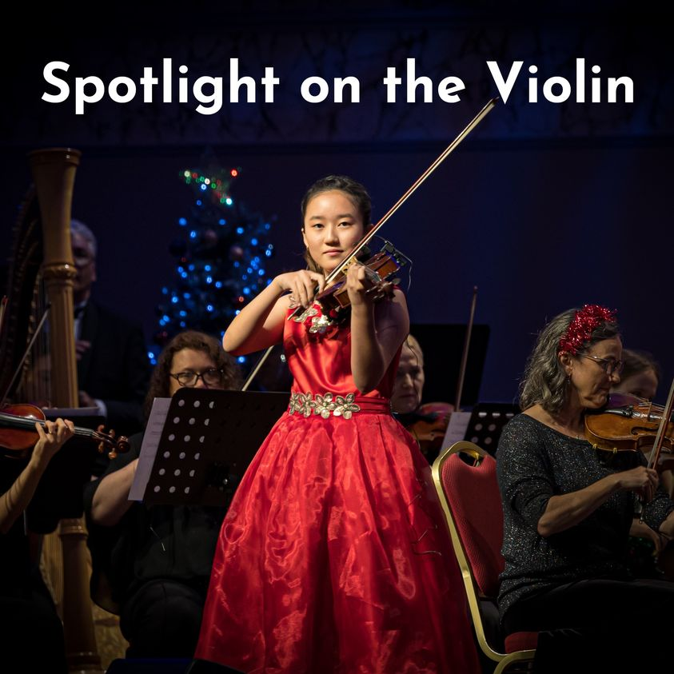

The Brisbane Symphony Orchestra presents a concert featuring 13-year-old Ein Na (winner of the 2022 National Youth Concerto Competition) performing Prokofiev’s Violin Concerto no.1.
Also on the program:
- The rarely performed Shostakovich Symphony no.1, composed when he was 19, and still considered one of his best works.
- Borodin’s Polovtsian Dances from “Prince Igor” – much loved and energetic music which includes sparkling solos from many of the instruments of the orchestra.
Special deal for school families:
2 Adults and 2 Students for the price of 2 concession tickets: $70
(B Reserve seating) Extra child tickets can be purchased for $20.
SCAN FOR TICKETS

