Level 1 Term 3 Homework Matrix #1
Homework tasks should ideally be completed with adult supervision. The Homework Matrix for each level will be available in the Connect newsletter once a fortnight. Tasks will be completed in student homework books and handed to the teacher, to be signed, two weeks later, on a Friday (even weeks). Teachers will sign homework books.
Reading + 5 tasks/fortnight
Due Date: 7/08/26

Reading (compulsory)  Read for: 10-15 minutes every day.  Record the title of your book and the pages read in your diary. Ask an adult to sign your diary. | Writing  Last term we learnt all about the world’s continents.  Can you remember some?  If you can, please write some facts that you know about a continent or two! | Physical Education Challenge  Underarm Throwing Practice  Grab a ball or a beanbag and practise your underarm throwing at home with a partner. Focus on using the “Swing, Step, Throw” technique we’ve been learning in class.  If you don’t have a partner, you can practise by aiming at a target, such as a bucket, wall, or chalk mark. | Gratitude  List the reasons why you are grateful that we have our SEPS swimming coming up soon.  Why do you think knowing how to swim is such an important skill?
Core Literacy  We have been looking at syllables this term.  Can you draw a line between the letters in the words below to show where the syllables are:  hospital  swimming  Australia  exploring  adventures | Maths  See Mrs Gau’s Maths Challenge in the Newsletter. | Art Challenge  Draw how you feel today. Use colours that match your feeling.   | Mindfulness  What are some mindfulness strategies you have used lately?  Can you write about why you felt you needed/wanted to use these strategies?
Handwriting  Copy this beautifully into your book:  The winter months are well and truly here. It is nearly the end of July, but we still have all of August to go before hopefully a lovely burst of spring. | Maths Skills/Fluency  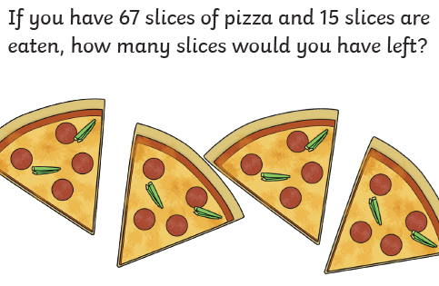 | Science  Survival of Living Things - Why would a cuttlefish camouflage? Explain your understanding to a parent or guardian. | Emotional Literacy  Can you act out some emotions?  Have a friend or family member try to guess each emotion.  e.g. joy, sadness, excitement…
Heart Words  around  about  again  Write each word out 3 times, while saying the letters. Write each word in an interesting sentence. | Online Platforms  Complete your tasks on Mathletics. | Mandarin  🌈 Draw and colour 3 fruits. Write the colour and fruit name in Chinese.  红色的苹果 hóng sè de píng guǒ - red apple  黄色的香蕉 huáng sè de xiāng jiāo - yellow banana  绿色的西瓜 lǜ sè de xī guā - green watermelon | Empathy  How could you help a friend who might be a bit sad and lonely in the yard?

