
09/10/2025

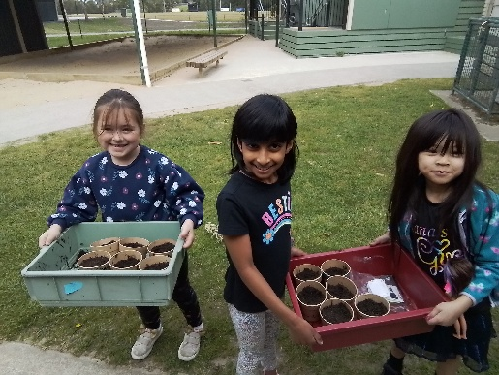
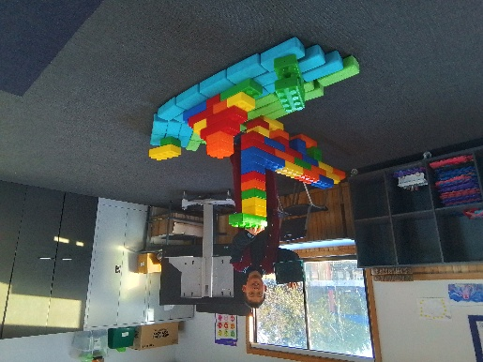


Welcome back to term four, we have children week coming up with variety of activities to be involved in at OSHC.
We have Big Art Competition start on the Friday 17th October, send your amazing entries to be judged and shared with the region.
We have a Pupil Free Day coming up on the Monday 3rd November, this will be a fun packed day with many activities cooking creation and science ideas and water games also we make smoothies to enjoy.
- Big Art Lego
- Talent Competition
- Superhero masks
- Clay Animal Habitat
Activities coming up
Join in the fun of Outside School Hours Care activities and experiences with Your OSHC and Rocketeers.
Make a booking
Book now
Oatlands Primary School OSHC

