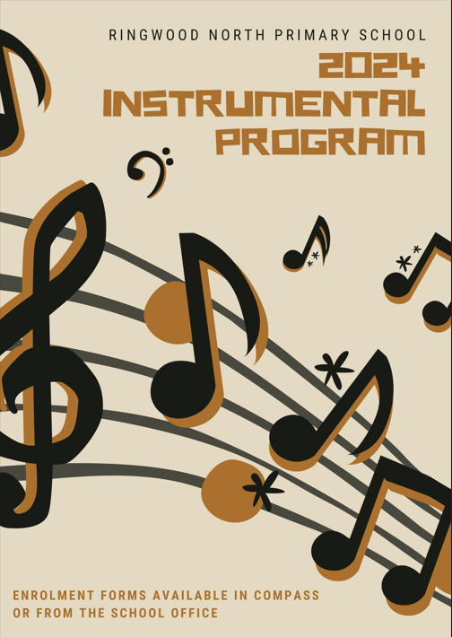

RINGWOOD NORTH PRIMARY SCHOOL
INSTRUMENTAL MUSIC PROGRAM

Ringwood North primary School offers parents/guardians the opportunity to enrol children in our instrumental program. During 2020, 200+ children were learning from a range of instruments including electronic keyboard, piano, violin, guitar, clarinet, flute, recorder and saxophone, trumpet, trombone and percussion.
Participation in the program is optional. Lessons are half an hour in duration and timetabled during the school day, on a rotating timetable.
At Ringwood North we view our Performing Arts Program as an enriching opportunity for students. We value the importance of this program in the education of children.
The goals of the program are clear:
- To provide the opportunity at school to learn a musical instrument in order for children to develop lifelong leisure music skills.
- To encourage skills that are developed through this initiative to be extended into normal core curriculum areas, notable: self-discipline, commitment, perseverance, enhance self-esteem and increase confidence.
- To provide lessons at affordable rates in groups of no more than 2 children thereby increasing access to instrumental music to greater numbers of children.
- To provide opportunities for group performances at concerts, public gatherings in the local community and in the school band.
- To provide parents with 2 reports each year discussing their child’s progress.

COST:
$24.00 per half hour lesson for groups of 2
$36.00 per half hour individual lesson
Please consider this opportunity for your child while at Ringwood North Primary School. An enrolment application form can be collected from the office, or in Compass under School Resources.

Ken Chatterton
PRINCIPAL

FOOD FOR THOUGHT
Music May Boost Brain’s Abilities
Alex Messina, Education Report - The Age 29th September 1995.
_______________________________________________________________
“It might go in one ear and out the other, but if it is music there’s a good chance it’s doing something in between that is boosting your child’s intelligence.
According to a U.S. research psychologist, Dr. Frances Rauscher, learning keyboard for 15 minutes a week and a 30-minute daily singalong can boost aspects of a three-year-old’s intelligence quotient by an average of 47 per cent.
Also, just listening to a Mozart sonata for 10 minutes will cause a similar but lesser short-term effect on 18- to 22-year-old students. It may mean that you have to get them young to gain lasting benefits.
The results are part of recent research by Dr. Rauscher, whose team at the University of California, Irvine, says it has confirmed a causal link between music and intelligence. Two years ago, Dr. Rauscher began a project with 34 three-year -olds who were all measured at closely equivalent intelligence levels. Nineteen of the children were given 15-minute weekly keyboard lessons and daily singing. The rest did whatever kids do. After eight months, Dr. Rauscher found that the 19 students had on average increased their spatial intelligence by 47%, although two had shown no significant increase.
Over the same period, the other children’s spatial intelligence increased by an average of 6% - a divergence of 35 percentage points. Spatial intelligence relates to the ability to visualise, rotate and assemble objects. Children were assessed by being timed while reassembling disassembled objects, such as animals.
It might not sound dramatic, except that the process calls on the same higher level brain conceptualisation used in mathematics, engineering, science or playing chess, Dr Rauscher says.
Separate tests involving 100 adults showed that simply listening for 10 minutes to a Mozart sonata for two pianos in D major, number K448, increased college students’ spatial intelligence by 9%.
Dr Rauscher said the results did not mean classical music alone gave benefits. Rather, the melody or rhythm seemed the critical factor.”

School Ensembles
RNPS will invite experienced learners to be a member of one of two school ensembles. These will be small groups that will work towards public performances during an out-of-class time. These ensembles will be taught by Instrumental Teachers Damon Goulas and Anthony Merchant.

Woodwind
Krysten Ioannides
As a woodwind specialist, I love introducing woodwind instruments to young people as they’re great for beginners but never need to be outgrown! There are Flutes, Clarinets and Saxophones which are especially designed for small hands and are ideal for Primary School students. Using these instruments, I teach students not only how to read music notation but also to develop their musical ear. I also love to work with the students at achieving tangible music goals to help grow their confidence in their newfound craft. As a bonus, playing woodwind instruments can help greatly with dexterity, breath control and lung capacity.
I was a highly enthusiastic music student all through high school and sat AMEB exams on both Flute and Saxophone. I performed a solo on Flute for VCE Music Performance and Saxophone at the Victorian College of the Arts foundation course.
I’ve enjoyed performing to range of audiences from busking in humble beginnings, to competing in Eisteddfods, playing at weddings and functions, and as part of a Jazz big band – even playing alongside Aussie Jazz legend James Morrison.
I’d be happy to discuss any queries you have via phone or email.
0425 299 080 or krysten.ioannides@gmail.com

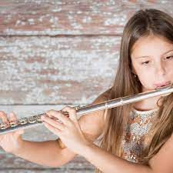

Drums
Daniel McKenzie

My name is Daniel, and I am the new drum teacher at RNPS.
I began my musical journey as a student at this school, so I am very excited to be passing on my knowledge to the awesome kids here now. I have always been an obsessively passionate musician, having completed a Bachelor of Applied Music in 2017 and being a multi-instrumentalist, performer in multiple bands, as well as composing and producing music for myself and others.

I have been teaching for quite a few years and have loved being able to inspire and educate students. Learning the drums is a particularly great way to improve timing, coordination and rhythmic muscle-memory, whilst also being a fun way for kids to exert their energy. We focus mainly on playing songs, practising rudiments/exercises, and developing a strong reading ability.
Please contact me on 0424 837 408 or danielmckenzie569@gmail.com.

Piano and Keyboard
Diana Matthews

Lessons are offered to children from Grades 1 to 6.

The keyboard is an excellent instrument to commence a child’s musical studies. It develops finger independence and good co-ordination between the hands.

The development of the skills in reading music and translating this to the keys through finger independence, helps develop spatial relationships involving the left and right hemispheres of the brain.

Consequently, the keyboard gives a good foundation for a child wanting to go on to the guitar or other instruments later.

Where appropriate children will be placed in groups of two. In some instances, private tuition is recommended.

Students have the opportunity to sit external examinations at the end of the year if they wish, and the repertoire given includes both modern and classical at Preliminary level.

If you have any queries, please ring Diana on 9874 8285 or send an email at dianamatthews818@gmail.com.

Guitar
Damon Goulas
The guitar is a relatively inexpensive instrument to begin learning and is suitable for a wide range of musical styles. Students have the option of learning electric or acoustic guitar, and they will learn aspects of playing which are relevant to both styles of guitar.
Current Pop/Rock material is taught while learning the basics of reading and music theory.
Students will have the opportunity to participate in in guitar exams on either electric or acoustic guitars which increases their knowledge of the instrument in many different ways.
If you have any queries, please contact Damon on 0404 204 132.

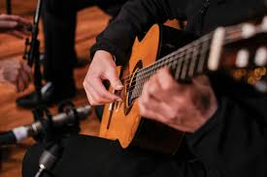

Singing
India Teagle

India is a professional singer with 20 years of vocal training and almost 10 years of coaching experience. She performs weekly around Melbourne at weddings and corporate events with her duo "Indi Acoustic".
India has featured as a lead vocalist in the Victorian State Spectacular, performing on Channel 7's "The Morning Show" and featured on The Voice Season 3. She has also released original music and spent a year in the UK performing with cover bands.
India is highly versatile in teaching various popular styles including Pop, RnB and Musical Theatre and encourages her students to explore many different styles and techniques of singing, she is passionate about providing a personalised approach to all of her students in a fun, nurturing environment. She is able to assist students with preparation for auditions, competitions and performance exams.
If you have any queries, my number is 0476348103 and my email address is singwithindi@gmail.com

