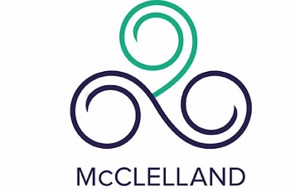
Year 12 October Practice Exams 2018
Monday 1st October | 8:45-12:00pm  English (3hr15m)  EAL (3hr 15m) | 1:00-2:15 pm  Maths Methods Exam 1 (1hr 15m)  1.00-2:45 pm  Studio Arts (1hr 45m)  1.00-3:45pm  Psychology (2hr 45m)
Tuesday 2nd  October | 8:45-11:30am  Chemistry (2hr 45m)  8:45-11:00am  Media (2hr 15 min)  Physical Education (2hr 15m)  Music Performance  (2hr 15 min) | 12.00 – 1:45 pm  Further Maths Exam 1 (1hr 45 m) | 2:15 -4:30 pm  Health and Human Development (2hr 15m)  Systems Engineering (2hr 15m)  Japanese (2hr 15m)
Wednesday 3rd October | 8.45-11:30am  Biology (2hr 45m)  8.45-11.00 am  Accounting (2hr 15 min)  Philosophy (2hr 15 min)  8.45 – 10.30 am  Visual Communication & Design (1hr 45m) | 12:00-1:45 pm  Further Maths Exam 2 (1 hr 45 m) | 2:15-4:30pm  Business Management (2hr 15m)
Thursday 4th October | 8.45-11.30 am  Physics (2hr 45m)  8.45 – 11.00 am  Ancient History (2hr 15 min)  8.45-10.30 am  Design Technology (1hr 45m)  Food studies (1hr 45m) | 12:00 pm-2:15 pm  Legal Studies (2hr 15m)  Computing: Informatics (2hr 15m) | 2:30pm-4:45pm  Maths Methods Exam 2  (2hr 15)
NOTES:
- All exams are in the PAC except for EAL, MUP and JAP. (These will be held in sc4)
- Wait outside the PAC or SC4 at the start of each exam. Please ensure you arrive at least 10 minutes before the start of your exam.
- You must remain until completion time of your exam then leave the PAC quietly as other exams will still be running.
- Please bring water bottle & equipment your teacher has instructed you to bring i.e. Dictionary, calculator.
- No mobile phones or electronic devices are permitted into the PAC.
- The senior centre will be open between exams for students to access toilets and the lounge area. Students will have only access to only this area and the PAC.
- School uniform is not required to be worn but closed in foot wear is compulsory (no thongs).

