

AN INITIATIVE TO SUPPORT OUR LOCAL COMMUNITY.
Kyneton Baptist Church, Omnia Community Health and the
Macedon Ranges Shire have partnered together to support local families this Christmas.
WE NEED YOUR SUPPORT!
This year we are providing families with gift cards to spend at our local businesses. We need your financial help
to make this possible. Donations can be made at Bendigo Bank Branches and via bank transfer by
14th November 2026. Find us on Facebook for more details.

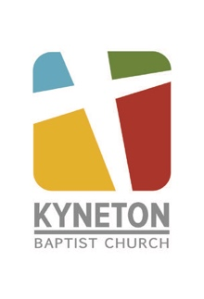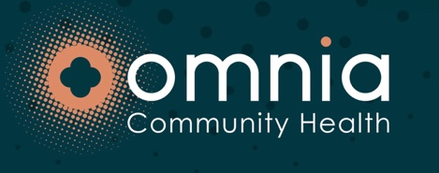 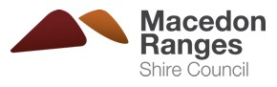 P: (03) 5422 1782
M: 0404 442 891
E: macedonrangesgiftshop@gmail.com
A community initiative of the Macedon Ranges
Supporting local families at Christmas

