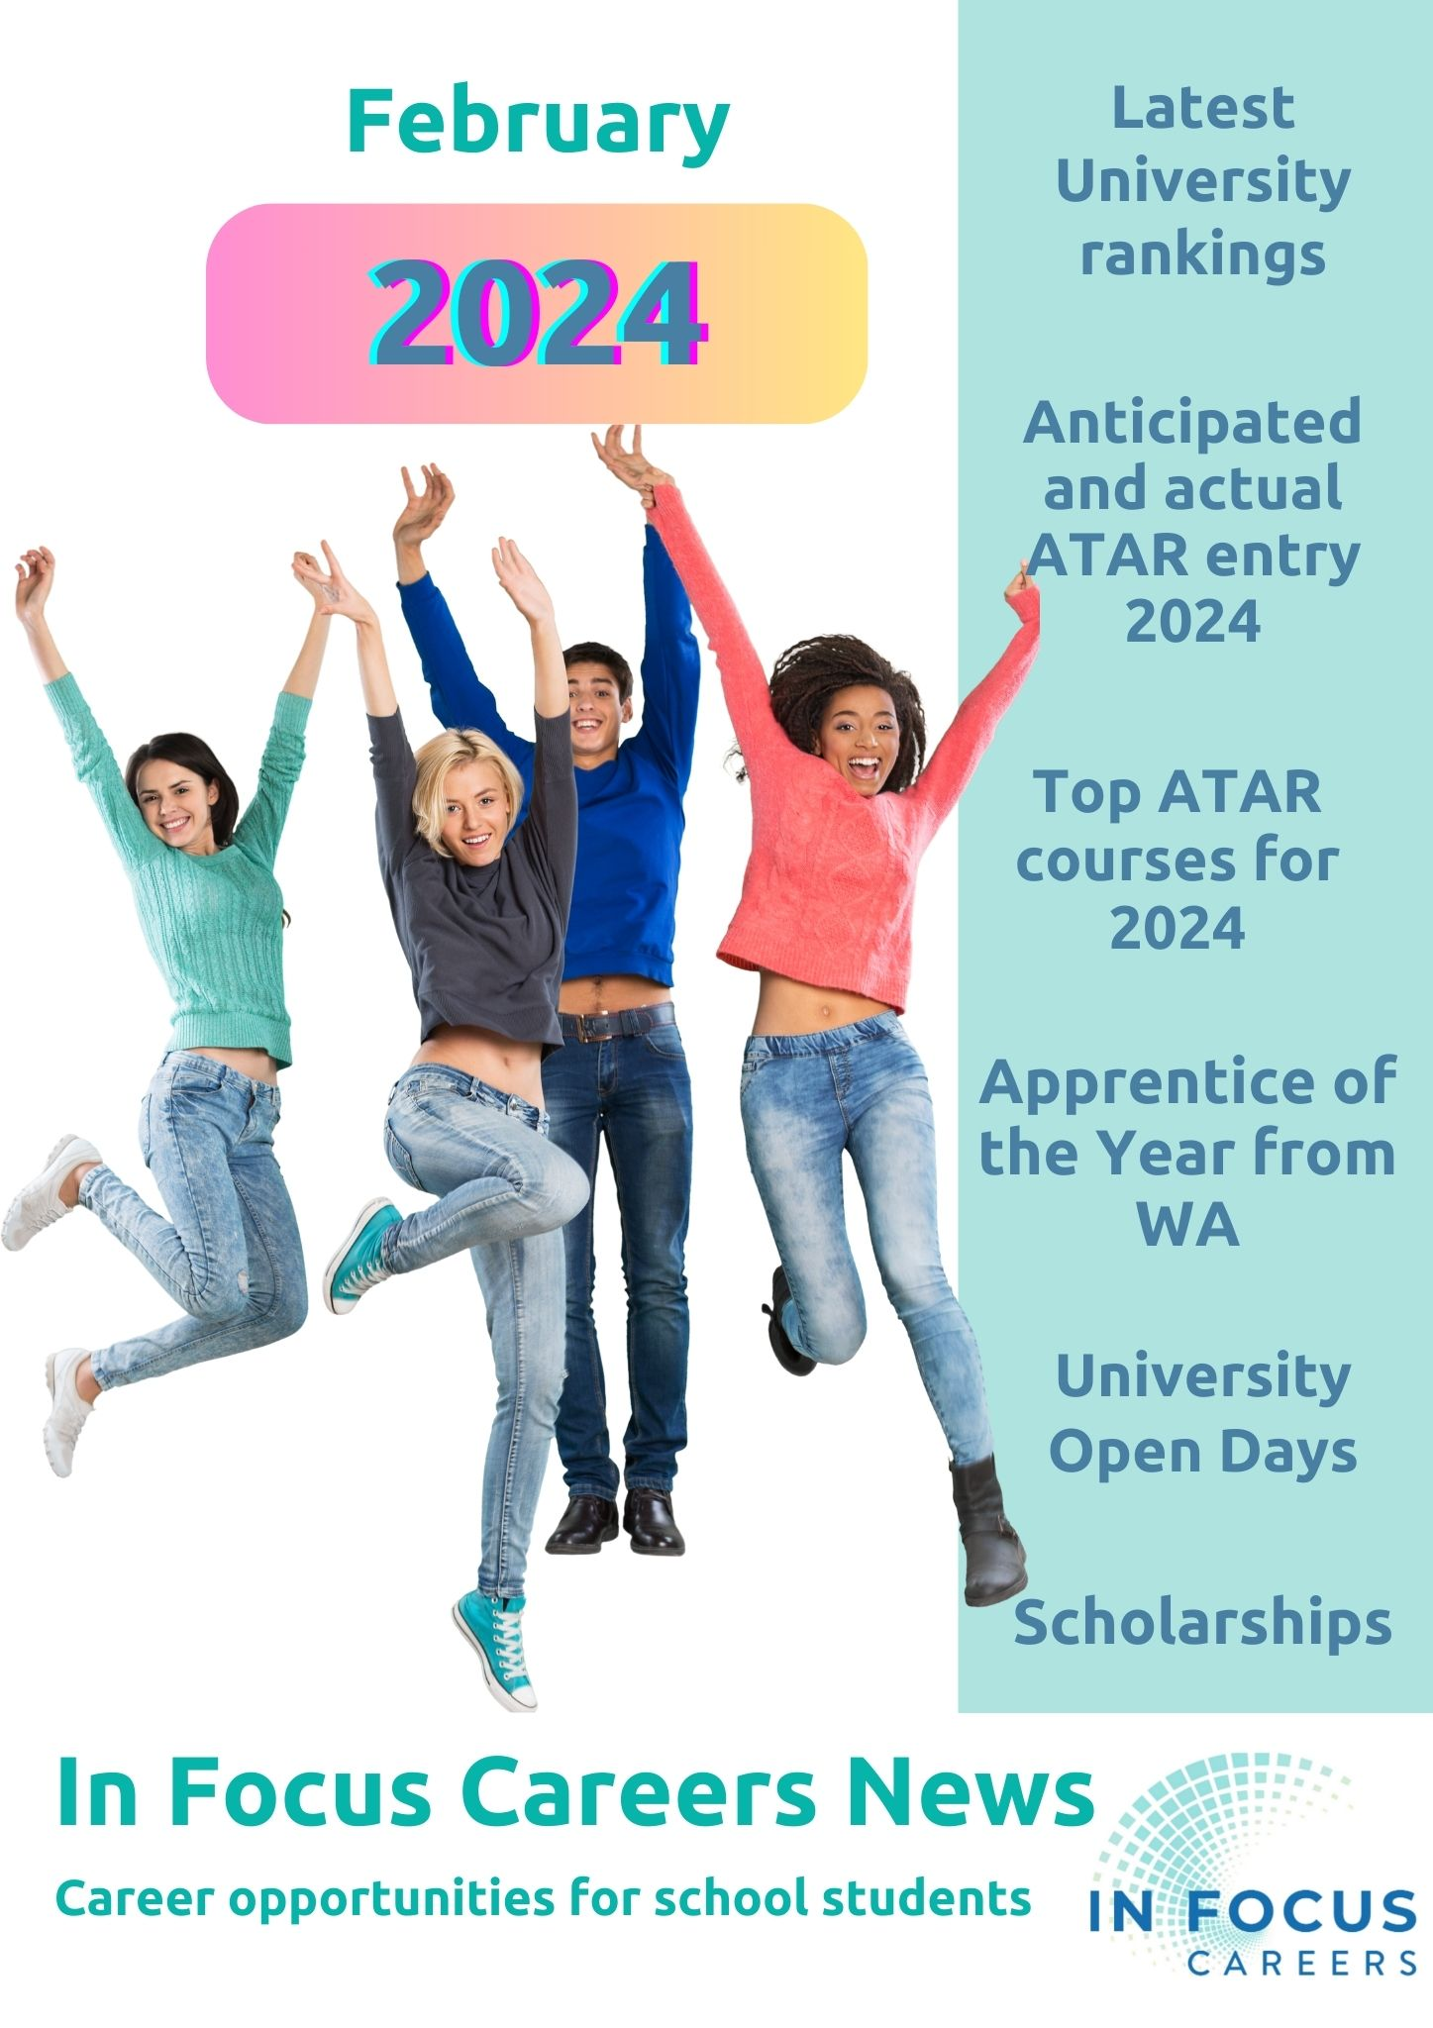

New Armadale TAFE Campus & Jobs and Skills Centre
There is a new TAFE campus in Armadale and a Jobs and Skills Centre is located nearby at the Armadale Shopping Centre.
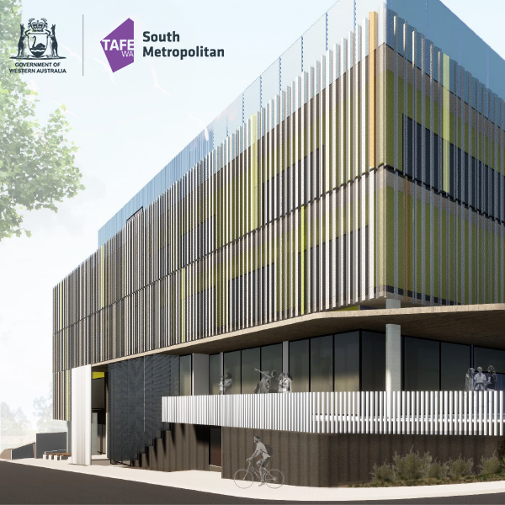
Jobs and Skills Centres offer support to anyone wanting career advice. You don’t have to want to go to TAFE. Check out their services HERE.
You can make an appointment by calling us on 13 64 64 or 9497 0990, or email armadalejsc@smtafe.wa.edu.au.

Career Opportunities for the bold and curious

Fogarty Foundation Opportunities
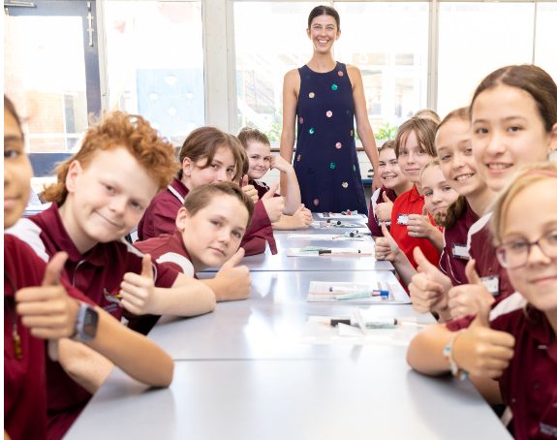
Families seeking new opportunities to support their students to achieve their full potential can connect with the Fogarty Foundation which is committed to ensuring all young West Australians can receive high quality education.
Opportunities include:
- Fogarty Scholarships. These highly sought after scholarships are for high achieving, high potential students. You can read about the scholarship program HERE.

- EDfutures CoderDojo free sessions to help 7 – 17 year olds to be creative and solve problems using computers. You can find out more at CoderDojo@Curtin.

- The Smith Family program provides opportunities for talented students from disadvantaged backgrounds.

- ABCN Fogarty Accelerate Scholarships provides intensive mentoring scholarships.

You can get regular updated about the Fogarty Foundation programs by connecting HERE

WAAPA Junior Academy for secondary school students
The WAAPA Junior Academy is designed specifically for young people who have a passion for performing.
The program runs in 8 week blocks from February to December each year, in line with the school terms.
2024 Courses
- Acting and Performance Making - School Years 7 to 12
- Music Theatre - School Years 7 to 12
- Tell Your Story - (For CALD Students)
Education Coordinator: Gabrielle Metcalf Phone: (+61 8) 6304 6775
Email: explore.waapa@ecu.edu.au

MyFuture – your one stop shop for career information.
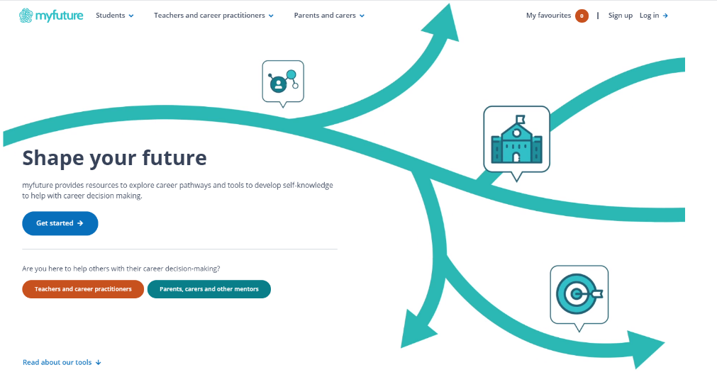
Do quizzes, watch career videos, check out courses and what happens when you get into the job. MyFuture takes you on a career exploration pathway.
- MyFuture is thorough and delivers loads of free information.
- It is supported by ALL Australian governments.
- The information is not biased by someone trying to sell you something.
- They have a strong privacy policy and DO NOT share your data.
You can register HERE.

University News

How WA based universities performed in the Good Universities Guide 2023/24 Ranking
Edith Cowan University led Western Australia with 82.7% of students being satisfied with the overall quality of their educational experience. ECU has a consistent record as best in Western Australia for overall student experience.
Measure | WA universities ranking
Overall Experience  This rating looks at the proportion of students who were satisfied with the overall quality of their educational experience | - Edith Cowan again ranked top in WA and third highest in Australia with 82.7% overall experience.  The top-ranking Australian University for Overall Experience was Seventh Day Adventist Avondale University in NSW with 87.9%. Second was Bond University in Queensland with 86.3%.  - Notre Dame held steady with 77% after its sudden drop from equal first place with Bond University, in 2021.  - UWA has improved considerably over recent years and now has an overall student satisfaction ranking of 75.8%  - Curtin is also improving with 74.2%  - Murdoch is also getting better approval ratings with 72.6%
Social Equity  This rating shows what proportion of domestic students enrolling at each university come from low socioeconomic or disadvantaged backgrounds. | - Murdoch highest in WA with 22%  - Curtin scored 17%.  - ECU scored 16%  - Notre Dame scored 11%  - UWA scored 9%.
Undergraduate courses Staff Qualification  This rating looks at the proportion of staff who hold a master’s or doctoral degree. | - Curtin 82%  - Murdoch 76%  - ECU 73%  - UWA 68%  - Notre Dame 51%
Student Demand  This rating looks at where high-achieving domestic students choose to study. | - UWA is highest in Australia with Low 6% Medium 66% and High 28% ranking ATAR students choosing UWA.  - Curtin Low 10% Medium 71% and High 19% academic scores.  - ECU Low 14% Medium 73 High 9%  - Murdoch Low: 25% Medium: 73% High: 2%
First Generation  The proportion of students commencing a bachelor’s degree whose parents’ education did not exceed Year 12 | - ECU 40%  - Murdoch 35%  - Curtin 29%  - Notre Dame 29%  - UWA 23%
Learner Engagement  The extent to which students were prepared to study, had a sense of belonging, were prepared to participate in discussions, worked with other students. | - Notre Dame 64.5%  - ECU 58.6%  - UWA 55.7%  - Curtin 50.1%  - Murdoch 48.3%
Skills Development | - Notre Dame 87.1%  - ECU 86.8%  - Murdoch 79.6%  - Curtin 78.7%  - UWA 76.2%
Student Support | - ECU 80.2%  - UWA 73.9%  - Notre Dame 73.2%  - Murdoch 72.6%  - Curtin 69.7%
Graduate Outcomes
Rating Type | West Australian based universities
Starting Salaries of graduates*  *These salaries are the same as last year, so I suspect it is too soon to gather these figures for 2023 graduates. | - Notre Dame $62,000  - Curtin $53,200  - ECU $49,200  - Murdoch $48.400  - UWA $35.500
Full time employment | - Notre Dame 78.2%  - Curtin 73.7%  - ECU 65.5%  - Murdoch 62.8%  - UWA 61.4%

ATARs ranks 10 or more ABOVE the estimated rank.
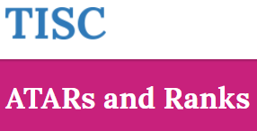
Each year universities estimate the minimum estimated ATAR rank which they think students will need to be offered a place in each course.
When the Tertiary Information Service Centre collates the ATAR results, it matches students with places from top ATAR rank down until all places have been filled.

This is a collation of the Actual ATAR accepted by the university for courses in 2024. I have only recorded where the cut off is 10 or more ABOVE the estimated rank. You can see all ranks HERE.

University | Course | Minimum estimated  ATAR | Lowest ATAR offered a place
Curtin | - Bachelor of Science (Science) in Mathematics; Bachelor of Commerce (double degree)  - Bachelor of Science (Science) in Coastal and Marine Science; Bachelor of Commerce (double degree)  - Bachelor of Science (Science) Data Science  - Bachelor of Science (Science) Mining  - Bachelor of Science (Science) in Environmental Biology; Bachelor of Arts (double degree)  - Bachelor of Education (Secondary Education) - Humanities and Social Sciences Education in Economics  - Bachelor of Science (Science) in Earth Science  - Bachelor of Science (Science) in Environmental Biology; Bachelor of Commerce (double degree)  - Bachelor of Applied Geology; Bachelor of Science in Environmental Biology (double degree)  - Bachelor of Science (Oral Health Therapy)  - Bachelor of Innovation; Bachelor of Science (Information and Communication Technology)  - Bachelor of Arts in Korean  - Bachelor of Science (Science) in Mathematics  - Bachelor of Education (Secondary Education) - The Arts Education in Media Production and Analysis  - Bachelor of Science (Science) in Physics  - Bachelor of Science (Science) in Extractive Metallurgy  - Bachelor of Education (gifted Education) (Kalgoorlie) | 70.00  70.00  70.00  70.00  70  70.00  70  70  70.00  83.00  70.00  70.00  70.00  70.00  70.00  70.00  70.00 | 86.8  86.1  83.3  91.65  94.85  84.50  81.2  80.45  80.7  99.3  84.10  87.35  99.95  80.30  85.55  98.60  81.80
ECU | - Bachelor of Engineering (Electrical Power) Honours  - Bachelor of Engineering (Electrical and Renewable Energy) Honours  - Bachelor of Engineering (Maritime) Honours  - Bachelor of Engineering (Computer Systems) Honours / Bachelor of Computer Science (double degree)  - Bachelor of Social Science | 80.00  80.00  80.00  80.00  70.00 | 94.60  94.05  98.60  90.00  86.65
Murdoch | - Bachelor of Arts in History  - Bachelor of Arts in Politics and International Studies  - Bachelor of Arts in Theatre and Creative Production  - Bachelor of Science (Medical; Molecular & Forensic Sciences) in Clinical Laboratory Science  - Bachelor of Information Technology in Business Information Systems  - Bachelor of Information Technology in Games Technology | 70.00  70.00  70.00  70.00  70.00  70.00 | 86.65  88.40  80.10  80.95  80.95  82.00
Notre Dame | - Bachelor of Science  - Bachelor of Laws/Bachelor of Philosophy; Politics and Economics (double degree)  - Bachelor of Philosophy; Politics and Economics | 70.00  85.00  70.00 | 99.90  99.00  88.70
UWA | - Bachelor of Modern Languages and Bachelor of Arts  - Master of Teaching (Secondary) via Bachelor of Commerce Assured Pathway  - Master of Teaching (Secondary) via Bachelor of Biomedical Science Assured Pathway  - Master of Teaching (Secondary) via Bachelor of Chemistry Assured Pathway  - Bachelor of Biomedical Science - Albany | 82  80  80  80  80 | 95.65  91.10  93.40  93.10  98.3
This table shows data relating to offers made through TISC as published on the TISC website.

Courses with the highest ATAR entrance score
- Medicine at Curtin: Curtin is the only university in WA where medicine is run as an undergraduate course. School leavers can apply and go straight into the course without doing a degree first. Notre Dame and UWA both require you to have an undergraduate degree before you apply for medicine.
*Curtin had over 3000 applicants for 120 places in Medicine. Applicants must have an ATAR of 95 and there are other entry requirements. You can find details HERE.

- Veterinary Science at Murdoch: Veterinary Science is only run at Murdoch in WA. The minimum ATAR is 94 and there are additional entry requirements for applicants. Check details HERE.

Course with highest ATAR entrance |  | Lowest ATAR selection rank offered
Curtin | - Bachelor of Advanced Science (Honours) in Environmental Science  - Bachelor of Advanced Science (Honours) in Physics  - Bachelor of Laws; Bachelor of Science (Environmental Science)  - Bachelor of Science (Science) in Mathematics  - Bachelor of Science (Science) in Extractive Metallurgy  - Bachelor of Advanced Science (Honours) in Data Science | 98.5  95.10  96.25  99.95  98.60  95.00

ECU | - Bachelor of Engineering (Electrical Power) Honours  - Bachelor of Engineering (Electrical and Renewable Energy) Honours  - Bachelor of Engineering (Maritime) Honours | 94.60  94.5  98.60
Murdoch | - Bachelor of Global Security in Cyberspace; Policy and Security  - Bachelor of Laws; Bachelor of Information Technology (combined degree)  - Bachelor of Laws; Bachelor of Science in Psychology (combined degree)  - Bachelor of Science (Physical Sciences) in Chemistry | 96.00  94.05  96.00  99.00
Notre Dame | - Bachelor of Science  - Bachelor of Laws/Bachelor of Philosophy; Politics and Economics (double degree)  - Bachelor of Physiotherapy/Bachelor of Exercise and Sport Science (double degree)  - Bachelor of Physiotherapy | 99.90  99.00  98.60  97.90
UWA | - Bachelor of Biomedical Science – Albany  - Bachelor of Philosophy Honours (This is an assured pathway to a number of higher level degrees)  - Bachelor of Modern Languages and Bachelor of Arts  - Juris Doctor (Law) via Bachelor of Arts Assured Pathway  - Juris Doctor (Law) via Bachelor of Commerce Assured Pathway  - Juris Doctor (Law) via Bachelor of Science Assured Pathway  - Juris Doctor (Law) via Bachelor of Philosophy; Politics and Economics  - Juris Doctor (Law) via Bachelor of Human Rights  - Juris Doctor (Law) via Bachelor of Criminology and Criminal Justice  - Bachelor of Earth Sciences and Master of Oceanography  - Bachelor of Science (Frontier Physics) and Master of Physics  - Bachelor of Biomedical Science - Albany | 98.30  98.00  95.65  96.00  96.00  96.00  96.00  96.00  96.00  95.85  96.30  98.30

Your life is dyed with the colour
of your experiences.

UWA Fogarty Scholarship Program
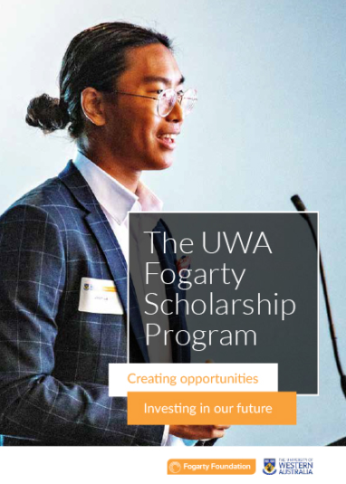
If you are aiming for an ATAR of 98+ consider going for a Fogarty scholarship.
This is a prestigeous scholarship that is awarded to 10 outstanding year 12 graduates each year.
To be eligible you must demonstrate outstanding achievement across Years 11 & 12.
Find out about the program HERE.

Dream not half a dream, nor cling to a half hope.
Kahil Gibran

University Open Days

Go to Open Days 2024 to find what’s available.
Because students can apply for a place at university in 2025 from about April, universities now hold open days early in the year, and they now run more events throughout the year to help prospective students to make informed decisions.
- You can apply for a place within a course at university and change your mind.
- There is no advantage to applying for a place in a course early.

University Open Day Calendar 2024
17 March |  | 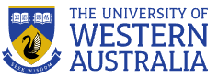  UWA Open Day
23 March |  | Murdoch University
24 March |  | Curtin Open Day
5 May |  | Notre Dame
14 April Joondalup  21 April South West  28 April Mt Lawley | 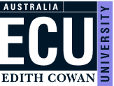  Edith Cowan

Senior School Opportunities

31 March 2024: Applications Close for Rotary Youth Exchange 2025
Rotary Youth Exchange students spend 12 months in a foreign country with board and accommodation provided by host families.
Students:
- make lifelong friends,
- expand their world views and
- have a brilliant time.

Students must be between the ages of 15 and 18 on the 1 January of the year of their exchange.
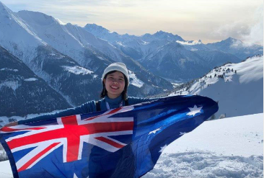
Contact Rotary Youth Exchange Western Australia for details on how to apply.

Fully supported volunteering overseas
Projects Abroad supports students aged 15 – 18 who would like to volunteer to work overseas for approximately 2 weeks. There is a range of fantastic opportunities available and Projects Abroad support participants through all stages of the experience. Programs cost about $3000.
The most popular High School Special projects include:
- Conservation in Thailand | - Childcare in Cambodia
- Medicine in Nepal | - Conservation in Botswana
- Childcare in Fiji | - Medicine in Sri Lanka

You can find more HERE.

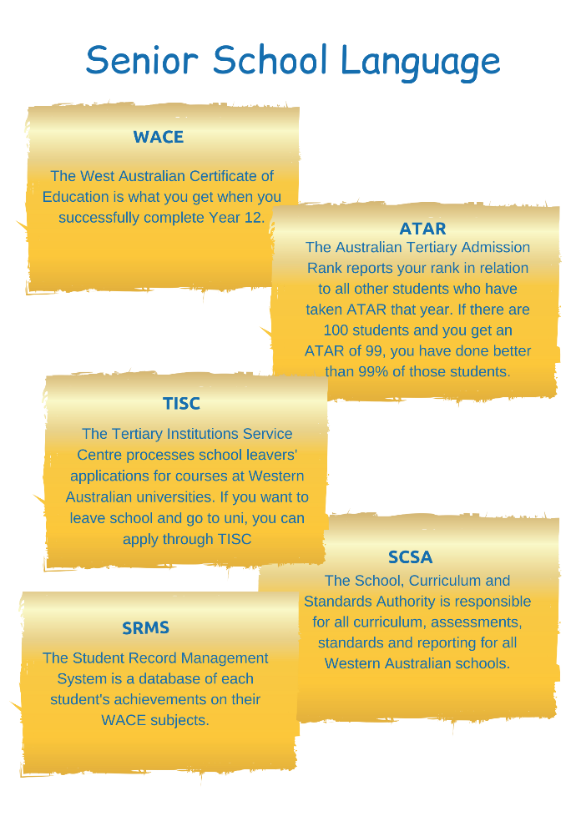
Senior School Language
Here is a quick guide to some of the acronyms and initials that you will her in senior school.
You can download a free copy HERE.

Year 12 Opportunities

Early Offers to universities in WA
All West Australian universities will make early offers available from about April. All of the Open Days, apart from the Notre Dame one, will be held BEFORE applications open for 2025.

Weekly WA Police Recruitment Sessions – Saturday mornings
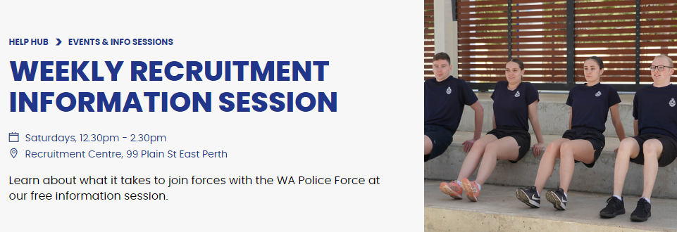
There is no age limit to apply for the WA Police Force. You must be 17 years and 6 months or older to apply for a Police Officer (Entry-level) and over 17 to apply for Cadet or Police Auxiliary Officer roles. You can register for a session HERE.

Year 12s - Register NOW for Scholarship Alerts
Set up your infrastructure to support your transition from school at the end of the year. Register for scholarship email alerts at
- universities of your choice
- at the Good Universities Guide Scholarships page.
- Your local TAFE college
Check out special needs scholarships like:
- Australian Indigenous Education Foundation
- Australian Disability Clearinghouse on Education and Training

2025 Scholarships to Boost Diversity in STEM
The Australian Academy of Technological Sciences and Engineering (ATSE) has announced 116 scholarships to support women and diverse people to thrive in science, technology, engineering and mathematics (STEM) careers.
Applications for the Elevate program commencing in 2025 will open in early 2024.

Entry to Medicine for 2025 (UCAT)
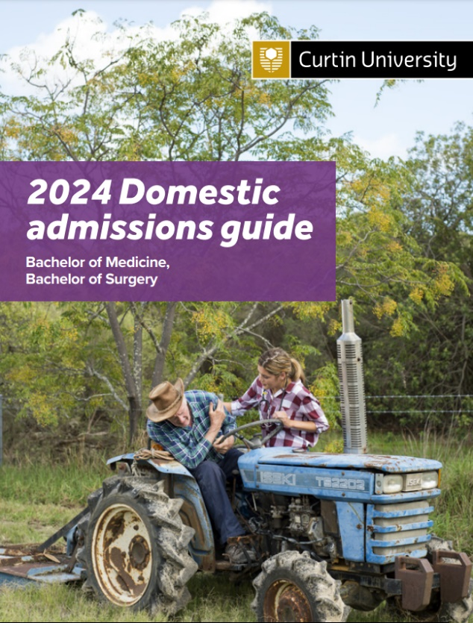
In Western Australia, only Curtin University takes students into medicine straight from school*. It was designed as a pathway for West Australian school leavers.
Candidates from rural and regional areas and Aboriginal and Torres Strait Islander students and those from disadvantaged backgrounds will be prioritised.
- Rural and remote applicants: The Medicine Faculty at Curtin is keen to address the shortage of doctors in the bush in WA. Contact Associate Professor Keith McNaught - Rural Academic Lead, Curtin Medical School at Keith.Mcnaught@curtin.edu.au
There were over 3000 applicants for the 120 places being offered at Curtin in 2024.
- Applicants need to have an ATAR of 95 or higher, including Chemistry with a final score of 50 or higher. (See P4 of the Admission Guide for details.)
- A competitive score on the Universal Clinical Aptitude Test. Bookings for the Test open 5 March. Testing begins 1 July.
- Applicants then take the Casper Test which was introduced by Curtin last year.

Please refer to the Domestic admissions guide for information.
School leavers with an outstanding ATAR may be granted an Assured Pathway into post graduated medicine or dentistry degrees at UWA.
Find details HERE.

Year 11 Opportunities

Start Building Your Resume Now for scholarships, apprenticeships and jobs.
Many VET and uni scholarships look for year 11 and 12 academic results, and many scholarships are awarded to those who have demonstrated skills and commitment outside of the classroom:
Employers of apprentices will compare your application against those of others. You can build your resume by:
- Doing sport/hobbies.
- Leading service projects or events at school.
- Entering academic competitions at school.
- Volunteering.
- Get a part time job.

University Admissions 2026
For students in Year 11 in 2024
- How to apply for a place at university, requirements and different pathways
- Pre Requisites
- Check out the University Admissions 2026 for a comprehensive list of prerequisites from each West Australian university.
- Make an appointment with your school career advisor and go through university courses that you might choose.
- Make sure you are doing the subjects you need to get into those courses.

Gap Year Study
If you think you might like to do something different in 2025, you could try studying overseas. You can find courses @ hotcoursesabroad.
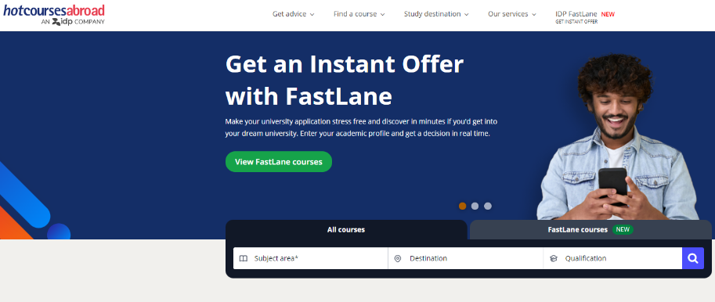

Crimson provides services that link you to universities in the US or UK. Crimson staff come to Perth and give presentations each year. Register on their site for updates.
For information about Gap Year opportunities for the end of the year check School Leavers 2025 Gap Year Opportunities HERE.

Year 9 & 10 Opportunities

Famelab Academy 2024
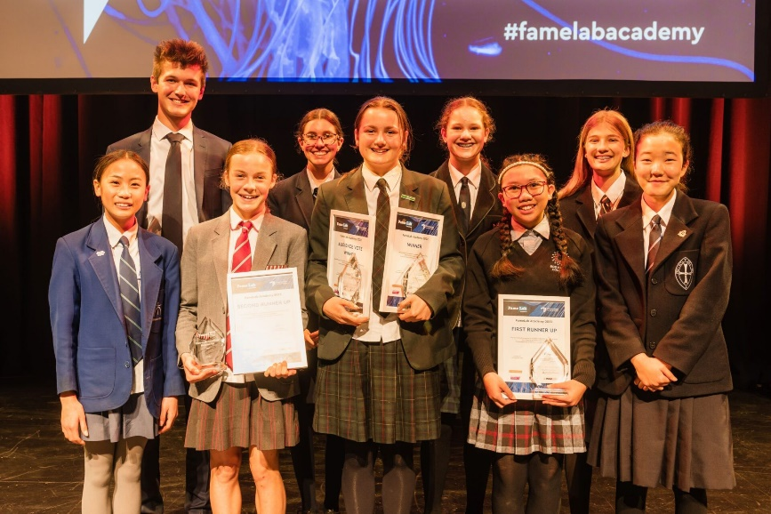
FameLab Academy is an initiative for Years 9 and 10 students to encourage their interest in STEM and develop their science communications skills.
FameLab is the world’s leading science communication competition that aims to discover charismatic early career scientists who can inspire people to see the world from new perspectives.
To find out more go HERE.

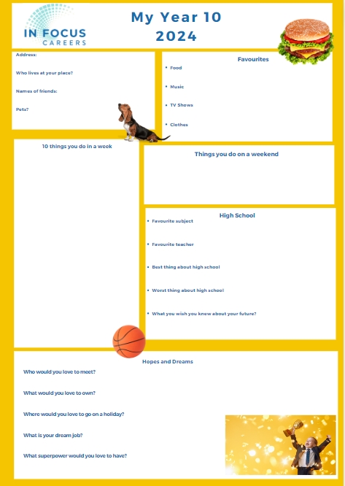
Year 10 Opportunities

Your line in the sand – My Year 10, 2024

Magic Happens in Year 10. Year 10 is a year of change. Print off and fill out this chart and check it at the end of the year to see how much you have changed.
You can download it HERE.

Grab your opportunity to explore university in Year 10
If you go to University Open Days in Year 10, it won’t matter if you ask dumb questions. You will be younger than many of the people there and no one will expect you to know anything.
When you go to Open Days, there is lots of freedom to wander around and check out the campus. There may be tours of the university accommodation and labs.
In year 10 you can ask what subjects you should take in years 11 & 12.
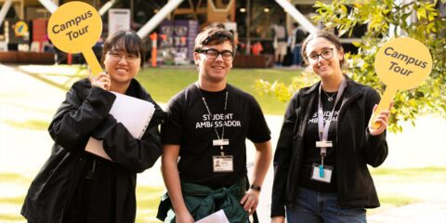
You can check out if any of the courses you like require you to have studied high level maths, physics, chemistry or biology and what level of English competency you need.

Year 7
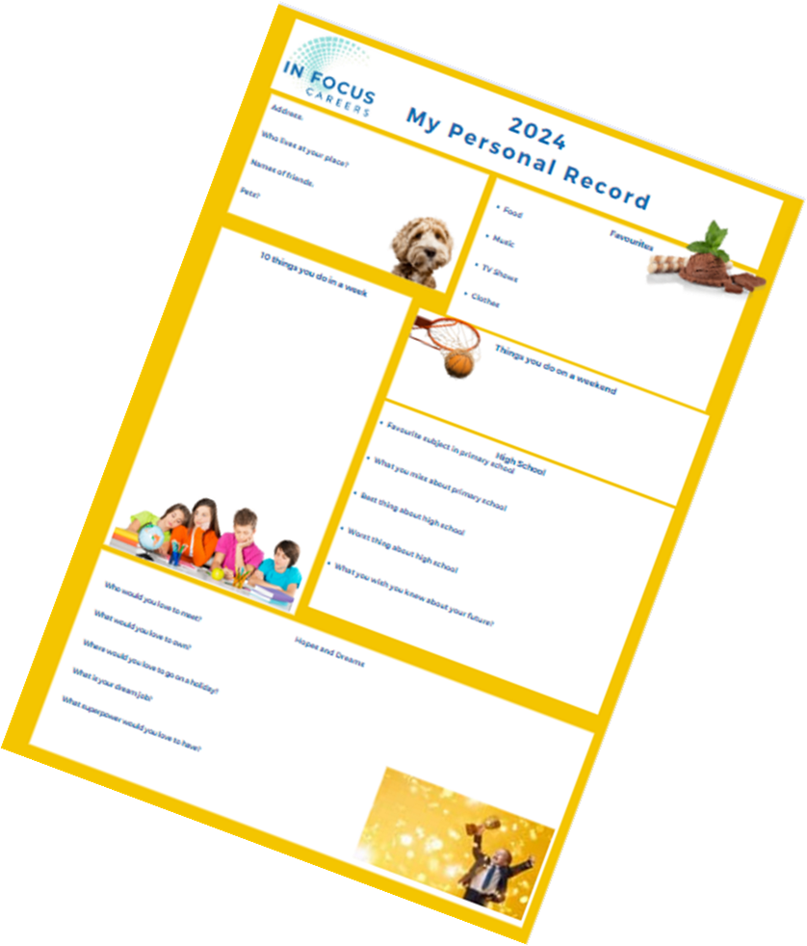
Starting High School. My Personal Record
Students starting high school are about to go through significant change.
This FREE poster helps students to record what they were like at the start of high school.
You can download it HERE.
Privacy Note: This is a free resource made available for fun.
I don’t collect any details from people who download the poster.

Primary School Opportunities

11 February Applications Close for 2025 Gifted and Talented
The Department of Education in Western Australia offers exceptionally able children a choice of secondary schools as part of Gifted and Talented Secondary Selective Entrance programs.
Children who are offered placement can enrol at the school, even if they do not live in that school’s local catchment area. Participation in the selection process requires the completion of an online application submitted prior to 11.59am on 12 February.
Children can apply for entry for Years 7, 9, 10 and 11, providing they are in the appropriate year group.
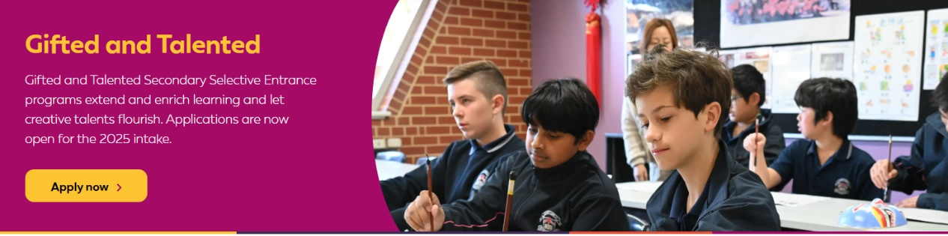
Find details HERE.

Aboriginal Career Opportunities

Applications Open for Secondary Scholarships 2025
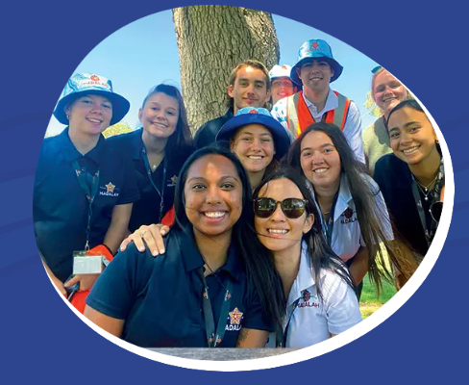
MADALAH provides opportunities for Indigenous students from remote and regional communities to attend Western Australia’s leading boarding schools and universities from around Australia.
If you are interested, check out the opportunities HERE.

UWA Year 12 Leadership Seminar – April school holidays
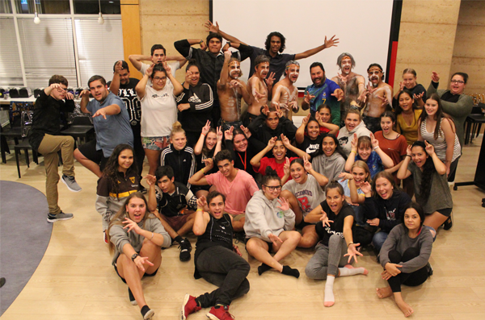
This seminar is a five-day residential camp, introduces to various courses in which they are interested. Sports Science, Medicine, Dentistry, Law, Arts, Architecture, Psychology and Engineering have been some of the courses that have been explored in Year 12 Seminars.

Information on applying for university, enrolment, scholarships and support from the School of Indigenous Studies and Student Services is discussed on an individual and group basis. Travel and accommodation costs are covered.
Find details HERE.

UWA Year 10 & 11 Science, Health & Engineering Camp – July school holidays
This year both year 10 & 11 students who are interested in any area of science are invited to attend. They will explore options in all areas of science, engineering, technology and health. Find details HERE.

Curtin Early February Applications Open for Mining and the Lands free residential program for girls.
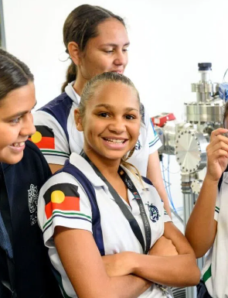
Curtin University and Ashanti Gold Australia have partnered to bring a unique opportunity to WA Indigenous high school girls.
Mining and the Lands is a five-day residential camp in April, for students to experience what it’s like to study and work in the mining industry in WA.
Students tour operational mine sites in the Southwest where they will meet mining industry leaders and visit Curtin University to participate in hands-on workshops and meet lecturers and students. The program targets female students in Year 9, 10, 11 and 12.
The camp is free with all travel, meals and accommodation provided thanks to the support of Anglo Gold Ashanti and Curtin University.
For information register HERE.

Curtin Indigenous Australian Engineering School
The Indigenous Australian Engineering School (IAES) is a week-long residential camp introducing students to engineering studies and careers. Students will do site visits, meet industry representatives and participate in educational activities. The program targets Indigenous students in Year 9, 10, 11 and 12 with an interest and aptitude towards engineering, science and mathematics.
The program is run 8 – 14 July.
Students will have an experience they will never forget, make connections with industry engineers for the future and forge relationships with other like-minded students from across Australia to become part of the IAES community. Find information HERE.

Aboriginal and Torres Strait Islander School Leavers kit
A School Leavers Information Kit specifically designed for Aboriginal and Torres Strait Islander school leavers has been developed. You can find a copy HERE.

Tailored Assistance Employment Grants
Tailored Assistance Employment grants are available to provide funding support to connect working age Indigenous Australians with real and sustainable jobs, as well as assisting Indigenous school students to transition from education into sustainable employment.
Schools and RTOs that would like more information should contact info@naen.com.au.

Aboriginal Youth Services list - Perth
Knowing what services are available to support our work is tricky. The Department of Health has put this list together.
It includes projects including:

- Madalah Youth Leadership program, | - Fairbridge Freedom Centre
- Belmont The Base Youth Service Centre. | - Billy Dower Youth Centre Mandurah
- Freedom Centre Northbridge | - Indigo Junction Midland
- Indigenous Youth Leadership Program - Secondary | - Indigenous Youth Leadership Program - Tertiary
- Midnight Basketball | - Nyaarla
- Outcare | - Smyl Community College
- Waalitj Foundation | - Youthlink
- YouthReach

Australian Indigenous Education Foundation Scholarships
The Australian Indigenous Education Foundation provides funds for Indigenous students to attend boarding school or university.

To find out more about the scholarships go HERE.
These are the participating school in Western Australia:

Big Picture Program at Northam High School
Molly West is a great role model and ambassador for the Big Picture Program at Northam High School. She is remarkable.
She gives lots of examples of how she worked with the program to achieve her success. The examples she gives could be adopted by others. Check her out.

Rural Entry Pathways to Medicine
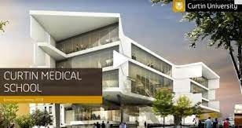
Curtin is the only university in Western Australia that offers an undergraduate medicine program that students can go into straight from school.
Curtin Medical School Rural Academic Lead, Assoc Prof Keith McNaught is happy to run small group, online information sessions for career practitioners in rural schools on the Rural Entry Pathway to Medicine.
They will explain the components required for an applicant, and also how the Medical School weights the various elements which form a student’s application.
Aboriginal Student Information
The team will also be offering sessions explaining the unique pathway for Aboriginal students considering Medicine.
To register an EOI for either of these PD sessions, please contact Jennifer Hanna, Admin Officer, Curtin Rural Health Campus, Kalgoorlie. Jennifer’s contacts are: Jennifer.hanna@curtin.edu.au or via 9088 6014.

People with Disability News

Support for Australian Apprentices with Disability
The Australian Government provides support to Australian Apprentices with disability to help them to reach their full potential as skilled workers. A range of assistance is available including tutorial, mentoring and interpreting services as well as the Disabled Australian Apprentice Wage Support (DAAWS) incentive, which is paid to employers.
Find out more and how to claim HERE.

Can Do Training for people with disability.
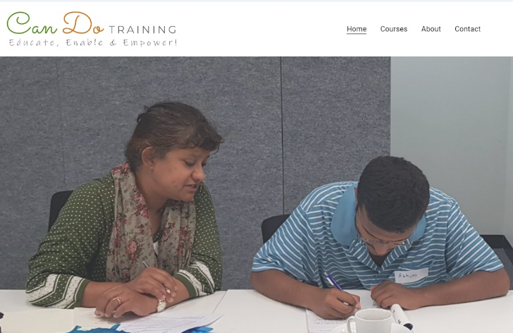
Marilyn Garbin has been around the WA careers education world for some time. She is providing short courses that develop soft skills, for people with disability.
Some courses like these have been cut from TAFE and Marilyn is addressing the need identified by families of people with disability.
I went to the graduation of the Term 4 group in December and all participants were supported by a family member or carer.
Check out the pictures and find out about the courses HERE.

Employment Pathways for People with Intellectual Disability
Everyone Can Work is a website designed to help people with intellectual disability and their families to understand the supports available to get into open employment.

School Leavers kit for students with Disability
A School Leavers Information Kit specifically designed for school leavers with disability has been developed. You can find a copy HERE.

Entry Roles Supporting Deaf and Hard of Hearing
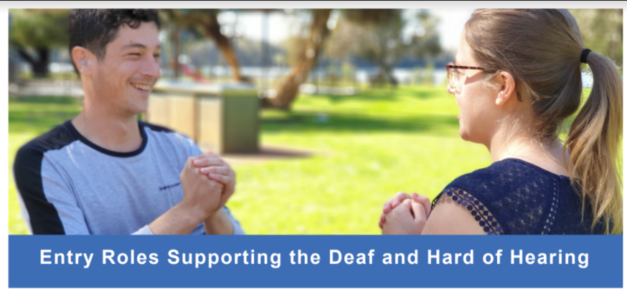
Find information about entry roles supporting the Deaf and Hard of Hearing HERE.

International Student News

South Metropolitan TAFE Migrant English Program
The Adult Migrant English Program is available at TAFE Colleges for Australian citizens. You can also get career information through the Migrant English Centres in TAFE colleges.

Migration Services
The Department of Training and Workforce Development, through their Migration Services area provides a range of services and information to help skilled migrants settle and work in Western Australia.
Find out more:

- Skilled Nominated visa
- Skilled Work Regional (Provisional) visa
- Skilled Employer Sponsored Regional (provisional) visa

