HOT CROSS BUN & CINNAMON DONUTS DRIVE 2023

Eight Artisan Bakers Burwood is once again offering us the opportunity to purchase fresh and delicious HOT Cross Buns and donuts to help raise funds for our school! We will receive $1.50 for every pack sold! Money raised will go towards improving and upgrading student furniture in classrooms.
Please note products will be distributed to students on Wednesday 5th April.
We are selling: Delicious Hot Cross Buns - 6 pack for only $7.00
Cinnamon Donuts - 6 pack for only $6.50

Remember to ask your friends and extended family to buy some too and for any allergy concerns feel free to call the Eight Artisan Bakers on 9808 0440.

Please Choose ONE of the following options:
HOT CROSS & DONUT ORDERS MUST be returned NO LATER THAN MONDAY 27th MARCH.

OPTION 1 – Order & Pay ONLINE via Flexischools

We are now offering an online payment option. If you would like to order and pay online via the Flexischools app, please refer to the attached flyer. This is the app used to purchase lunch orders at Great Ryrie.
Please note that a 29cent fee will be added onto your order.

You do not need to complete and return the below form if you order via Flexischools.

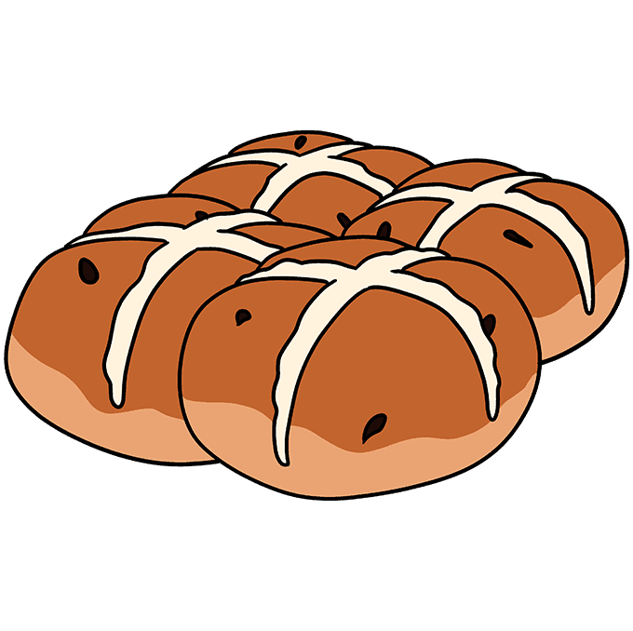
----------------------------------------------------------------------------------------------------------------------------------------------------------------
OPTION 2 – Complete Order form below & payment via CASH

Student’s full name: _______________________________________ Class: ________
 | Traditional Hot X Buns  $7.00  Quantity | Choc Chip Hot X Buns $7.00  Quantity | Mocha Hot X Buns  $7.00  Quantity | Fruitless  Hot X buns  $7.00  Quantity | Cinnamon Donuts  $6.50  Quantity | Total Paid
Our Family

