St Mary’s Ascot Vale

A message from the team
We had a creative and fun-filled week!
Children explored a variety of arts and crafts, including drawing Santas and creating their own Christmas “craft meals” using yarns, pom-poms, patty pans, and other materials. Some made pizzas, others made pasta dishes. This letting their imaginations turn these creations into their festive dinner. Many also made Christmas friendship bracelets, showing great teamwork and sharing ideas.
Our animal-themed crafts were especially popular. Children made tiny dinosaurs, turtles, and other creatures from pipe cleaners, and added accessories like masks or hand puppets. We also created cute flowers and bees using pipe cleaners and small garden pots and painted the clay pieces they made last week.
The children continued to enjoy our LEGO challenge, building new rooms and imaginative structures. We also introduced dodgeball, which quickly became a favourite activity, giving everyone a chance to be active and have fun together.
It was a week full of creativity, collaboration, and festive excitement.
We can’t wait to see what the children come up with next!

Check out the fun!
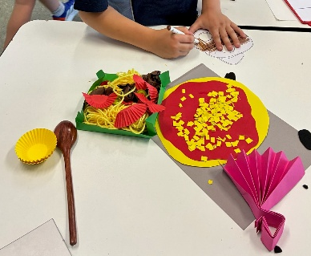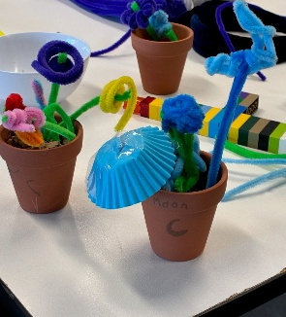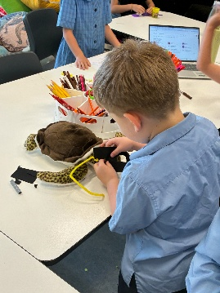

Important Dates

- 4th December,
National Hugging
- 5th December,
Internation Volunteer Day
- Day

Term Dates
October 6, 2025 – December 16, 2025

Projects we are working on

- Christmas friend’s bracelet
- DIY bath bomb ball
- Doily snowman craft

Make a booking!
Experience the fun of MACSEYE's OSHC program at St Mary’s Ascot Vale today!
Call our friendly team: 0493 136 327 or 1300 501 029
Visit us: 74 Roseberry St, Ascot Vale (7:00 am – 9:00 am & 2:30 pm -6:00 pm)
Email: enrolments@macseye.vic.edu.au | Website: www. macseye.vic.edu.au

