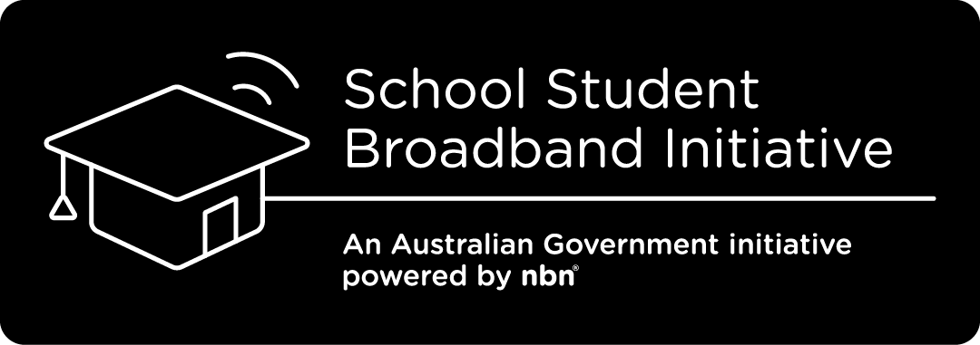

Dear Parents/Caregivers

Are you eligible for the School Student Broadband Initiative?
The Australian Government has established the School Student Broadband Initiative (SSBI) to provide free home internet until 31 December 2025 for up to 30,000 unconnected families with school aged students.
Eligible families receive free home internet over the National Broadband Network by selecting an offer from a participating internet provider.

Who is Eligible for the SSBI Program?
The SSBI is primarily intended as an affordability measure to help families with school-aged children.
To be eligible for the SSBI, families must:
- Have a child living at home that is enrolled in an Australian school (up to year 12 including from Prep in Qld/Vic/Tas, Kindy in NSW, Reception in SA, Transition in NT/ACT and Pre-Primary in WA).
- Not have an active nbn® network internet service in the previous 14 days. Having a mobile internet service does not affect eligibility.
- Not have had an active nbn connection in the previous 14 days.
- Live in a premises that can access a standard nbn service.
- Either be referred by a Nominating Organisation or have your suitability determined via an assessment conducted by the National Referral Centre (NRC).

How can I check my eligibility?
A National Referral Centre has been established to help Australian families that meet the eligibility criteria to have the National Broadband Network connected at their home. To check your eligibility, follow these simple steps:
- Contact the National Referral Centre on 1800 954 610 (Mon-Fri, 10am-6pm AEDT), https://www.anglicarevic.org.au/student-internet or email studentinternet@anglicarevic.org.au. Callback and webchat functions are also available via the website.
- Check your eligibility – the National Referral Centre team will assess your eligibility for the SSBI, by checking a number of things including your residential address and current financial situation.
- If eligible, you will be issued a voucher which can be redeemed at any of the participating SSBI retail service providers. The National Referral Centre will also be available to assist with contacting your SSBI internet provider of choice or providing follow-up support.

What services will the National Referral Centre offer?
The National Referral Centre (NRC) is the first point of contact for both self-nominating families and Nominating Organisations.
The NRC will:
- Help people interested in the SSBI understand if they are eligible, issue vouchers and provide information regarding participating retail service providers.
- Provide support to eligible people who are experiencing challenges redeeming the voucher.
- Provide follow-up support to eligible families who have been issued a voucher. The NRC will make three attempts to contact these families to offer their assistance in getting connected.
- Refer, where appropriate, ineligible people to other support services which may assist with financial hardship.
- Answer and resolve queries relevant to the Initiative.
For people from non-English speaking backgrounds, or people with accessibility challenges, the NRC can offer translation services through Language Loop and some of their own bi-lingual staff; and their website is equipped with ReciteMe technology.

IMPORTANT INFORMATION
Eligibility for the SSBI does not guarantee a free service. Vouchers are valid until 31 December 2024 unless the initiative reaches the limit of 30,000 activations ahead of this date. Vouchers can only be used once and can only be used in relation to the address listed, they cannot be transferred to another family.
Once you sign up, the internet provider will help you to set up your connection. The initiative does not include devices such as a computer or tablet or internet filtering.
If you move home at any point, your internet provider will continue to supply you with free home internet over the National Broadband Network at your new address until 31 December 2025 . If you move to an address that does not have access to the National Broadband Network, you will no longer be able to access the free broadband service. You can disconnect at any time but if you do so, you cannot re-join later.
Your family’s safety online matters. You can find information from the eSafety Commissioner about staying safe online attached to this letter. More resources for parents can be found on the eSafety Commissioner website at www.esafety.gov.au/parents
More information about the initiative is available by contacting the National Referral Centre on the details above.

This is subject to continued involvement in SSBI of participating internet providers beyond the previously announced deadlines and provided the cap of 30,000 SSBI services has not yet be reached.
A standard nbn service refers to a standard installation of nbn supplied equipment. This includes connecting a fibre optic cable from your street to the nbn utility box outside your premises, then inside to the nbn connection. nbn does not charge end customers for a standard installation. Remember to ask your chosen SSBI participating internet provider if they have any other fees. A small number of premises located in Limited Access Areas (any area within the footprint of the Satellite Network that cannot reasonably be accessed by road and would require some element of air or water transportation) are ineligible to access the SSBI.

