My Life In Isolation
In this Coronavirus pandemic it has been really challenging. Everyday is filled with uncertainty.
Because of this pandemic I can’t see friends and family, play at my soccer club, go out somwhere with the family like eating at a restaurant, physically going to church and going to school.
I am definitely missing regular school because I get to see friends, teachers and have fun playing soccer at recess, lunch and P.E.
It’s been harder to stay fit and healthy because at school I’m always walking to classes and running at recess and lunch. At soccer training and games I’m always running and sprinting every second, kicking the ball, juggling the ball with my feet and always stretching. But now in this pandemic I get lazy to exercise. It’s so boring all I want to do is eat.
I am grateful for being with my parents and three sisters at home because some people live by themselves in apartments which they can’t see their family but when technology comes in you are able to facetime which I am happy for. I am also grateful for my mum putting the effort in going to Taralgon which is 1 and a half hours away from my home to do locum work at the hospital so my family can live under shelter, eat good food and have clothes and shoes. But many other people cannot work and continue with their business which is very unfortunate.
I deeply thank the frontliners that work at the hospital who have to deal with the risk of getting Coronavirus. I don’t know what would happen to everyone of us if we did not have their help.
Reading positive things of Covid-19, China recorded 85 percent increase in days with good air quality in 337 cities between January and March. And “Home-schooling is becoming the new way of learning, exposing many parents to what their children do”. There are more positive things on this website about Covid-19 https://lighthouse.mq.edu.au/article/april-2020/seven-positive-outcomes-of-covid-19
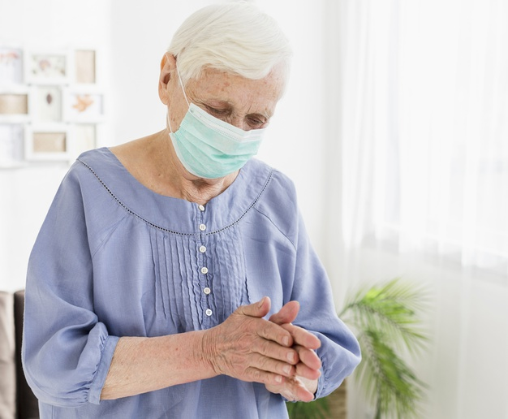
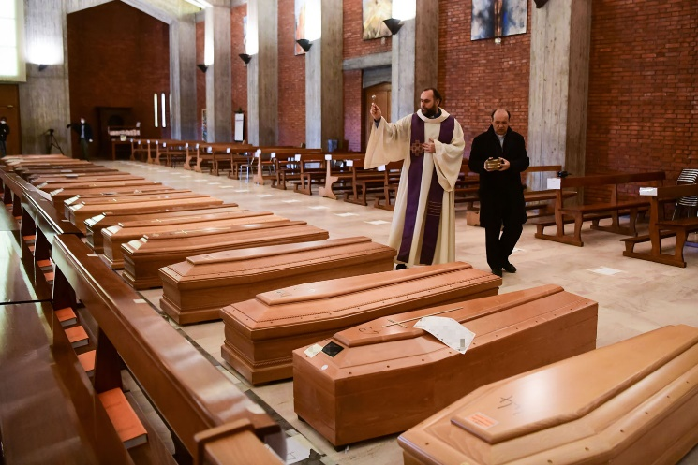
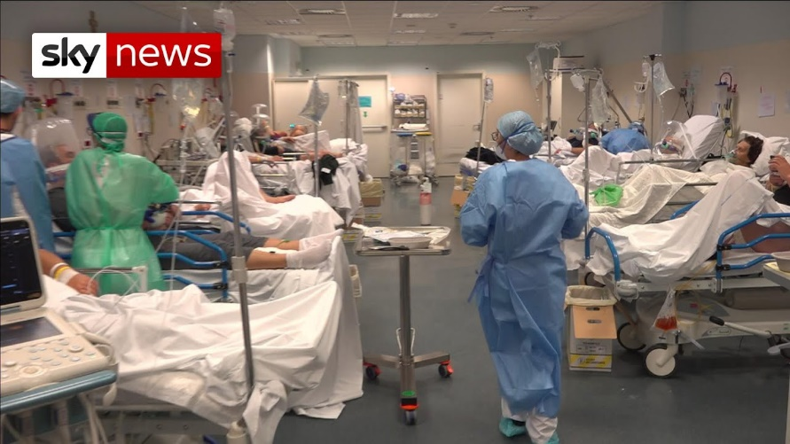
The priest at my local church are doing an amazing job. They go to the church and film themselves for people to watch on Youtube so we still keep in touch with God and Jesus. I think that this pandemic is a test for us Christians to turn to God to strengthen our fate, ask forgivness for all our sins and rely all our problems into God’s Hands.
Here’s a funny song about the pandemic :)
https://www.facebook.com/JasonOwenOfficial/videos/1112459152434485/

