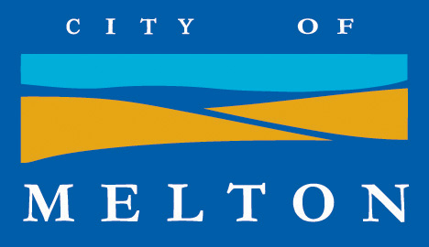
BOOK EARLY! Don’t miss out!
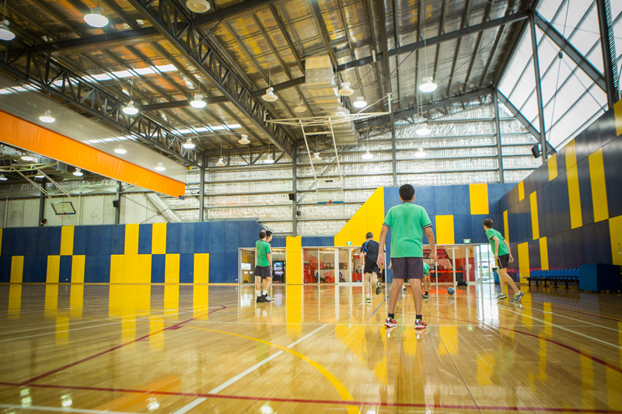 INSERT IMAGE HERE ***
Bring your ‘A’ game!
Come down to the Melton Rec Centre and get involved in a variety of sports and activities.

This is not only an opportunity to compete against your mates but also against community and youth workers from your local council. Can you handle this kind of competition?
There will also be a free feed for all those that attend.
See you at the courts!

iPlay After Dark
DETAILS:
WHEN: Saturday 16 September

TIME: 6.30pm-10pm

WHERE: Melton Rec Centre (161 Coburns Rd)

AGE: 10 – 24 years of age

COST: FREE

NAME Matthew Jamieson
Email: mathewj@melton.vic.gov.au
Phone: 9747 7200
For bookings visit https://www.trybooking.com/308531

