**Future Problem Solving National Finals Weekend, 2023**

**Hosts: Brisbane Grammar School**

The Future Problem Solving Program (FPSP) is a national competition that challenges and extends students and fosters critical and creative thinking. You will be given a list of five topics and you must choose one of them on which to write a scenario (short story) that explores what this topic will look like 20 years in the future.

"Future Problem Solving teaches students a process driven approach to creative problem solving and helps them develop essential life-long skills."

I am excited to share that 11 students across Year 5 – Year 9 were selected as State winners to participate in the National Finals held at Brisbane Grammar School on Friday 13 October – Sunday 15 October 2023. We had 9 students actually attend the National Finals weekend and each of them gained a great deal from the experience and were wonderful ambassadors for the school.

Some wonderful results were achieved:

* Junior/Middle Division National Finals Scenario Writing Competition, Best Group (First Place) – Dante Di Felice (Year 5) & Rishab Saravana Babu (Year 8)

**Background Info:** These students were randomly placed into a team of four comprising of students form different schools.

Each team member received a Future Scene related the focus topic for the National Finals which was ‘Throw Away Society’.

Each group member wrote a piece separately, at the same time, and at the end had to discuss how to organise their final story so that all parts worked together.

* Individual Results

Junior Division – 4th Place was awarded to Muskan Kapoor (Year 5)

Middle Division – 3rd Place was awarded to Ewan Harrison (Year 9) – Ewan has qualified to compete at the International Finals to be held at Indiana University, Bloomington, USA from 5th – 9th June 2024.

Congratulations to all students who selected to participate in the Future Problem Solving, Scenario Writing program in 2023. I wish to sincerely thank Mr French for supporting me in attending the National conference and also to the parents who selected to take their child/ren to Brisbane over weekend.

*Some photos on the next page…I can also airdrop these to you if easier.*

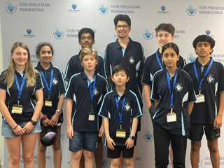

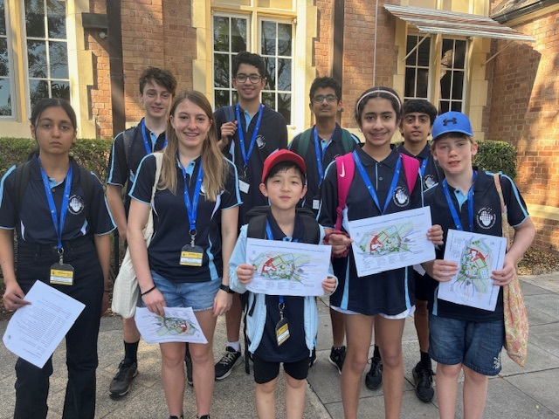

**Our prize winners**

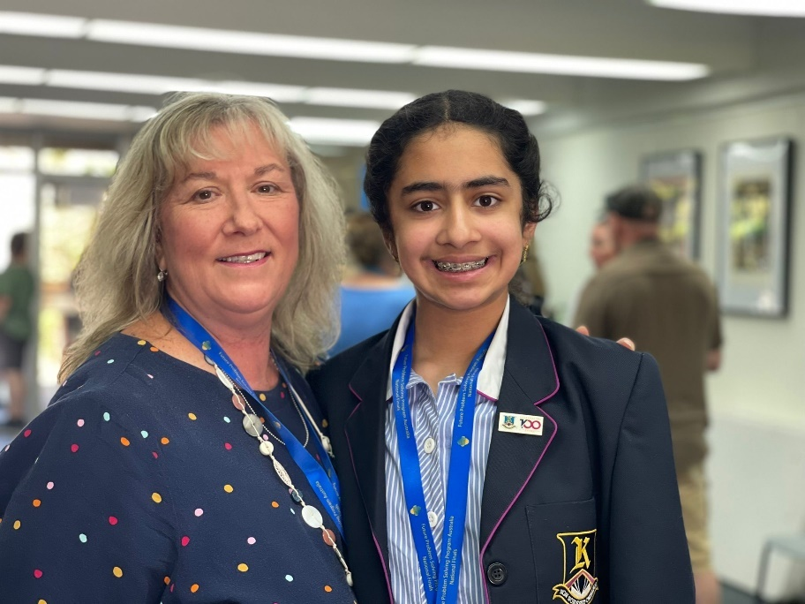

Muskan Kapoor – 4th Place Individual Competition & Coach, Tania Whitehead

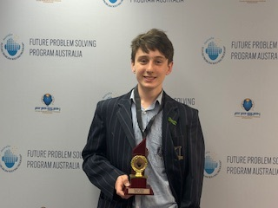

Ewan Harrison (Year 9) – Middle Division 3rd Place in the Individual Competition

Ewan has qualified to compete at the International Finals to be held at the Indiana University, Bloomington, USA from 5 – 9 June 2024!

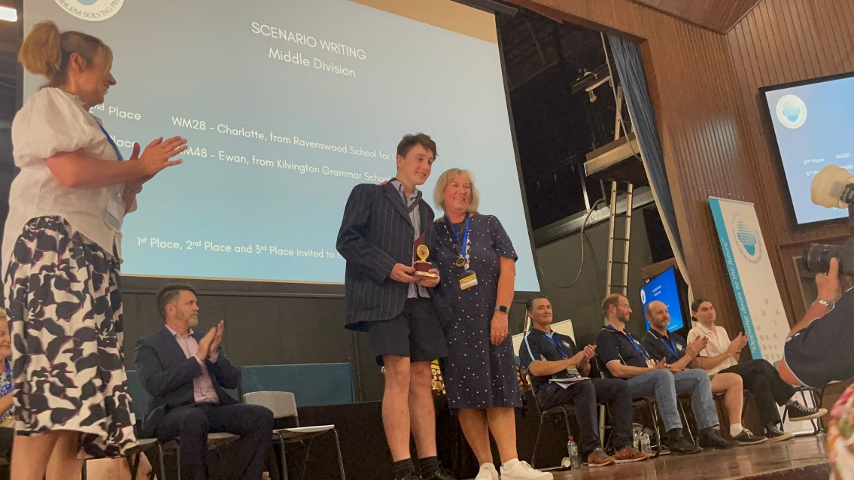

Ewan Harrison – 3rd Place in the Individual National Competition & Coach, Tania Whitehead

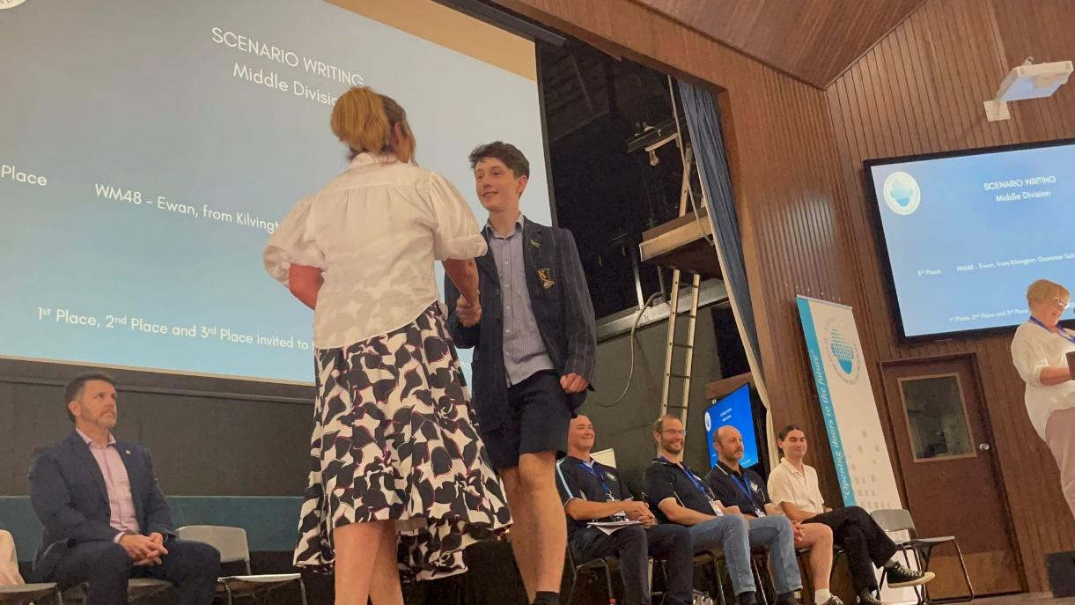

Ewan Harrison – 3rd Place in the Individual National Competition

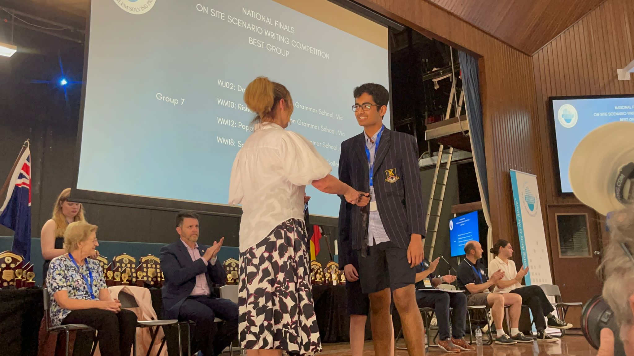

Rishab Saravana Babu (Year 8) – Junior/Middle Division National Finals Scenario Writing Competition, Best Group – First Place (along with Dante Di Felice – see next photo)

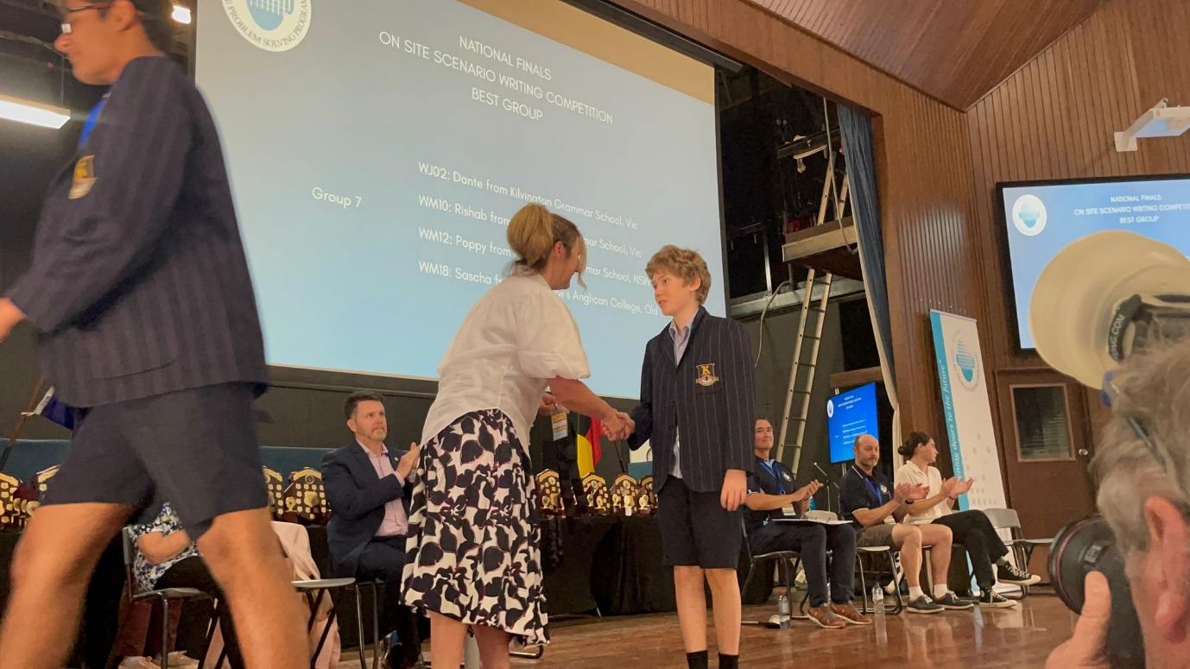

Dante Di Felice (Year 5) – Junior/Middle Division National Finals Scenario Writing Competition, Best Group – First Place (along with Rishab – see photo above)

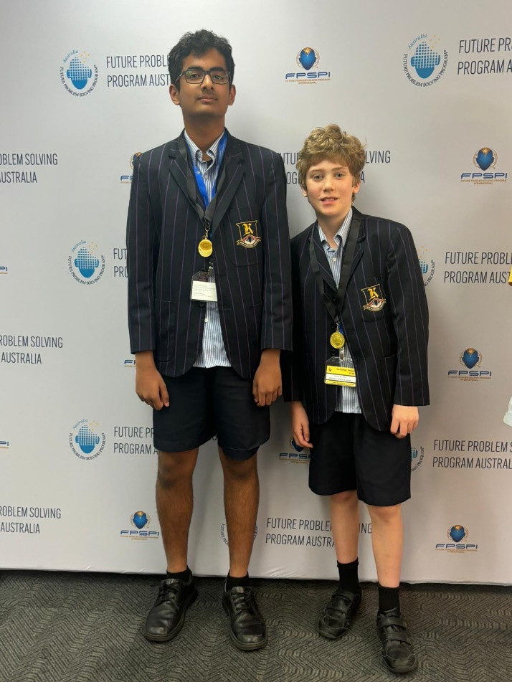

Rishab & Dante – Junior/Middle Division National Finals Scenario Writing Competition, Best Group/First Place

KGS students and families arrive for the Opening Ceremony of the Future Problem Solving National Finals at Brisbane Grammar School.

Final Day – After the conclusion of the Awards Ceremony

