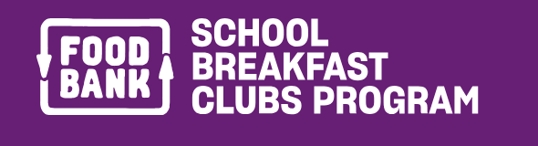

Korumburra Secondary College’s Breakfast Club has family food boxes available for our families.

If you would like a box, please email korumburra.sc@education.vic.gov.au or call the school 5655 1566 ask for Amy Gallagher.
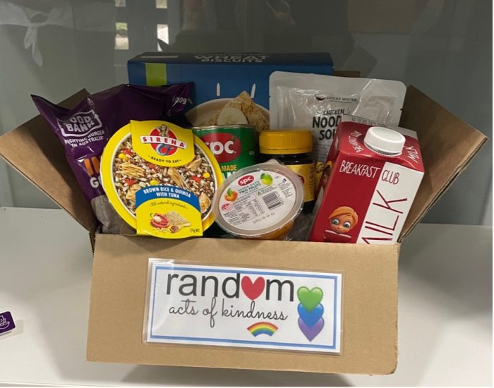
We can then set up a date and time that suits you to pick up and I will have it ready for collection at the General Office

Foodbank School Breakfast Clubs Program – Eat. Learn. Succeed.

