

**11/10/2023**

[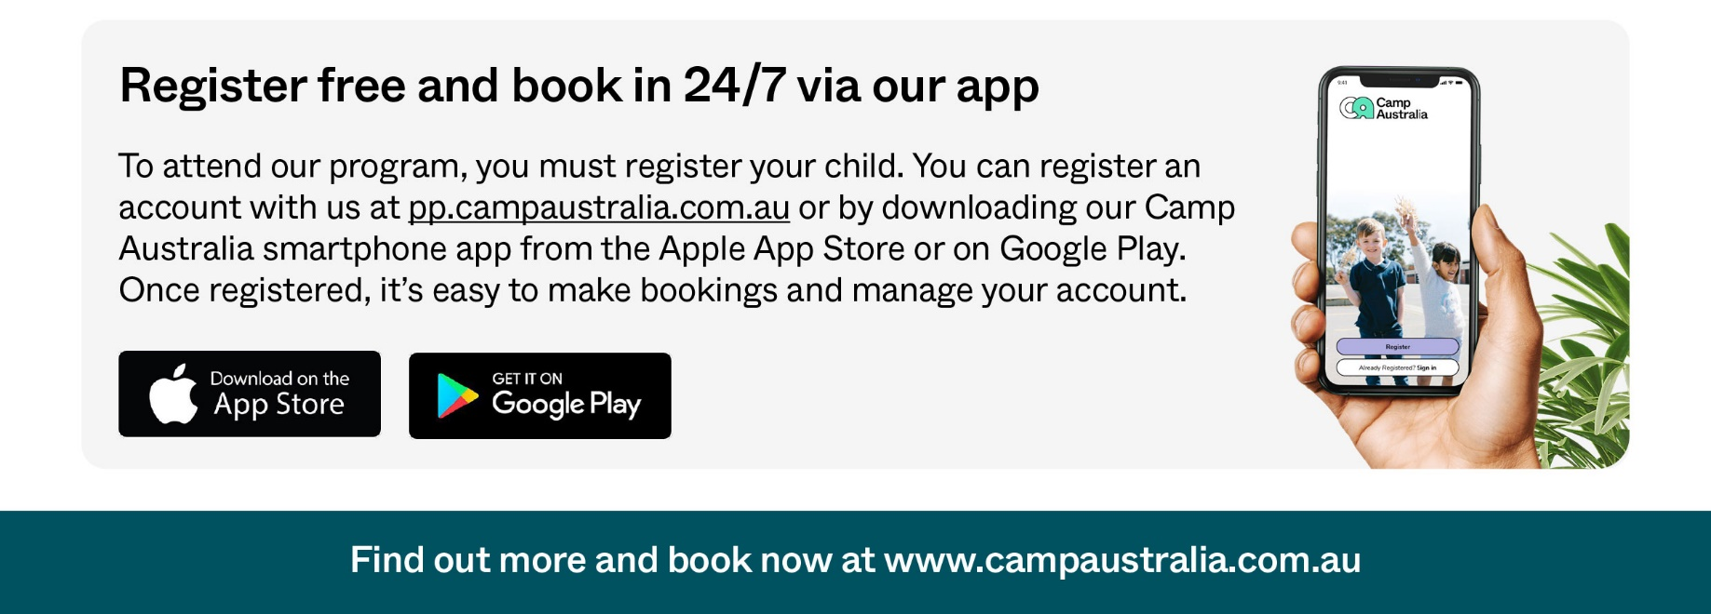](https://pp.campaustralia.com.au/)

**A message from your Coordinator**

Hello, welcome back to term 4, highlights this term will be WORLD PLAY DAY 12/10 we have lots of LEGO fun we will spread out over 3 weeks different days so children won’t miss out. We have been cooking up a storm with pan fried bananas, fried rice, pasta. We will be celebrating recycling week, Halloween, and many more things. Rubbish Robots is back after winning last year lets see what we can come up with this year.

**Things to remember**,

Hats

Suncream if using own

Please keep sending in boxes, and anything else we can use for recycling.

We would also like any type of plastic lids brought in.

We are getting very busy so please remember to book early

Emma & Bo

* Lego fun
* Space week
* Robot rubbish

**Activities coming up**

Join in the fun of Outside School Hours Care activities and experiences with Your OSHC and Rocketeers.

**Make a booking**

Book now

**Skye Primary School**