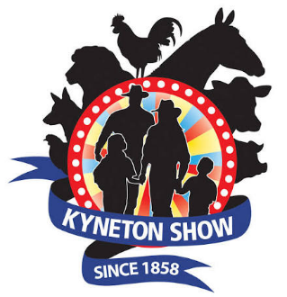
Essay & Creative Writing Competition
This year the Kyneton Show is celebrating its 164th Show. The Show is growing from strength to strength with close to 10,000 people through the gates in 2025, bringing the community together from far and wide to celebrate the talents of all those who enter.

The Essay & Creative Writing Competition is one of our growing areas. It is an opportunity for people of all ages to display their writing talents for all to see. In the past, students from Kyneton Primary School have been keen participants in this competition, and we would love to see many of your students involved again.
There are 6 classes in the Essay & Creative Writing Competition this year:
• Essay Competition – Students in Years 5 & 6
The Essay Competition - open to all students in Years 5 & 6.
The Topic for this year is “ELECTRONIC DEVICES RUIN FAMILY TIME.” Something I’m sure all students would have an opinion about.
Essays must be no more than 300 words, on a single A4 page (one side only) with the entrant’s name, age and school clearly written on the back.
Entry is free, with an overall first prize, and ribbons awarded to second and third. The overall winner’s essay will be entered in the regional final, held in Lilydale in 2027, to compete against the winners from other local shows.
Creative Writing
Creative Writing – 7 years & under
• Up to 100 words
• All essays must be on an A4 page (single sided only) with the entrant’s name, age and school clearly written on the back.
Creative Writing – 8 years to 10 years
• 100 to 200 words
• All essays must be on an A4 page (single sided only) with the entrant’s name, age and school clearly written on the back.
Creative Writing – 11 years to 12 years
• 200 to 300 words
• All essays must be on an A4 page (single sided only) with the entrant’s name, age and school clearly written on the back.
• If multiple pages the pages must only be bound by one staple in the corner.

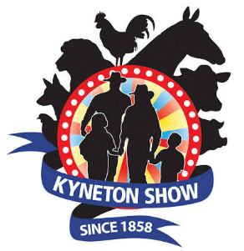
Creative Writing – 13 years to 17 years
• 300 to 500 words
• All essays must be on an A4 page (single sided only) with the entrant’s name, age
and school clearly written on the back.
• If multiple pages the pages must only be bound by one staple in the corner.
Creative Writing – Adults (18 years and over)
• Maximum 1000 words
• All essays must be on an A4 page (single sided only) with the entrant’s name, age
and school clearly written on the back.
• If multiple pages the pages must only be bound by one staple in the corner.
All essays must be received by Thursday 29th October 2026 at the latest, or earlier if possible.
This gives our judge the time to read all the amazing pieces we receive. Please don’t
hesitate to contact me to arrange the collection/drop off of your writing pieces.
Encourage your students to put pen to paper and don’t miss this chance to be a part of the 164th Kyneton Agricultural Show.
Thank you in advance for your continued support for this important district event. We love seeing
the students' faces when they are showing their friends and family their efforts on public display,
this year on Friday 20th and Saturday 21st November 2026.
If you have any questions, please feel free to contact me.

Regards
Mary Connelly
Kyneton Agricultural Show
Ph: 0403 003 508

