**MITCHAM PRIMARY   
 2024 TEA TOWELS**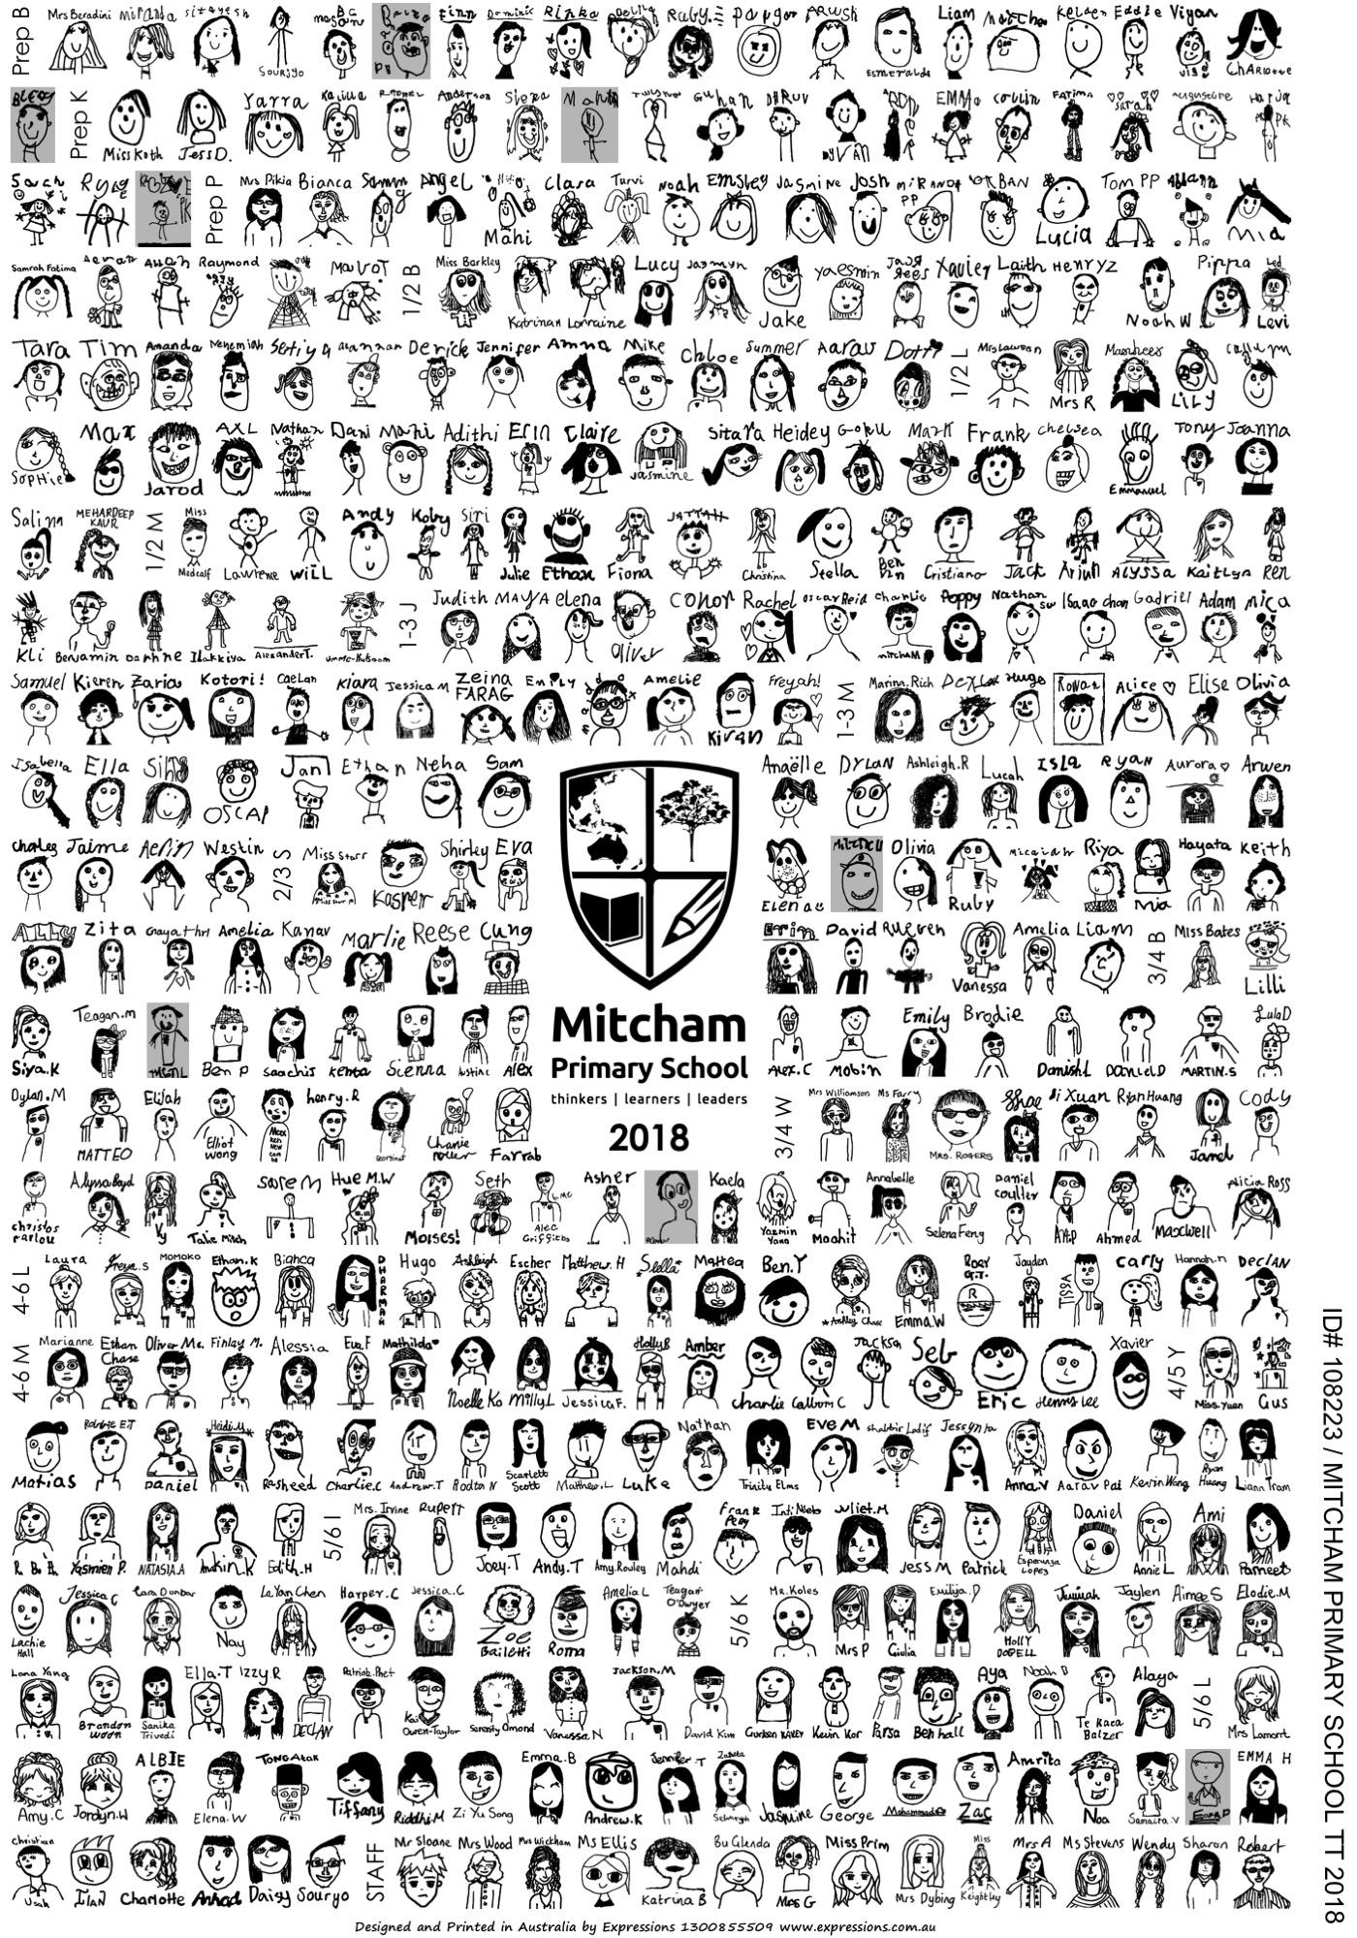

18th October 2024

Dear Parents / Carers / Friends,

**The Tea Towel Fundraiser is back for 2024!**

The unique tea towel design is made up of self-portrait drawings by all of the students and staff at our school. The drawings are arranged into one commemorative design and screen printed in Bottle Greenonto high quality white tea towels.

We chose tea towels because the project gets the children involved, produces a wonderful memento and meaningful gift for parents, grandparents, relatives and special friends. The tea towels look amazing and make a fabulous reminder of your child’s early years, and are easy to post, making them a wonderful gift idea for family and friends. These also make a great Christmas gift, given that they’ll be arriving at school in mid to early December.

ONLY **$13.00 each**for a limited edition tea towel **OR SAVE** by ordering 5 or more and receive a 10% discount ($58.50 for 5). Tea towels can be ordered by:

1. **CASH PAYMENT:**

Place Order Form and cash payment in an envelope clearly marked:

*“TEA TOWEL ORDER”, with the amount enclosed, your child’s name and their class.*

Envelopes can be given to class teachers or dropped at the Office.

1. **EFT PAYMENT:**

Parents can bring the Order Form to the Office and pay via EFT (Credit or Debit Card).

Make sure you do not miss out! Preserve your child’s artwork and remember friends and teachers forever!

Final orders are due on or before →  ***Wednesday 1st November 2024***

Delivery will be in early to mid December.

**An example of the previous tea towel will be on display at the office. If you have any queries please contact Aysha Rowe (ayshar@xtra.co.nz)**

**✀-------------------------------------------------------------------------------**

**TEA TOWEL ORDER FORM**

Student Name: _________________________________________________ Class: ____________

Contact Name and Phone Number: ____________________________________________________



Number of Tea Towels Ordered: 1 2 3 4 5 or more →

TOTAL amount $_______________

Please enclose payment with your order Less 10% if ordering 5 or more $_______________

TOTAL Enclosed $____________