

#### Newsletter Term 4 Week 6 2021

***St Marys Primary School St Kilda***

**Welcome Back TheirCare Children!**

We have planned creative and fun activities to welcoming our children!

We cannot wait to see you again at OSHC.

# **Toy Library at Theircare during week 6 & 7.**

# We are having ‘Robotics Kits’ at TheirCare, as support from the Toy Library, from the 10th of November to the 15th of November. Come and get fun with these new resources. Don’t miss the opportunity.

**Photo Gallery**

**Trick or Treat! Week 4**

We had a scary week making Halloween Craft & Art, sensory activities, origami and cooking activities. We did some bats, pumpkins, ghosts, Frankenstein, skeletons, witches, Dracula, with paper, cottons, balloons and decorated some Halloween ornaments, as creations to take home or make a gift for friends. In addition, we did some stress balls as sensory play with flour and rice, and decorated them as ghosts, Frankenstein and pumpkins, vampires and witches. Some child initiative were related to construction games using Lego and Jenga blocks, making houses, towers, ships and swords. Also, groups games such as ‘Red Light, Green Light’, Octopus, Lava monster, Shark tag, tag, ‘hide and seek’, were played by our children in the playground as physical exercises and enjoying of the good weather this week. As special activity for the week, we decorated some cookies with white chocolate and sprinkles. Our kids loved it!

**Diwali, Festival of Lights! Week 5**

The 4th od November is celebrated the victory of light as symbolic tradition in some countries such as India, as multicultural celebration at TheirCare. Art & Crafts activities were related to the celebration making paper lanterns, Diya plate with clay, fireworks painting with straws and forks, chalk art and suncatchers. Also, we did chocolate bliss balls as the special cooking activity for the week, and sport activities following our child interest and observations, and parents suggestions. We played soccer, tennis and we went outside to do physical activities in the playground when the weather was good.

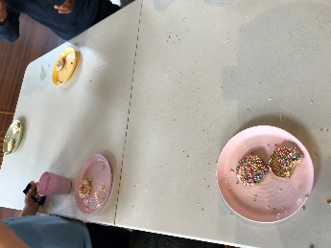

|  |  |  |  |  |
| --- | --- | --- | --- | --- |
| Contact Service | Contact Head Office | Times |  |  |
| Phone: 0475 577 404 | Phone: 1300 072 410 | Before School: 7:00am – 8:45am |  |  |
| Email: stmarysstkilda@theircare.com.au | Email: info@theircare.com.au | After School: 3:30pm – 6:00pm |  |  |