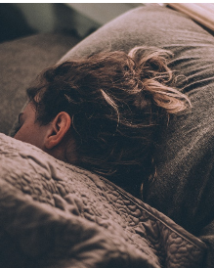 Getting a good night’s sleep (teenagers need between eight and 10 hours sleep every night)
WHY | HOW | MY PLAN
Sleep deprivation – impacts mental wellbeing, low mood, anxiety, low self-esteem and academic performance at school – concentration difficulties, lack of enthusiasm, slower physical reflexes, poor decision making, poor diet choices … | Establish a relaxing bed-time routine – keep the same routine for at least four weeks – learn some relaxation techniques  Stay active during the day so that you are more physically tired at night  Set up a regular wake-up time  Try keeping a to-do list – jot things down before you go to bed, to avoid staying awake thinking about things  Put screen based devices away an hour before bed-time – you’ll gain an extra 21 minutes sleep a night
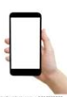 Limiting your screen time (no magic number – 2-2.5 hours a day – comes back to purpose)

WHY | HOW | MY PLAN
General health and wellbeing  Headaches, eye-strain, sleep disturbance  Obsession with screen use – might this be procrastination?  Decline in academic performance and failure to complete school work | Avoid media multitasking  Establish screen-time limits  Examine screen-time use: purpose, time spent and why
Eat right….
There are seven nutrition groups found in the food we eat, these are:
- Carbohydrates.
- Proteins.
- Fat.
- Fibre.
- Vitamins.
- Minerals.
- Water.
WHY | HOW | MY PLAN
Growth and development  Energy | Eat mainly from the core food groups  Three regular meals a day – breakfast!!!!  Healthy snacks and keep up the water!
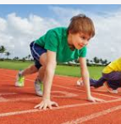 Physical activity - recommended 60 minutes a day (three times a week)
WHY | HOW | MY PLAN
develop healthy musculoskeletal tissues (i.e. bones, muscles and joints);  develop a healthy cardiovascular system (i.e. heart and lungs);  develop neuromuscular awareness (i.e. coordination and movement control);  maintain a healthy body weight  psychological and social benefits | Put down your phone!  Walk or run with a friend  Join a social sporting group  Plan for daily exercise routines that you can do at home  Dance, dance, dance like there’s’ nobody watching!

