[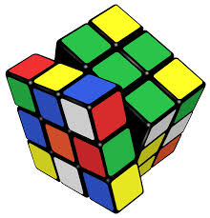](http://www.google.com.au/url?sa=i&rct=j&q=picture+rubik's+cube&source=images&cd=&cad=rja&uact=8&ved=0CAcQjRw&url=http://en.wikipedia.org/wiki/Rubik's_Cube&ei=zuGEVKeFJs6F8gXPz4CICg&bvm=bv.80642063,d.dGc&psig=AFQjCNGj_XEdYe46bIZtNBVU0Sm25OQN-Q&ust=1418081105388927)

KINGSWOOD PRIMARY SCHOOL

RUBIK’S CUBE LUNCHTIME CLUB

TERM 1 2018

**We will continue to run RUBIK’S CUBE CLUB with Anna Janai in Term 1 2018.**

Anna is a qualified secondary school Maths / Science teacher, with previous Chess Club experience. The Rubik’s Cube Club is aimed at promoting critical thinking and problem solving skills, along with many mathematical concepts.

Rubik’s Cube Club is open to all students Prep to Year 6. Rubik’s cubes are provided in the sessions.

**There is a limit of 15 students for each session.**

**The cost of the program will be $40 for 7 sessions**. The sessions will begin on Monday

12th February.

To confirm your child’s place, please complete the form below and send it to the office with the money by Friday 9th February2018.

If you require any further information please leave a message at the office for Anna.

Aaron Cox

Assistant Principal

[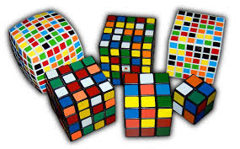](http://www.google.com.au/imgres?imgurl=http://upload.wikimedia.org/wikipedia/commons/9/9a/Rubik's_Cube_variants.jpg&imgrefurl=http://en.wikipedia.org/wiki/Rubik's_Cube&h=744&w=1200&tbnid=6xK6nHgBet1SUM:&zoom=1&q=picture%20rubik's%20cube&docid=Lp_sKmeu1vFy6M&ei=0eGEVM3yDcT48QWAxYHwBA&tbm=isch&ved=0CCQQMygDMAM&iact=rc&uact=3&dur=612&page=1&start=0&ndsp=40)✂------------------------------------------------------------------------------------------------------------------------------------------

RUBIK’S CUBE LUNCHTIME CLUB

TERM 1 2018

I agree to allow my child ___________________________________ of Grade ___________

to participate in the Rubik’s Cube Lunchtime Club Term 1, 2018.

Signature of Parent: _________________________________ Date: __________________

Amount enclosed ____________________

CASH CHEQUE **Cheques made payable to “A Janai”**