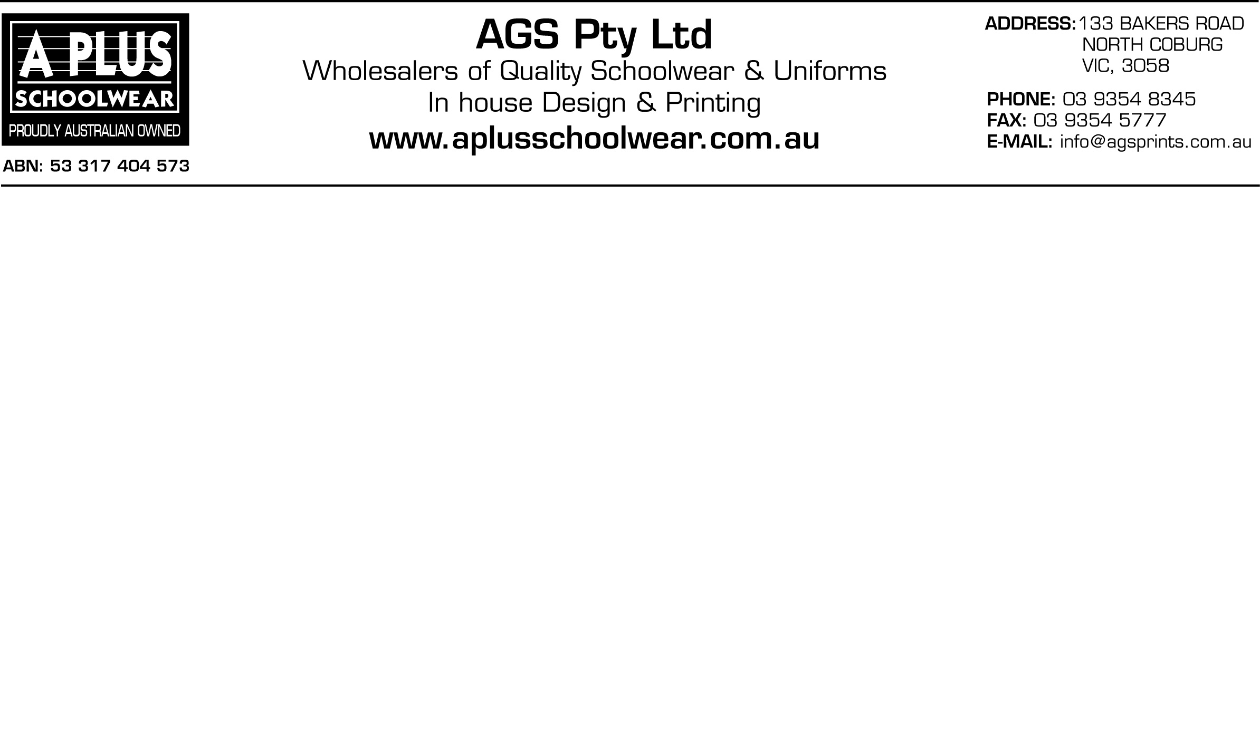

JACKSON SCHOOL – HOODED JACKET ORDER FORM

Student Name: __________________________________________________ PHONE: ________________________

Teacher Name: _________________________________________________ DATE:__________________________
08/08/2022

Style No |  |  | Item |  |  | Sizes |  | Cost |  | Size |  | Qty |  | Total
 |  |  | HOODED JACKET |  |  | C12 |  | $50.00
 |  |  | HOODED JACKET |  |  | C14 |  | $50.00
 |  |  | HOODED JACKET |  |  | C16 |  | $50.00
 |  |  | HOODED JACKET |  |  | A14 |  | $50.00
 |  |  | HOODED JACKET |  |  | A16 |  | $50.00
 |  |  | HOODED JACKET |  |  | A18 |  | $50.00
 |  |  | HOODED JACKET |  |  | A20 |  | $50.00
 |  |  | HOODED JACKET |  |  | A22 |  | $50.00
 |  |  | HOODED JACKET |  |  | A24 |  | $50.00
 |  |  | HOODED JACKET |  |  | A26 |  | $50.00
 |  |  |  |  |  |  |  |  |  |  |  |  | $

ORDERS FOR HOODED JACKETS MUST BE ORDERED AND PAID FOR BY THE
FRIDAY 26TH AUGUST 2022 ORDERS AND PAYMENTS TO BE LEFT AT THE OFFICE
(PLEASE NOTE NO ORDERS WILL BE ACCEPTED AFTER DUE DATE)
PAYMENTS CAN BE CASH, CREDIT CARD OR CHEQUES
(CHEQUES TO BE MADE OUT TO AGS PRINTS)

Payment Details: -
□ Please debit my Bankcard / Visa / Master Card (Circle appropriate)
Credit Card No: _________ / _________ / _________ / _________ Expiry Date: ______ / ______
Name on Card: __________________________ Signature: ________________________________

