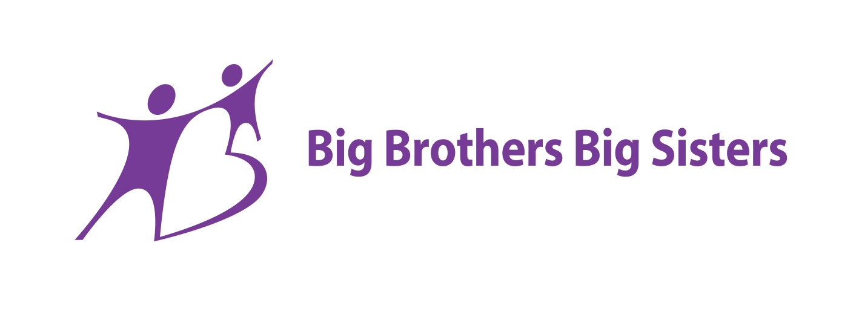

Young Achievers Program

2023

A Workshop and Mentor Program for Young People in Years 10, 11 and 12.  
  
The Young Achievers Program (YAP) provides support for students who excel in an academic, sporting or artistic field but who may not reach their full potential due to limited adult professional networks. Young people in the program are matched to a mentor who works in their field of interest in order to gain an insight into the field. The mentor will also provide support and friendship to the young person as they navigate the latter years of high school. The young person and mentor are ‘matched’ for a minimum of 12 months within which they will catch up every 2-4 weeks, participating in career based and interest-based activities, which might include visiting the mentor's workplace, attending networking events, attending lectures, talks and seminars.

Application Package

Forms to be completed by:

1. The young person
2. School staff member nominating the young person
3. The parent/guardian of the young person if under the age of 18.

***Submit application by November 4th 2022*** *to:*

Kater Worth

* Email: kathryn.worth@bbbsau.org
* Phone: 0417 181 874

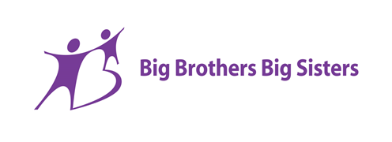

Please

insert

a photo

of yourself

here

Young Achievers Application Form 2023

***Personal Information provided on this form will be handled in a manner consistent with applicable Privacy Laws.***

**Applicants Details**

Name:   
 Preferred Name: ….................................................................................................................................

Address:   
…................................................................................................................................................

Home phone…………………………………………………………..Mobile…………………………………………………………………

Email:…………………………………………………………………………………………………………………………………………………

Gender:…..........................................................................................  
  
Personal pronouns:…..........................................................................................................................

Date of Birth: / / Country of Birth: ………………………………....................

Cultural and/or religious background:  
 ….........................

Languages spoken:   
  
Preferred contact method:

Are you involved with any other organisations or services? Please give details:

##### Contact Details of Parents/Legal Guardians

##### 1.Parent/Guardian’s Name………………………………………………………………………………………………………………….

##### Address………………………………………………………………………………………………………………………………………………..

##### Phone……………………………………………………………………… Email……………………………………………………………..

Preferred contact method ……………………………………………………………..

2. Parent/Guardian’s Name**………………………………………………………………………………………………………….**

##### ………………………………………………………………………………………………………………………………………………………….

Phone……………………………………………………………………….Email……………………………………………………………..  
  
Preferred contact method ……………………………………………………………..

**MEDICAL**

Do you have any health conditions or disability that may impact upon your involvement in the program? If yes, please detail:

Do you take any prescribed medication? If yes, please detail:

Do you have any allergies, injuries, asthma or dietary requirements?

**COURT ORDER DETAILS**

Are you subject to any Family Court or Children’s Court order? If yes, please specify:

Are you subject to any other legal orders? If yes, please specify:

**Education Details**

Name of School or Tertiary institution:

Current year level:

Address of school:

Postcode:…….……..

School contact person:

Position:  
 Phone:

Please list the subjects currently being studied:

1. …………………………………………………
2. …………………………………………………
3. …………………………………………………
4. …………………………………………………
5. ………………………………………………..
6. ………………………………………………..
7. ………………………………………………..

Are you intending to study after Year 12? Please circle: Yes or No

If yes, where do you hope to go? TAFE University

What do you hope to study?....................................................................................................................

If no, what do you intend doing after Year 12?........................................................................................

Have you had any work experience in your field of interest or in any other field? Please discuss.

**Goals and Interests**

What are your personal goals?

What are your interest and hobbies?

Are you involved with any extra-circulator activities? If yes, please provide details

Who is your role model? Why?

How do you think the Young Achievers Program can help you achieve your goals?

What do you see as your greatest skill or talent and why?

**General**

Describe yourself.

Describe your passion

What do you believe makes a good leader?

Write about a time when you have had to overcome an obstacle.

**Big Brothers Big Sisters Privacy Notice and Authorisation for Release of Personal Information**

All personal information will be collected and handled by Big Brothers Big Sisters (BBBS) in accordance with our Privacy Policy. If you have not been provided with a copy of this Policy, please ask for one.

*\*In respect of all other individuals whose personal details are collected on this form, you must ensure that those individuals are aware that this information is being collected, used and disclosed by Big Brothers Big Sisters for the purposes outlined in the Privacy Notice and Authorisation for Release of Confidential and Personal Information (see below).*

**Collection of information**

BBBS needs personal information (including sensitive and health information) about or related to the young people in the program so that it can discharge its functions and activities. The information provided will help us determine how we best help you. For example, personal information assists us to:

* Assess suitability
* Establish matches
* Promote health and safety
* Promote the best interests of the child; and
* Protect the longevity of matches.

BBBS may request personal information during the application and selection process and from time to time during participation in the program.

Where you provide personal information about other people, you must ensure that those people are aware that this information is being collected and used by BBBS for its functions and activities.

**Disclosure**

The personal information you provide to us will be kept confidential. However, the information may be released in limited circumstances where:

1. disclosure is consistent with the primary purposes for which the information was collected;
2. where you have provided your consent to the disclosure of such information; or
3. where the law otherwise requires or authorises us to disclose that information.

For example, we may provide information about individuals to other BBBS programs or others who assist us with providing our services, including (amongst others) legal or professional advisers, schools, doctors and community agencies. Unless you contact us to request otherwise, your personal information will be included in the BBBS database of young people.

**Access**

You may request access to your personal information which BBBS holds by contacting our office.

**Authorisation**

* I have legal authority to represent the young person referred to above.
* I acknowledge that it is necessary for BBBS to collect personal information about or related to the young person in order for it to discharge its functions and activities.
* I undertake to co-operate with the collection of personal information during the selection process and as required from time to time.
* I understand that I am required to inform BBBS of any changes in the young person’s circumstances during involvement in the program.
* I understand that a failure on my part to disclose personal information may result in BBBS refusing to accept the young person’s application or removing them from the program.
* I understand that the information sought by BBBS might relate to me, as well as to the young person. In particular, information from the young person’s school and/or the referring agency may be relevant to the young person’s involvement in the program. Accordingly, I authorise the young person’s school and the referring agency to release information relating to the young person, and/or myself, if requested by BBBS.  
    
  BBBS may also require information from other entities (such as the young person’s physician, therapist/counsellor or any welfare or community agencies with which the young person has had contact) that is relevant to the young person’s involvement in the program. If BBBS considers that information relating to me or the young person from any other entity will be relevant, it will discuss the reasons with me and additional consent will be sought for that information to be released to BBBS on a need to know basis.
* I agree that a photocopy of this authorisation is sufficient evidence of my consent to release information about or relating to the young person to BBBS.
* I agree that if I am accepted into the program, my personal information will be retained by BBBS for the life of the file, which may be up to 100 years. If my application is unsuccessful, I agree to BBBS securely disposing of all personal information relating to my application following 12 months.

I have read the Privacy Notice and Authorisation for Release of Personal Information and I consent to Big Brothers Big Sisters use of this information.

Young Persons Signature: Date:……../……../……..

If under 18,

Parent/Guardians Signature:……………………………………………………….. Date:……../……../…….

**Optional consent for research**

From time to time, BBBS conducts research into its services, in order to improve and report on those services. Sometimes this research can be conducted using de-identified information, however on other occasions it is preferable for personal information to be used. By providing the consent below, you can contribute to improving the effectiveness of this research.

By circling “I agree” below, you agree to the following:

*“I agree to personal information (including sensitive and health information) held by BBBS about me, or the young person named on this form, being used and disclosed by BBBS and its research providers for the research purposes described above. I understand that research providers will be subject to confidentiality obligations and that our personal information will not be included in the published findings of that research without my further consent”*

(Please circle) I agree / I don’t agree

Young Persons Signature: Date:……../……../……..

If under 18,

Parent/Guardians Signature:……………………………………………………….. Date:……../……../…….

**APPLICANT’S COMMITMENT FORM**

I, …………………………………………………………………………………… have applied to the Young Achievers Workshop and Mentor Program and if my application is successful, I agree to (tick below):

• meet fortnightly or monthly with my mentor

• attend scheduled activities arranged by the Young Achievers Program

• behave in an appropriate manner during activities

• not to be under the influence of drugs or alcohol during mentor catch ups or workshops

• to maintain contact with the Coordinator of the Young Achievers Program on a regular basis

• to address any issues of concern with either the mentor or the program coordinator

• to enjoy and make the most out of the Young Achievers Program

• to undertake a 3 month probationary period at the beginning of the program.

I understand that failure to meet any of these requirements may result in my removal from the program.

Is there anything else that Big Brothers Big Sisters should know about you that would help us with assessing your application?

Young Persons Signature: Date:……../……../……..

**PARENT/CARER CONSENT TO PARTICIPATE FORM**

Dear Parent/Carer,

Your child has made an application for the Young Achievers Program 2023. The Young Achievers Program is a 12 month program that aims to assist students to develop links with educational, career and employment opportunities, increase self esteem, develop leadership skills and offer opportunities for personal development. This is provided through the attendance of the young people at monthly workshops and by matching the young person with a mentor who can guide and encourage the young person. Catch ups between the young person and the mentor occur fortnightly or monthly.

If your child is under the age of 18, it is necessary for us to receive your consent so that Big Brothers Big Sisters may continue with processing the applications. By signing below, your child’s application will be processed confidentially.

Name of Applicant:……………………………………………………………………………………………………………………………

Name of Parent/Carer: ……………………………………………………………………………………………………………………….

Address……………………………………………………………………………………………………………………………………………

……………………………………………………………………………………………………………………P/Code…………………………..

Contact Number………………………………….

I agree to my child applying for the Young Achievers Program 2023

Signed……………………………………………………………………………………………………………………………….

Date-……………………………………………………………………………………………………………………………….

**SCHOOL ENDORSEMENT FORM**

*To be completed by a member of staff who has known the nominee / student for a significant amount of time*.

The Young Achievers Program aims to assist talented and committed young people, to reach their full potential. The program consists of assistance in the form of workshops and a one on one mentor.

How long have you known the young person and in what capacity?

…………………………………………………………………………………………………………………………………………………………..

…………………………………………………………………………………………………………………………………………………………..

It is important for us to know why this applicant would make a good candidate for the program. Some considerations might include:

* A track record of commitment at school
* Service to the community
* Excellence in a particular area; eg academic, the arts, sport, other
* Limited access to tutoring or educational resources
* Desire for self development opportunities
* Leadership qualities

Please tick any of the above that you believe are applicable to the student.

Places in the program are limited and highly sought after. What makes this person a superior applicant?

…………………………………………………………………………………………………………………………………………………………..

…………………………………………………………………………………………………………………………………………………………..

…………………………………………………………………………………………………………………………………………………………..

Describe how the student can be assisted best by the Young Achievers Program.

…………………………………………………………………………………………………………………………………………………………..

…………………………………………………………………………………………………………………………………………………………..

…………………………………………………………………………………………………………………………………………………………..

Any other comments?

…………………………………………………………………………………………………………………………………………………………..

…………………………………………………………………………………………………………………………………………………………..

…………………………………………………………………………………………………………………………………………………………..

…………………………………………………………………………………………………………………………………………………………..

Endorsement provided by:

Name………………………………………………………………………………………………………………………………………………….

Position……………………………………………………………………………………………………………………………………………..

Address of School:…………………………………………….......................................................................................

……………………………………………..................................................................................................................

Phone No………………………………………………………………….. Mobile…………………………………………………………..

Email…………………………………………………………………………………………………………………………………………………..

Thank-you for taking the time to complete the form.