**CAREER NEWS** **Friday 31 May**

 **Career as a Business Site Manager**

The Good Careers Guide states that *building site managers supervise the work carried out on construction sites.* Some building site managers are self-employed as contractors or consultants to larger building companies.   
  
A building site manager may perform the following tasks:

* Provide skilled assistance to builders in planning and organising building projects by interpreting and carrying out their directions.
* Interpret building plans, regulations and codes of practice in order to direct the progress of work and monitor compliance with construction documents.
* Calculate costs and estimate completion times to prepare tender bids and deal with contract variations.
* Arrange supply of materials and equipment.
* Draw up detailed programs for site works and the coordination of building workers, and record variations from design drawings or specifications.
* Negotiate with subcontractors and make reports for builders and architects.

Site managers usually have a tertiary qualification in building and/or construction management.

[**How to become a Building Site Manager - Good Universities Guide**](https://www.gooduniversitiesguide.com.au/careers-guide/building-site-manager#you)

**Group of Eight Universities**

*The****Group of Eight (Go8)*** *is an association of leading Australian universities - comprehensive in general and professional education and distinguished by depth and breadth in research.* The **Go8** universities continually aim to -

* enhance the contribution of its member universities to the nation’s social, economic, cultural and environmental well-being and prosperity,
* extend the contribution of its member universities to the generation and preservation of the world’s stock of knowledge,
* strengthen Australia’s capacity to engage in and benefit from global developments, respond to global and local challenges,
* expand opportunities for Australian students, regardless of background, to participate in higher education of world class.

**To find out more about the *Group of Eight Universities*, visit** [**Group of Eight Universities**](http://www.go8.edu.au/)**.**

** Career as an Orthoptist**The **Good Universities Guide** states that an Orthoptist *detects, diagnoses and treat disorders of the eye and associated eye movement and vision problems*. Orthoptists may specialise in:

* Ophthalmic eye care, which involves treatment of general eye diseases such as glaucoma, cataracts, diabetic eye disease and age-related macular degeneration.
* Neuro-ophthalmology, which involves the treatment of neurologically based eye disorders caused by stroke and head injury.
* Eye movement disorders and paediatric eye care, which involves the treatment of conditions such as strabismus, amblyopia and double vision.
* Vision rehabilitation, which involves maximising remaining sight in people with low vision using rehabilitation strategies and magnification aids.

Orthoptists are employed in a wide range of settings, including private practices, specialist eye clinics, public hospitals (including children’s hospitals), vision impairment agencies and research centres.   
 [**Good Universities Guide – Orthoptist**](https://www.gooduniversitiesguide.com.au/careers-guide/orthoptist#you)La Trobe University offers the [**Bachelor of Orthoptics (Honours)**](https://www.latrobe.edu.au/courses/bachelor-of-orthoptics-honours#/overview?location=BU&studentType=dom&year=2025), a 4-year degree with a strong focus on clinical experience which commences in the first year of study. Students also have the opportunity to complete a placement beyond Melbourne in their final year with one of the university’s partner clinics in regional Victoria, interstate or overseas.

 **Certificate III in Travel**

The ***Certificate III in Travel*** course is ideal for those wishing for a career in retail or, corporate travel, travel related events, airline operations, wholesale travel or wishing to become a broker or travel booker.   
  
The course provides students with the hands-on skills needed to work in the ever-changing travel and tourism industry. Up to three reservation systems will be taught along with fares and ticketing, product costing and selling and the course also includes up to date legal and consumer laws and agency obligations. This is a 6-month intensive course and cannot be done part time.

*Candidates who successfully complete the Certificate III in Travel are able to enrol in the* [*Diploma of Travel and Tourism Management*](https://www.angliss.edu.au/courses/tourism/travel/diploma-of-travel-and-tourism-management-SIT50122/) *and will only need to successfully complete another two stages or six months to obtain a dual qualification.*

**Find out more at** [**Certificate III in Travel | William Angliss Institute**](https://www.angliss.edu.au/courses/tourism/travel/certificate-iii-in-travel/)**.**

**What is a Circular Economy?**  
[Wikipedia](https://en.wikipedia.org/wiki/Circular_economy) states that a Circular Economy is **a model of resource production and consumption in any economy that** involves sharing, leasing, reusing, repairing, refurbishing. With sustainability central to the circular economy, the focus is on transforming our economy into one that is renewing; an economy that innovates to pro-actively reduce the impact of industries’ waste on the environment prior to it happening, rather than waiting to address the consequences of these issues.  
  
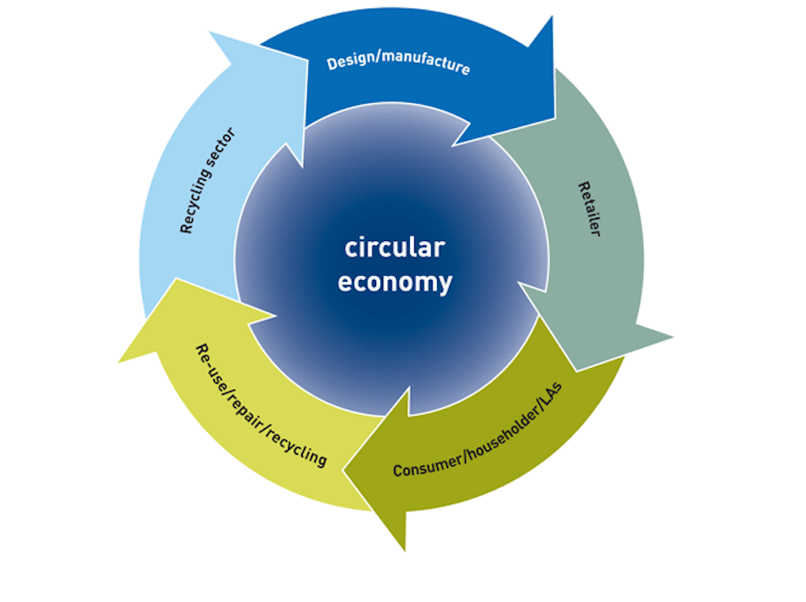

**Collarts Winter Holiday Workshop Series – July 2024**Collarts will once again open its doors during the winter holidays for High School students in Years 10, 11 and 12. There will be up to 15 practical workshops on offer on **Saturday 6 July** and **Sunday 7 July** across all study areas at Collarts.

**Register at** [**www.collarts.edu.au/holidayworkshops**](http://www.collarts.edu.au/holidayworkshops)**.**

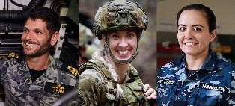 **ADF Careers**Australian Defence Force (ADF) offers over 200 roles across a wide range of specialist military positions, support roles, traditional and technical trades, and professions that range from medicine to engineering. **Find out more by clicking** [**ADF Careers by Category**](https://www.adfcareers.gov.au/careers/browse-by-category) **and browse the categories.**

|  |  |  |  |  |  |  |  |  |  |  |
| --- | --- | --- | --- | --- | --- | --- | --- | --- | --- | --- |
| |  | | --- | | [Air Force Mission Aircrew](https://www.adfcareers.gov.au/sitecore%20modules/Web/EXM/RedirectUrlPage.aspx?ec_eq=7xOHnROyGLg84yLtcoB5%2bGfSjCfrMa43UB5GhZ5mf2i%2f6pVZ4INwbxfbK3gVLx%2bo46yv2qFAUW4k8fF0OTtVBwwTD6XzipSz%2fMLDwJrkO4IaVebyQo80KkYAZUnERgvwnSMZI4rFkXplOs8KO%2beX8bwwyqn2k8ycYoWhBBF15p6k1shCi9XeIzcMF%2fNQWSW%2bqGE%2b3EMDsB1aD0pa3VCrpoZIzloiGFZF395BBB5e7ae6nmfQJVKUvoAtD6ISKCz90L%2fJwIiRGL2if%2b32NlMYMuUH3zR%2f6NeuqHos2D6JIvPlL%2bL3pKdwwpgXPMMY96AsS1h0TxhuMAG1Mvq2blyXI60S56HcSNdCbjqFuM281bU16P1sGzcTaviBqI98glstdkKCKZ09FBYvUWN3keaXeuI29uAw2HZwN6PDI0uuVh0%3d) | | Aviation | | spacer-image | |  | | --- | | Woman at desk | | Business, Administration & Education | | spacer-image | |  | | --- | | Army Combat and Security | | Combat & Security | |

|  |  |  |  |  |  |  |  |  |  |  |
| --- | --- | --- | --- | --- | --- | --- | --- | --- | --- | --- |
| |  | | --- | | Man with radio headset | | Communications, IT & Intelligence | | spacer-image | |  | | --- | |  | | Engineering | | spacer-image | |  | | --- | | Air Force Healthcare | | Healthcare, Science & Chaplaincy | |

|  |  |  |  |  |  |  |  |  |  |  |
| --- | --- | --- | --- | --- | --- | --- | --- | --- | --- | --- |
| |  | | --- | | Air Force Logistics & Hospitality | | Logistics, Hospitality & Support | | spacer-image | |  | | --- | | Army Officers | | Officers & Management | | spacer-image | |  | | --- | | Navy Electronics Technician Submariner | | Trades | |

**Criminology and Paralegal Degrees in Victoria in 2024**Below are a number of **paralegal** courses on offer in Victoria. The prerequisite VCE subject is usually only an English. **Visit** [**VTAC**](http://www.vtac.edu.au/) **for a comprehensive list including all double degrees on offer.**

|  |  |  |  |
| --- | --- | --- | --- |
| **COURSE** | **UNI** | **MAJOR STUDIES IN 2024** | **ATAR 2024** |
| [**Criminology & Criminal Justice**](https://www.acu.edu.au/course/bachelor-of-criminology-and-criminal-justice) | **ACU** | Criminology. | **60.70 (M)** |
| [**Criminology**](https://www.deakin.edu.au/course/bachelor-criminology) | **DEAKIN** | Criminology (crime, crime prevention, policing, security, criminal justice, surveillance, victimology, crime and media). | **60.65 (G)**  **60.20 (M)** |
| [**Forensic Science**](https://www.deakin.edu.au/course/bachelor-forensic-science) | Forensic biology, Forensic chemistry, Forensic science. | **60.00 (G)** |
| [**Forensic Science/Criminology**](https://www.deakin.edu.au/course/bachelor-forensic-science-bachelor-criminology) | Criminology (crime, crime prevention, policing, security, criminal justice, surveillance, victimology, violence), Forensic biology, Forensic chemistry, Forensic science. | **65.35 (G)** |
| [**Criminology and Criminal Justice**](https://study.federation.edu.au/#/course/DHK5) | **FEDERATION** | Behavioural studies, Community and human services, Criminology and criminal justice, IT security, Sociology. | **51.10 (Ba) 50.20 (Be) n/p (Gi)** |
| [**Criminology**](https://www.latrobe.edu.au/courses/bachelor-of-criminology) | **LA TROBE** | Criminology. | **60.20 (B)**  **60.20 (M)** |
| [**Criminology**](https://www.monash.edu/study/courses/find-a-course/2020/criminology-a2008) | **MONASH** | Crime, Crime and justice, Criminal justice system, Criminology. | **75.00 (Cl)** |
| [**Criminology and Policing**](https://www.monash.edu/study/courses/find-a-course/2022/criminology-and-policing-a2014?domestic=true) | Crime, Crime and justice, Criminal justice system, Criminology, Policing. | **n/p (Cl)** |
| [**Criminal Justice**](https://www.rmit.edu.au/study-with-us/levels-of-study/undergraduate-study/bachelor-degrees/bachelor-of-criminal-justice-bp023) | **RMIT** | Criminal justice systems, Criminal justice workplace learning, Criminal law, Criminology, International crime. | **65.00 (C)** |
| [**Criminology & Psychology**](https://www.rmit.edu.au/study-with-us/levels-of-study/undergraduate-study/bachelor-degrees/bachelor-of-criminology-and-psychology-bp295) | Corrections, Crime prevention, Criminal justice administration, Criminology, Customs, Forensic investigation, Forensic psychology, Global justice, Information security, Justice, Law (court processes), Law (criminal), Law (evidence), Law enforcement, Legal studies, Police studies, Psychological testing and assessment, Psychology, Psychology (cognitive), Psychology (developmental), Psychology (personality), Psychology (social), Psychopathology, Youth justice. | **65.25 (C)** |
| [**Legal and Dispute Studies**](https://www.rmit.edu.au/study-with-us/levels-of-study/undergraduate-study/bachelor-degrees/bachelor-of-legal-and-dispute-studies-bp204) | Dispute resolution and mediation, Human rights, Justice, Law, Law (civil and criminal procedure), Law (civil obligations), Law (criminal), Law (evidence), Law (family), Law (information), Law (labour relations), Legal practice, Legal studies, Organisational processes, Social sciences, Sociology. | **67.00 (C)** |
| [**Legal Practice (Paralegal) AD**](https://www.rmit.edu.au/study-with-us/levels-of-study/undergraduate-study/associate-degrees/associate-degree-in-legal-practice-paralegal-ad015) | Business and Corporate Law, Civil Procedure & Dispute Resolution, Contract Law, Criminal Law, Evidence Law, Family Law, Intellectual Property Law and Trade Practices, Land Law & Conveyancing, Legal Research, Paralegal, Probate and Administration, Tort Law, Wills. | **40.10 (C)** |
| [**Criminal Justice and Criminology**](https://www.swinburne.edu.au/study/course/bachelor-of-criminal-justice-and-criminology/?utm_campaign=vtac&utm_source=course_guide&utm_medium=website) | **SWINBURNE** | Advanced topics in forensic psychology, Brain and behaviour, Corrections systems and practice, Crime and punishment in the international context, Crime society and culture, Criminal law and process, Deviance difference and conformity, Fundamentals of criminology, Global crime, Introduction to forensic psychology, Introduction to law, Law and social science, Policing systems and practice, Sentencing, Technological advances in dealing with crime, Youth justice and crime. | **55.35 (H)** |
| [**Criminology**](https://www.vu.edu.au/courses/bachelor-of-criminology-lbcr) | **VICTORIA** | Criminology. | **n/p (C)** |
| [**Criminal Justice**](https://www.vu.edu.au/courses/bachelor-of-criminal-justice-abcj) | Criminal justice. | **n/p (F)** |
| [**Criminal Justice & Psychological Sciences**](https://www.vu.edu.au/courses/bachelor-of-criminal-justice-and-psychological-studies-abcy) | Criminal justice, Psychology. | **n/p (F)** |
| [**Legal Services**](https://www.vu.edu.au/courses/bachelor-of-legal-services-lbls) | Advanced legal services, Law profession. | **n/p (C)(F)** |
| [**Youth Work and Criminal Justice**](https://www.vu.edu.au/courses/bachelor-of-youth-work-and-criminal-justice-abyc) | Criminal justice, Youth work. | **n/p (W)** |

Note: The University of Melbourne offers a *major in criminology* in its [Bachelor of Arts](https://study.unimelb.edu.au/find/courses/undergraduate/bachelor-of-arts/) degree (ATAR 87.00).

** Snapshot of Federation University Australia in 2024**

* [Federation University Australia](https://federation.edu.au/) was formed when the former University of Ballarat and the Gippsland Campus of Monash University were amalgamated.
* FedUni’s history actually dates back to 1870.
* FedUni is regional Victoria's largest education institution, with [campuses](http://federation.edu.au/about-us/our-campuses) in Ballarat, Berwick, Gippsland, the Wimmera, providing easy access to study, and over 1200 staff committed to teaching excellence and student support.
* FedUni has over 18,500 domestic and international students and 118,000 alumni across Australia and the world.
* FedUni offers a broad range of [courses](https://federation.edu.au/future-students/study-at-feduni/which-course) from apprenticeships to bachelor’s degrees.
* FedUni offers a range of [scholarships, bursaries, and grants](https://federation.edu.au/current-students/starting-at-federation/scholarships).
* FedUni students can access a wide range of [services and support](https://federation.edu.au/future-students/study-at-feduni/student-support) to assist them.
* Students who choose to live in residence gain the best start to their university experience - [accommodation](https://federation.edu.au/about-us/facilities-and-services/commercial-services/fedliving/fedliving-home).
* FedUni students also have the opportunity to study overseas at a range of institutions. Students can participate in a variety of programs that will provide them with a global experience. Students can choose between short-term programs and semester-long programs - [Study Abroad and Exchange](https://federation.edu.au/international/education-partnerships/study-abroad-and-exchange-programs).
* FedUni’s [Work Integrated Learning (WIL)](https://federation.edu.au/staff/learning-and-teaching/curriculum-quality/curriculum-frameworks-and-processes/work-integrated-learning) provides students with an opportunity to gain valuable workplace experience, to enhance their knowledge and skills. Federation University Australia is incorporating WIL across all programs and courses. WIL provides students with work-relevant education to support and enhance their learning and ensure our graduates are fully prepared for entry into the workforce.

