MESC Reporting and Assessment Guide
(updated February 2022)
Progress reports
Staff complete progress reports every 5 week learning cycle, assessing each student’s learning behaviours using the 5 areas below:
Evidence of Learning | Personal Learning | Working with Others | Orderly Behaviour | Learning Outside the Classroom
Measures the standard of the student’s work that has been submitted, class participation, application of skills and knowledge, effective use of class time and the completion of learning tasks. | Measures the student’s ability to meet learning expectations, set learning goals, management of equipment and the ability to reflect on their learning. | Measures the student’s ability to cooperate in a group, respect differences of others and manage conflict. | Measures the student’s ability to follow teacher instruction, adhere to rules and show respect for the learning environment. | Measures the student’s ability to complete homework tasks, conduct independent learning outside the classroom and to seek teacher assistance outside of the classroom.

EVIDENCE OF LEARNING:
- Years 7-10 students are assessed on their evidence of learning at their point of need eg if a student is on an ILP, working at their point of need that could be below the standard for that year level.
- For VCE/VCAL - EVIDENCE OF LEARNING should reflect the quality of the learning tasks they are submitting and what you are seeing in class ie meeting S/N or SAC requirements of VCAL competencies.

NOTE - If you are reporting any student as ‘Concerned’ in any of these 5 areas, you must have contacted home about your concerns BEFORE the report is published to families.

Non-CAT Formative assessment | CAT Summative assessment
- Compass learning tasks - should ONLY be made visible to students  - Communication with students and parents about these tasks should be done through:  - Compass emails  - Class News Feeds  - If students are not meeting deadlines:  - Post to Student chronicle and make visible to students and parents  - Contact home  - Use the Monday night Redemption Process  - Reflect this in personal learning reports  - DO NOT Categorise Non-CATS as “Assessment” | Each Semester all subjects need to complete 4 CATS  - Compass Learning Tasks CATS – should be visible to BOTH students and parents  - These CATS might be Formative or Summative (remember all criterion - A, B, C, D - must be assessed at least once each semester)  - Minimum expectation is one Summative CAT in a semester, more probably you will have 2 or 3.  - Categorise CATs on Compass as “Assessment”  - Follow the guide below for naming and components required in the Learning Task

All relevant Rubrics need to be communicated to students and parents at the start of a unit. This can be done in a variety of ways:
- Attached to Learning tasks
- Added as a Compass Resource
- Emailed
- Paper copies

After results have been entered for learning tasks – parents must be contacted via the Class News Feed to acknowledge that the work has been received and marked and that the feedback is available on Compass and returned to students.

Formatting of CAT Learning Tasks on Compass
We have implemented a consistent way to report Learning Tasks to parents so when parents view Learning task results on the Compass App they see a consistent piece of information for all tasks. In the tables below the first component should be “Starred” to provide this consistent information.
It is STRONGLY recommended that one person in each team (eg Year 7 L&L) creates the task in ‘school resources’ on compass and pushes it out to all classes to ensure consistency.
When setting up the Learning Task in school resources, make sure you attach a copy of the CAT and in the ‘task details’ section of the learning task, please write ‘ See attached task for details’ (or you could write a short summary of the task here).

Year 7 – 9 subject CATs (except Maths Booster)

Each CAT reported on Compass, visible to Parents and Students will be made up of 2 separate Learning Tasks.
Title | First Component  (starred *) | Second Component | Third /Forth Component
CAT 1 MYP: Task name | Student’s result 0-8 for the task for a MYP Criterion  (use Decimal Number – no Decimal places and edit the name so it reflects the criterion assessed eg: “Criterion A Knowing and understanding 0-8”) | MYP Rubric – from subject guide with task context added | If Multiple MYP Criterion Assessed in the one Task  Third Component – as per first component  Forth Component – as per second component
CAT 1 Vic. Curric: Task name  (Task Name should be the same for both MYP task AND Vic. Curric. task) | Grading Criteria  Drop Down Box  “Below the Standard through to Well Above the Standard” | Victorian Curriculum Result -Domain based, or  Capabilities for Connect and Electives which have a core subject.  “Orange Component on Compass” | Either Add a Rubric  Or  Add a comment which could say  “Detailed Feedback has been recorded on the assessment piece.”
NOTE: When a component has been added, it will appear as “hidden” in the component tab. Please change “Parent/Student Access” from “hidden” to “Students & Parents”

7-9 Maths Booster CATs

Title | First Component  (starred *) | Second Component | Third  Component | Forth Component
CAT 1 Vic. Curric: Task name | Grading Criteria  Drop Down Box  “Below the Standard through to Well Above the Standard” | Victorian Curriculum Result –Pre test Essential Assessment result | Victorian Curriculum – Post test Essential Assessment result | Written feedback – Areas of Strengths, Weaknesses and Improvement –  Cut and paste from Essential Assessment

A GUIDE for Awarding Grading Criteria Scale (First component of Victorian Curriculum part of a CAT)
- This is a rough guide only. If you assess a Curriculum Component multiple times over the year you might use the lower definitions of the scale earlier in the year and the higher values later in the year.

Grading Criterion reported on Compass | Year 7 | Year 8 | Year 9 | Year 7 Indonesian | Year 8 Indonesian | Year 9  Indonesian
Not Shown | DO NOT USE
Below Standard | $$≤5.0$$ | $$≤6.0$$ | $≤$ 7.0 | Phase 1 | Phase 1 | Phase 1
Approaching Standard | 5.0 – 6.0 | 6.0 – 7.0 | 7.0 – 8.0 |  | Phase 1/2 | Phase 2
At Standard | 6.0 – 7.0 | 7.0 – 8.0 | 8.0 – 9.0 |  | Phase 2 | Phase 2/3
Above Standard | 7.0 – 8.0 | 8.0 – 9.0 | 9.0 -10.0 |  |  | Phase 3
Well Above Standard | 8.0 – 11.0 | 9.0 – 11.0 | 10.0 -11.0

Year 10 CATs

Title | First Component (starred *) | Second Component | Third /Forth Component
CAT 1 Vic. Curric: Task name | Grading Criteria  Drop Down Box  “Below the Standard through to Well Above the Standard”  This judgement, where possible, needs to be made with reference to the task specific rubric. | Victorian Curriculum Result Domain based, or Capabilities for Connect and Electives which have a core subject.  “Orange Component on Compass” | Either Add a Rubric (self-constructed by teaching team)  Or  Add a Comment which could say  “Detailed Feedback has been recorded on the assessment piece.”

VCE – School Assessed Coursework (SAC)
Please note an S/N judgement for any given outcome should be awarded from a series of learning tasks completed for that outcome PRIOR to the SAC, not the SAC itself..
Student should NOT sit a SAC until they have achieved an S.
If students are at risk of obtaining an S for coursework, please log this on compass under ‘at risk’ and contact home.

Title | First Component (starred *) | Second Component | Third /Forth Component
YEAR 11 (UNIT 1 & 2)
UNIT 1- Outcome 1A SAC: Task name | Performance  Drop Down Box  “Very Low through to Very High ”  This judgement, where possible needs to be made with reference to the task specific rubric for the outcome. The rubric is to be attached for student/parents reference | Open Grade (numerical raw score)  Eg: 23/40 | Either Add a Rubric (this could be a moderated VCAA rubric, if applicable or self-constructed by teaching team)  AND/OR  Add a Comment which could say  “Detailed Feedback has been recorded on the assessment piece.”
YEAR 12 (UNIT 3 & 4)
UNIT 3 - Outcome 1A SAC: Task name | Performance  Drop Down Box  “Very Low through to Very High ”  This judgement MUST be made with reference to the VCAA performance descriptor rubric for the outcome. The Rubric is to be attached for student/parents reference | Open Grade (numerical raw score)  Eg: 23/40  MUST include this disclaimer  ‘ The numerical achievement score for this assessment is subject to change under the VCAA statistical moderation process’ | Must Add Rubric (VCAA)  AND  Must add a Comment which includes the following:  ‘Please Note: The numerical achievement score for this assessment is subject to change under the VCAA statistical moderation process’  “Detailed Feedback has been recorded on the assessment piece.”

VCAL
Title | First Component (starred *) | Second Component | Third Component
CAT 1 - Numeracy Outcome 1: Task name (if applicable) | Elements that have/have not been met in the Learning Outcome.  Drop Down Box  “Competent/Not Competent” | Overall S/N  Drop Down Box  “Satisfactory S or Not Satisfactory N” | Either Add a Rubric (must make reference to the Elements relevant to the Learning Outcome)  Or  Add a comment which could say “Detailed Feedback has been recorded on the assessment piece.”

ALL Unit 3 & 4 VCE Subject Specific Rubrics can be found on the VCAA website Example of VCAA Performance Descriptor Rubric

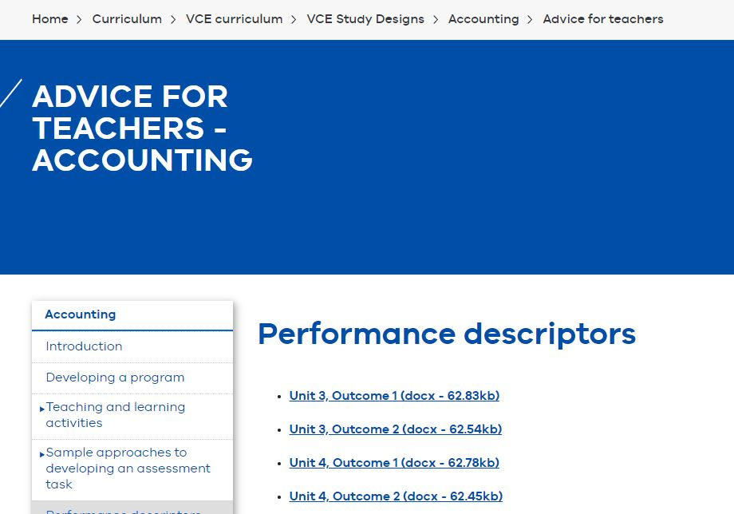
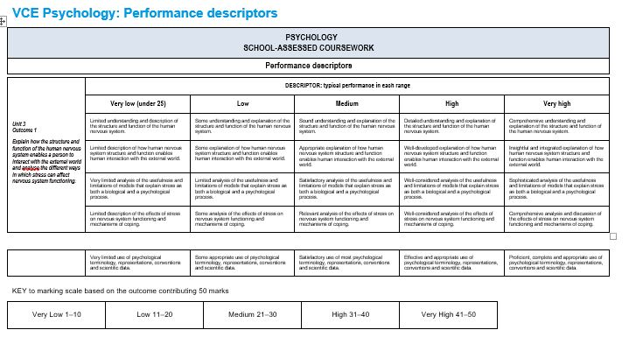
Home >Curriculum >VCE Curriculum >VCE Study Designs >Subject name >Advice for Teachers

