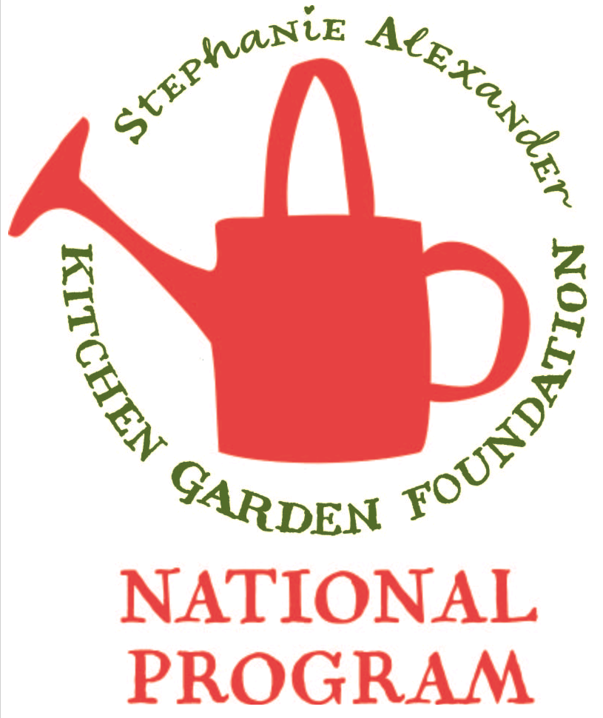
Vegetable Frittata

Season: Summer / Autumn

Type: Vegetable Dish

Difficulty: Medium

Serves: 20 tastes in the classroom or 4 at home

Fresh from the garden: parsley, silverbeet, broccoli

Recipe source: www.eggs.ca/recipes/cheese-and-vegetable-frittata

Volunteer information: Please double quantity!

Equipment:  * knives  * bowls  * wooden spoon  * whisk  * measuring cups  * chopping boards  * large frying pan  * serving dishes | Ingredients:  - 4 cups mixed vegetables, fresh or frozen  - 6 eggs  - 1/2 tsp dried basil  - 1/4 tsp salt  - 1 tsp vegetable oil  - 1 medium onion, sliced  - 2 garlic cloves, minced  - 3/4 cup grated cheese

What to do:
- Bring 2 cups (500 mL) salted water to boil in medium saucepan, Add vegetables and cover. Cook just until tender, then drain. Cut any larger vegetables.
- Whisk eggs, basil, salt and pepper in small bowl.
- Heat oil in 10-inch (25 cm) non-stick frying pan over medium heat. Add onion and garlic; cook, stirring occasionally, until soft, about 4 minutes.
- Stir in cooked vegetables. Pour egg mixture over vegetables in skillet. As mixture sets around edge of skillet, with spatula, gently lift cooked portions to allow uncooked egg to flow underneath. Cover and cook until bottom is set and top is almost set.
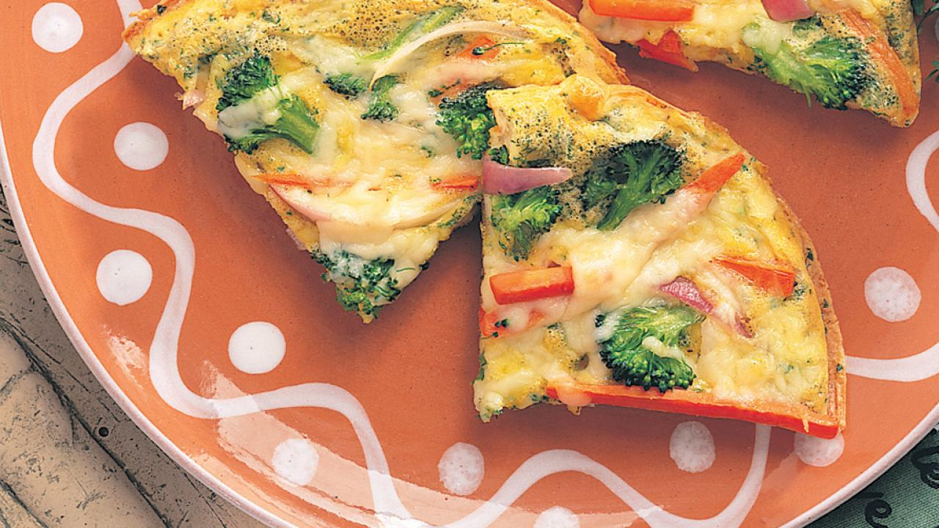
- Sprinkle cheese over top. Cover frying pan with lid and cook for another minute to melt cheese.

