SCHOOL CROSSING
CORRIGANS ROAD, CRANBOURNE EAST

Removal of Supervisors

The City of Casey regularly reviews its school crossing service to identify improvement opportunities to benefit Casey’s growing community. While the crossings are operated by Council, the rules around how they operate are set by the Road Safety Act (1986) and apply to all crossings across the State.
Under the State Government’s School Crossing Subsidy Program, and to meet the VicRoads standards for the management of a school crossing, more than 20 primary school children must use a crossing during both the morning and afternoon times for it to qualify as a designated crossing site.
Council assesses each crossing to track the average number of people that use it, identify those that are rarely used or where there are alternative road safety measures already in place, and consider areas where more resources need to be directed.
Consideration is given to the changing needs of the community and changed pedestrian patterns, traffic flow, speed limits and advancements in road and vehicle technology.
The following criteria must be met to qualify as a designated supervised school crossing site under the Road Safety Act (1986):
- School crossings for primary school children – the number of children (minimum 20) multiplied by the number of vehicles in the hour (minimum 100) must exceed 5,000.
- School crossings for secondary school children – the number of children (minimum 20) multiplied by the number of vehicles in the hour (minimum 250) must exceed 25,000.
- Pedestrian operated signals (Including the pedestrian crossings at signalized intersections) – more than 20 primary school children per hour.
- Other crossings – where the Council determines a need for supervision on account of special needs or other factors affecting safety.
A review of the school crossing on Corrigans Road near Stately Drive, Cranbourne East, showed that it does not meet the VicRoads criteria to retain a supervisor at this location. Given the very low pedestrian and vehicle numbers using this crossing, Council has made the decision to remove the crossing at this location, effective from the end of Term 4, 2023.
The School Crossings Education team, who manages the Safe Around Schools Program, has a range of educational information that can be located at https://www.casey.vic.gov.au/safe-around-schools.

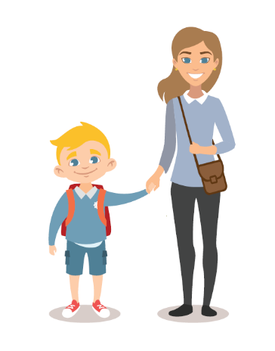
Getting children to school safely is everyone’s job.

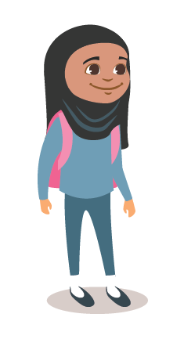
Tips for Walking to School
- Plan a safe route to school from your home.
- At every road crossing practice Stop, Look, Listen & Think before you cross the road.
- Discuss road rules in simple terms.
- Teach your children road safety and navigation skills by riding or walking around your neighbourhood.
- Find some walking buddies.
- Chat with other families about setting up buddy groups of younger and older children who can walk together.

Safely crossing the road
To help keep your children safe around roads, teach them how to follow STOP, LOOK, LISTEN and THINK:
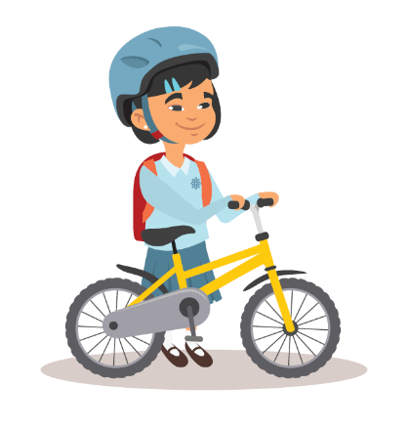
- STOP one step back from the kerb.
- LOOK in all directions for approaching traffic.
- LISTEN for traffic approaching from in all directions.
- THINK about whether it is safe to cross the road – when the road is clear or all traffic has stopped. When crossing, walk straight across the road. Keep LOOKING and LISTENING for traffic while crossing. Walk bikes and scooters across the road.
When choosing the best place to cross a road, teach your children they should:
- Use a pedestrian or pram crossing if there is one nearby.
- Find a place where there is a clear view of traffic coming from all directions and where drivers can see you.

