Souvenir T-shirts- $25
Sizes available:
Childs 6, 8, 10, 12, 14
Ladies 8, 10, 12, 14, 16, 18, 20
Mens S, M, L, XL, 2XL, 3XL, 4XL, 5XL
If you would like to purchase a souvenir T-shirt, please complete the order and payment details below and return to the General Office by Friday, 15th July. (first week back of Term 3)

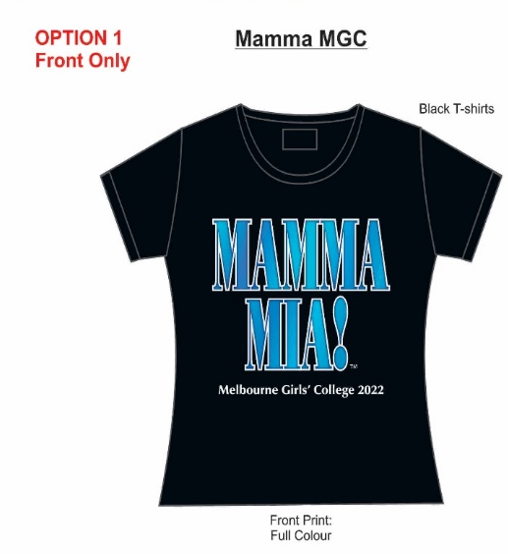
……………………………………………………………………………………………………………………………………………………………
NAME & FORM  (please print) | QUANTITY | SIZE | TOTAL

Melbourne Girls’ College
Yarra Boulevard, Richmond VIC 3121 Telephone: 9428 8955
STUDENT’S NAME: …………………………………………………………………………………………………….
PAYMENT FOR:
AMOUNT:
$

CARD DETAIL: Name…………………………………………… CCV:………. |  |  |  |  |  |  |  |  |  |  |  |  |  | Expiry Date: ……………..

