Communication toolkit for schools
Newsletter and website content

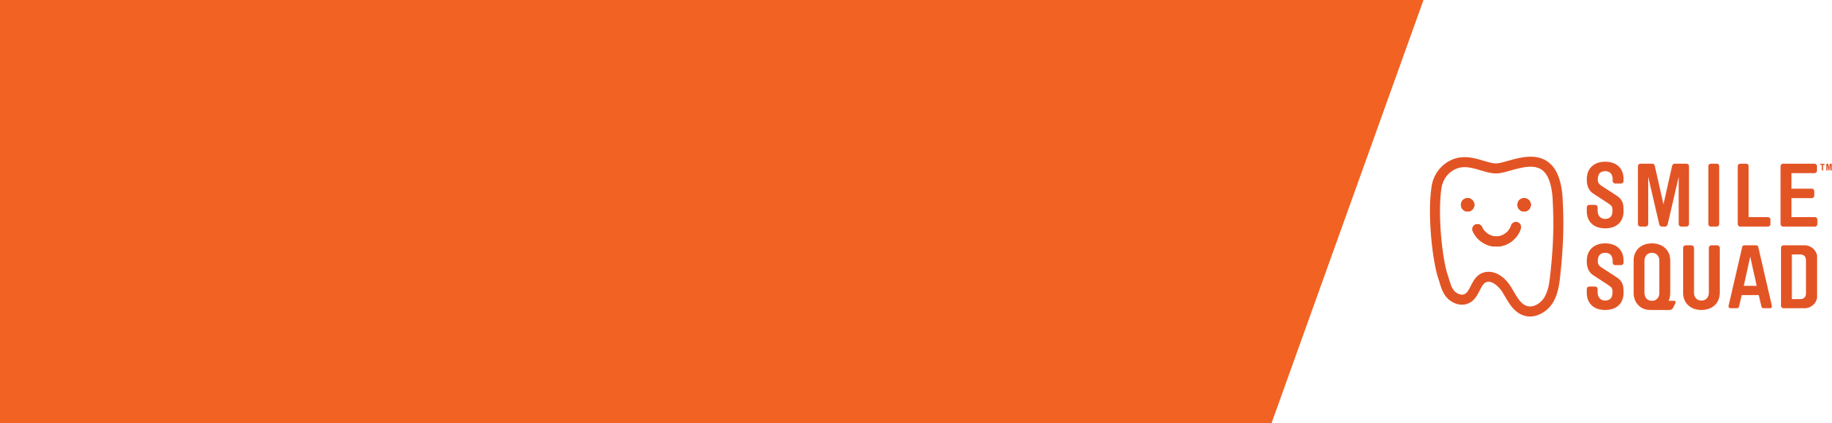
Before Smile Squad visits your school
It’s important to make sure families know what to expect when the Smile Squad visits your school. We’ve prepared some information about the program that you can share.
Mature minor consent (secondary schools only)
Students who are considered ‘mature minors’ may provide consent for their own dental care. Please determine the best communication channel to use to share this information with students.
School newsletter information
Copy and paste this content into your school newsletter. You can adapt it as needed to suit the needs of your school. You can also choose to put information up on your school website or share the information via your school portal (e.g. COMPASS).
Smile Squad is on the way to our school!
All children deserve a healthy smile, and the Smile Squad is coming to <INSERT NAME OF YOUR SCHOOL> to help make sure this happens.
Smile Squad is a Victorian Government program that provides free dental care to all Victorian government primary and secondary school students.
The friendly Smile Squad dental team will visit <INSERT NAME OF YOUR SCHOOL> soon to conduct a free annual dental health examination for every student and provide free follow up treatment as needed.
What do you need to do?
We need your consent before we can provide services. Consent is usually provided by a parent or guardian.
Sign up to Smile Squad at: https://bit.ly/smilesquadvic
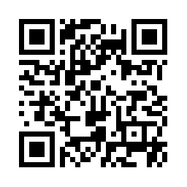
OR use the below QR code:

Although the engagement of parents/guardians is encouraged, in Victoria, students who are considered ‘mature minors’ may provide consent for their own dental care. To be considered a mature minor, the Smile Squad clinician must be satisfied that the student has sufficient understanding of the risks, benefits, and possible complications of their condition and proposed treatment to give informed consent.
The Smile Squad team will check the student’s teeth and mouth and show them how to keep their teeth healthy and strong. They will also provide any preventive services you have consented for. If the student needs more treatment, the Smile Squad will discuss this and seek consent.
Please complete and submit the consent form by <INSERT CLOSING DATE>.
Paper copies of the consent form are available. Please contact the school office if you would like to request one.
The electronic consent form can be translated into more than 100 languages, and the paper form is available in 13 languages.
Do I need to attend my child’s appointment?
No, you do not need to attend your child’s appointment. You can attend if you would like to, and you can take your child to the community dental clinic if you prefer.
Who is Smile Squad?
The bright orange Smile Squad vans are staffed by experienced oral health therapists, dental therapists, dental assistants and dentists. They all have lots of experience treating children and a passion for improving their oral health – for life.
Learn more about the Smile Squad by visiting www.smilesquad.vic.gov.au or contact the team at smilesquad@dhsv.org.au.

Contact
Thank you for supporting Smile Squad and sharing the messages in this toolkit. Please let us know if there is anything you would like to see in this toolkit in the future.
Email: smilesquad@dhsv.org.au

