**And just like that …..**

Our last term of the of the 2024 school year has started and what a busy few weeks it has been with some unique experiences & opportunities being offered to our students to participate in.

Last week a select group of students in Gr 4, 5, and 6 represented Oatlands at The Problem Solving and Maths Games Day competition held in the gym. Eleven schools attended with a total of 112 students participating in the competition.

Students worked in teams of 4 solving problems, completing mental maths activities, and strategy games. Congratulations to our Oatlands #2 team consisting of Zaidan 4LM, Ryan 5AM, Garret 5BR & Rahul 6NH. They had a successful day finishing in first place, winning by 24 points.

Well done to Emma Doyle for & the Maths team for organising the event and to our students who participated and represented Oatlands.

The Principal Team were invited to judge the annual Grade 6 MasterChef Finale last week and were absolutely impressed with the culinary skills and abundance of flavours in the dishes the students presented.

Six teams participated in the finale (each grade was represented by 1 team) and created some remarkable entrees, mains & desserts being scored out of 10 in the categories of creativity, presentation, taste, teamwork and the dreaded cleaning up. It was not an easy job judging as the quality of the dishes presented was high. We thoroughly enjoyed tasting all the delicious meals that were presented.

Congratulations to Aayan, Sharv, & Julian from 6MS for taking out the title of OPS 2025 MasterChef Team Champions creating Crispy Golden Aloo Tiki for entree, Thai Green Curry for main & Sweet Creamy Chocolate Shrikhand for dessert. Three amazing dishes.

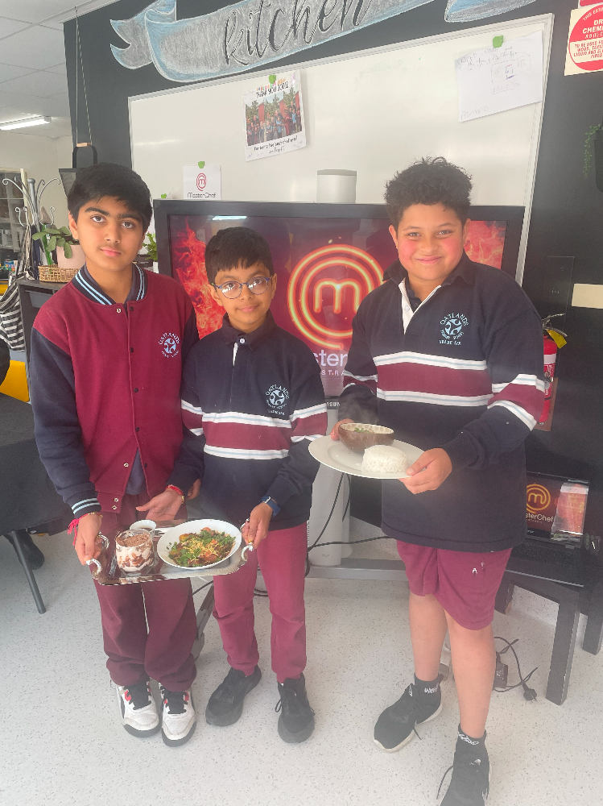

Jade from 6JR was awarded the best single dish of the day creating Jade’s Marvellous Mellow Chocolate Mousse which was encased in a white chocolate cup served with a curved crisp biscuit, raspberries & blueberries.

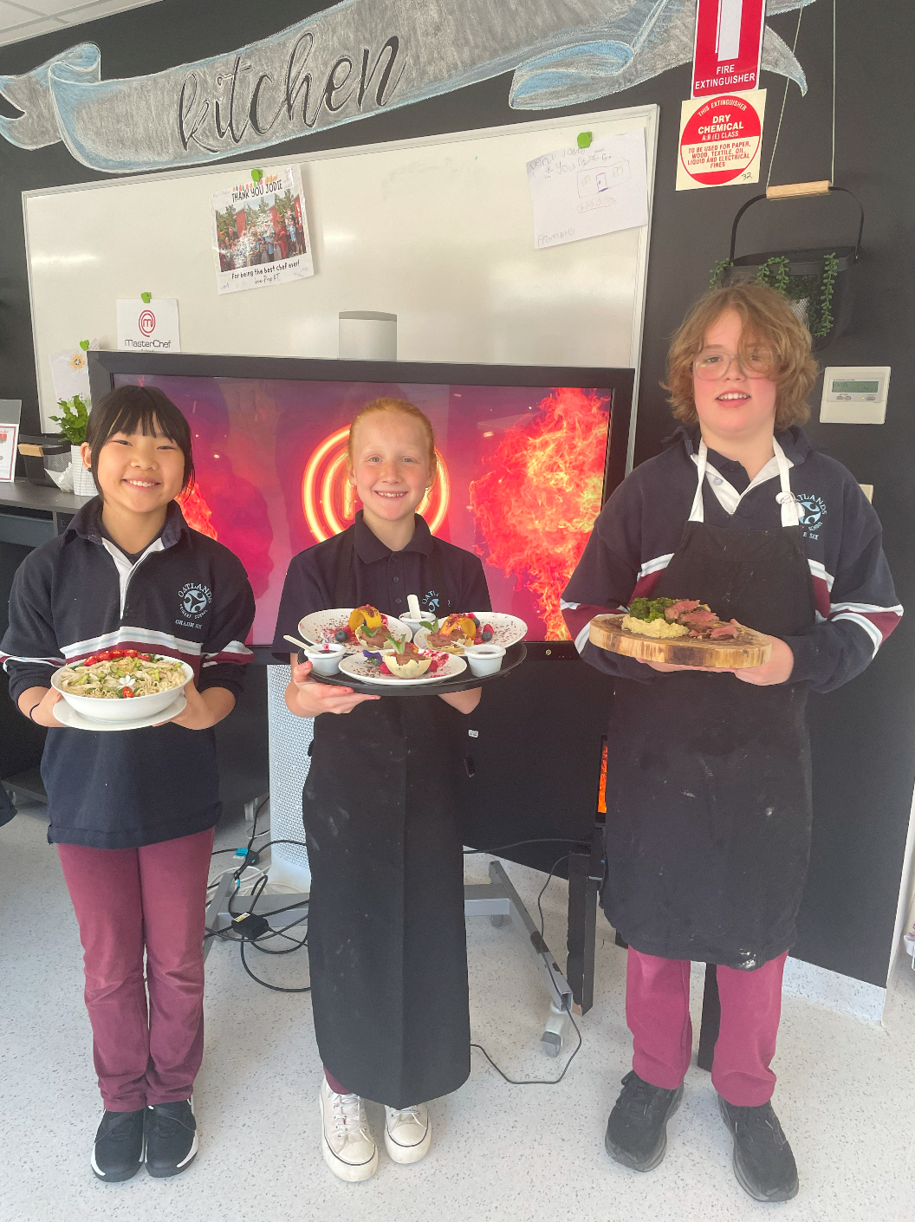

Our Gr 4 students enjoyed The Briars Outdoor Education Facility in Mount Martha last week for a day of fun and adventure. The students challenged themselves, worked in teams and encouraged and supported each other when completing the following activities throughout the day:

* Giant Swing
* Leap of Faith
* Flying Fox
* Raft Making
* Archery
* Initiative activities

The Principal Team thoroughly enjoyed their visit to The Briars and were very impressed with our student’s behaviour, resilience and willingness to give things a go that took some of them out of their comfort zone.

Thanks to our Gr 4 teachers and Education Support Staff who attended.

Our 2025 Prep students have begun their schooling journey with our Leap Into Learning Sessions beginning. There are lots of smiling faces visiting each week while learning the routines of school and becoming familiar with the surroundings in readiness for next year. We look forward to them being a part of our school community next year.

It has been wonderful visiting classrooms since returning from the holiday break and witnessing how settled and in routine our students are. Our staff do a great job in the first few days back each term revisiting rules and behaviour expectations and settling our students back into classroom routines.

We have many more exciting events occurring this term. We look forward to our school community attending Grandparents Afternoon, School Fete and Dance Production over the coming weeks.