Cupcakes
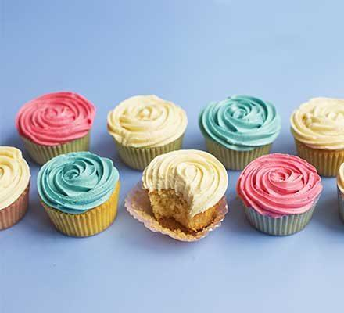
This makes 6 cupcakes
Ingredients
- 1 cup (150g) self-raising flour
- 1/3 cup (70g) caster sugar
- 1/3 cup (80ml) milk
- 75g butter, melted in small saucepan & cooled
- 1 large eggs
- 1/2 tsp Natural Vanilla Extract
Icing
- 1 cup icing mixture
- 1 tbsp (30ml) milk
- 1-2 drops of colouring
Equipment
- Measuring cups
- Measuring spoons
- Large mixing bowl
- Small mixing bowl
- Spoon
- Fork
- Small Saucepan
- Muffin tin
- Sifter
- Paper patty pan

Method – Cupcakes

STEP 1
Preheat oven to 200C (fan forced), Sift flour and sugar into a large bowl.
STEP 2
In a small bowl, beat eggs with a fork. Add milk, vanilla and cooled butter, stir to combine.

STEP 3
Add egg & milk mixture to the sifted flour and stir with a metal spoon.

STEP 4
Spoon into muffin sized paper cases (or a greased muffin pan) and bake for 12-15 minutes.

Method - Icing

STEP 1
In a medium bowl, mix icing sugar, food colour and milk until smooth.
STEP 2
Spread on cooled cupcakes and top your decorations!

