GRADE 2 NOVEL STUDY SPOTLIGHT
The Magic Faraway Tree - From Page to Screen

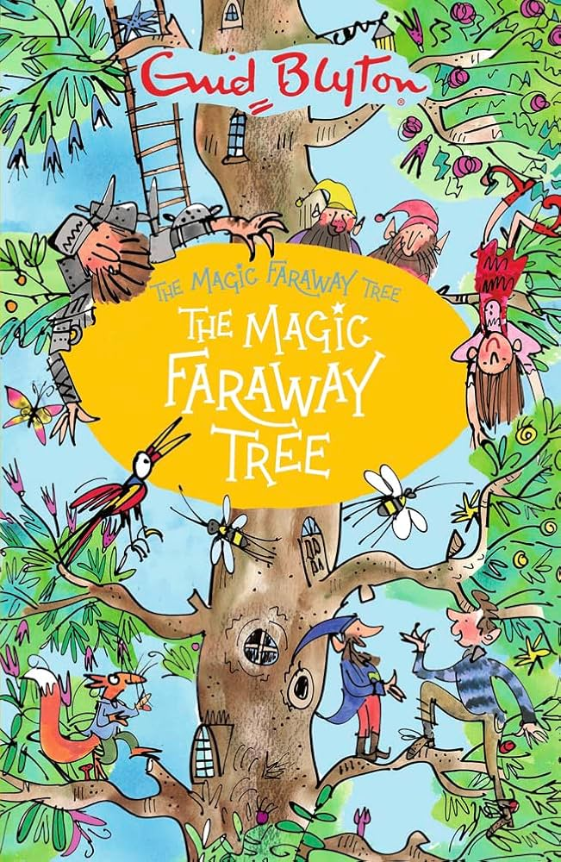
🎬 Movie release date in Australia: 26 March 2026
We are excited to share that our Grade 2 students have been enjoying the much-loved classic The Magic Faraway Tree as part of their novel study this term. Even more exciting, a brand-new film adaptation, The Magic Faraway Tree, will premiere in cinemas over the school holidays!
This has been a wonderful opportunity for students to experience the magic of a rich and imaginative story, and soon they will be able to see how this story has been brought to life on the big screen.
📚 Learning Highlights in Grade 2
Through this novel study, students have been developing important literacy skills, including:
✨ Building rich vocabulary
Students are discovering new and interesting words that strengthen their reading, writing and speaking.
👤 Understanding character development
Students explore how characters think, feel and change throughout the story.
🌍 Exploring imaginative settings
The magical lands inspire students to visualise and describe creative environments.
🧠 Strengthening comprehension and confidence
Students are learning to understand longer texts, share ideas and deepen their love of reading.
💬 Supporting Your Child at Home
You may wish to:
• Talk with your child about their favourite character
• Discuss the magical lands in the story
• Compare the book and movie if you see the film
• Encourage your child to continue reading for enjoyment
────────────────────────────────────────
🌟 A Brief Outline of the Story
The story follows three children—Joe, Beth and Frannie—who move to the countryside and discover a magical tree in the Enchanted Wood.
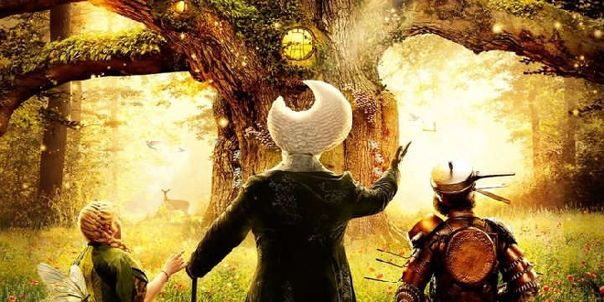
Inside the Faraway Tree, they meet fascinating and unusual characters such as Moonface, Silky the fairy and Saucepan Man. At the very top of the tree, different magical lands appear and disappear. Each land brings new adventures, surprises and important lessons about friendship, bravery and kindness.

🎬 Book and Movie: What’s Different?

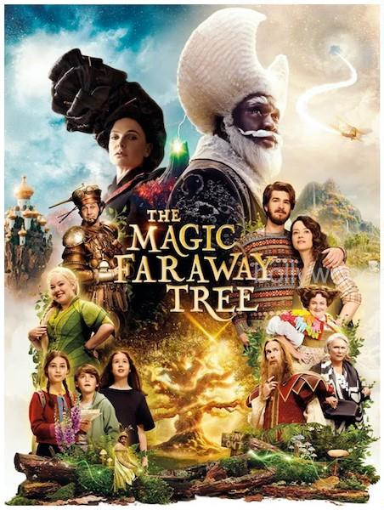
While the movie stays true to the magical world of the original story, there are some differences:
In the book:
• Focuses on Joe, Beth and Frannie
• Set in a traditional countryside
• Told through a series of magical adventures
• Emphasises imagination, friendship and discovery
In the movie:
• Features a modern family discovering the magical tree
• Includes updated settings and story elements
• Brings the magical characters to life visually
• Explores family relationships alongside adventure
🌳This provides a fantastic opportunity for students to compare and discuss how stories can be told in different ways.
🪄Stories like The Magic Faraway Tree help nurture imagination, language development and a lifelong love of reading.
We are so proud of our Grade 2 students and their enthusiasm for this magical adventure! 🌟We look forward to hearing our Gr2s thoughts about the movie. 🍿
Julianne Kelly
Literacy Leader
Learning & Teaching Leader
