Setting Up SIMON Everywhere
SIMON Everywhere is an application that you install on your mobile phone. It helps simplify access to the Parent Access Module (PAM) used for communication between the school and yourself. You can submit an absence, view the school calendar, review reports, manage parent teacher interview times and so much more.
Here are the steps for installing the application.

SIMON Everywhere is available on both the Android Play Store and Apple App Store | 
Seach for SIMON Everywhere  Install the application and open the application | 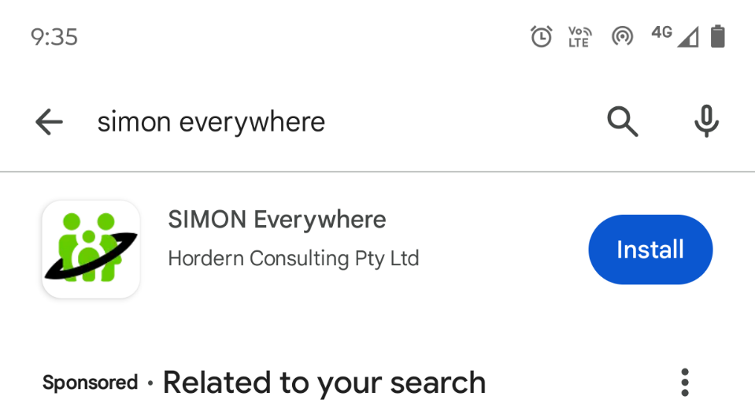
Inside the application click Pin School | 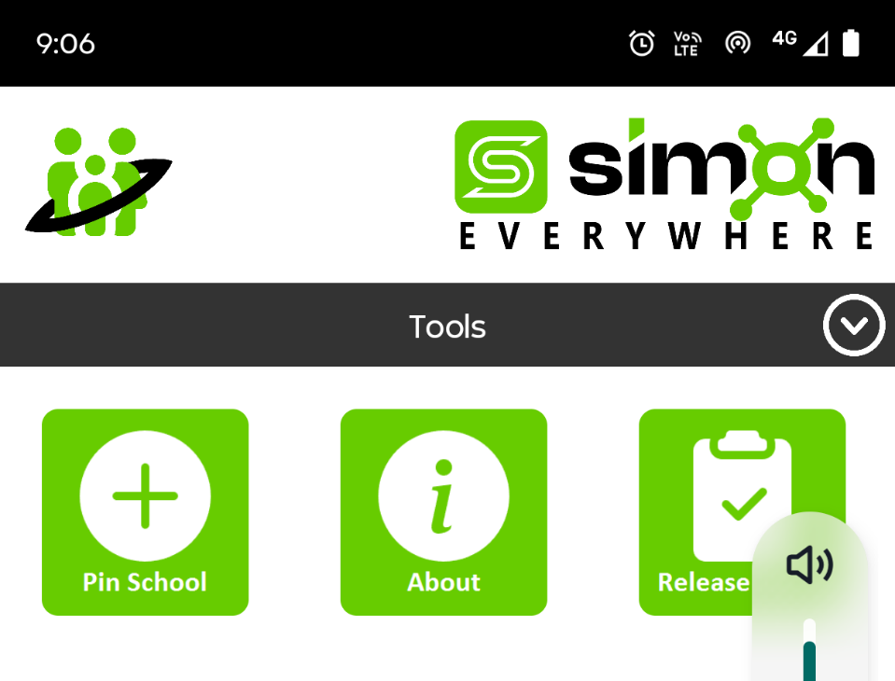
Add the school code 555052  Select PAM Login | 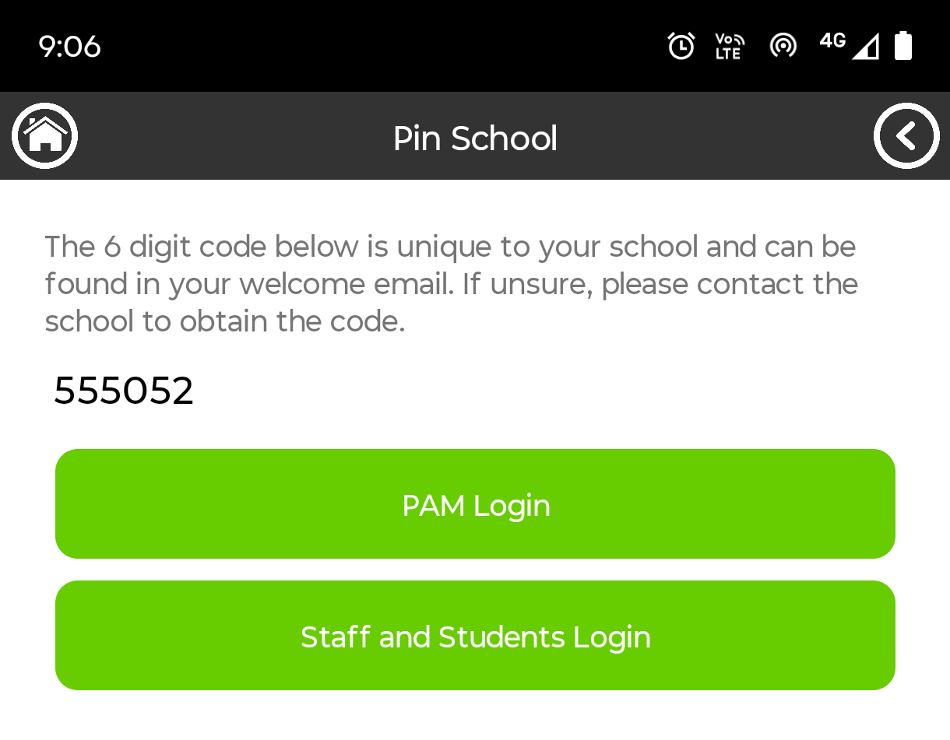
You will be required to complete Multi Factor Authentication (MFA) using CloudFlare  Wait until you have a green tick before adding your email address and your password  Click the Sign In button. This will emailed you an MFA code | 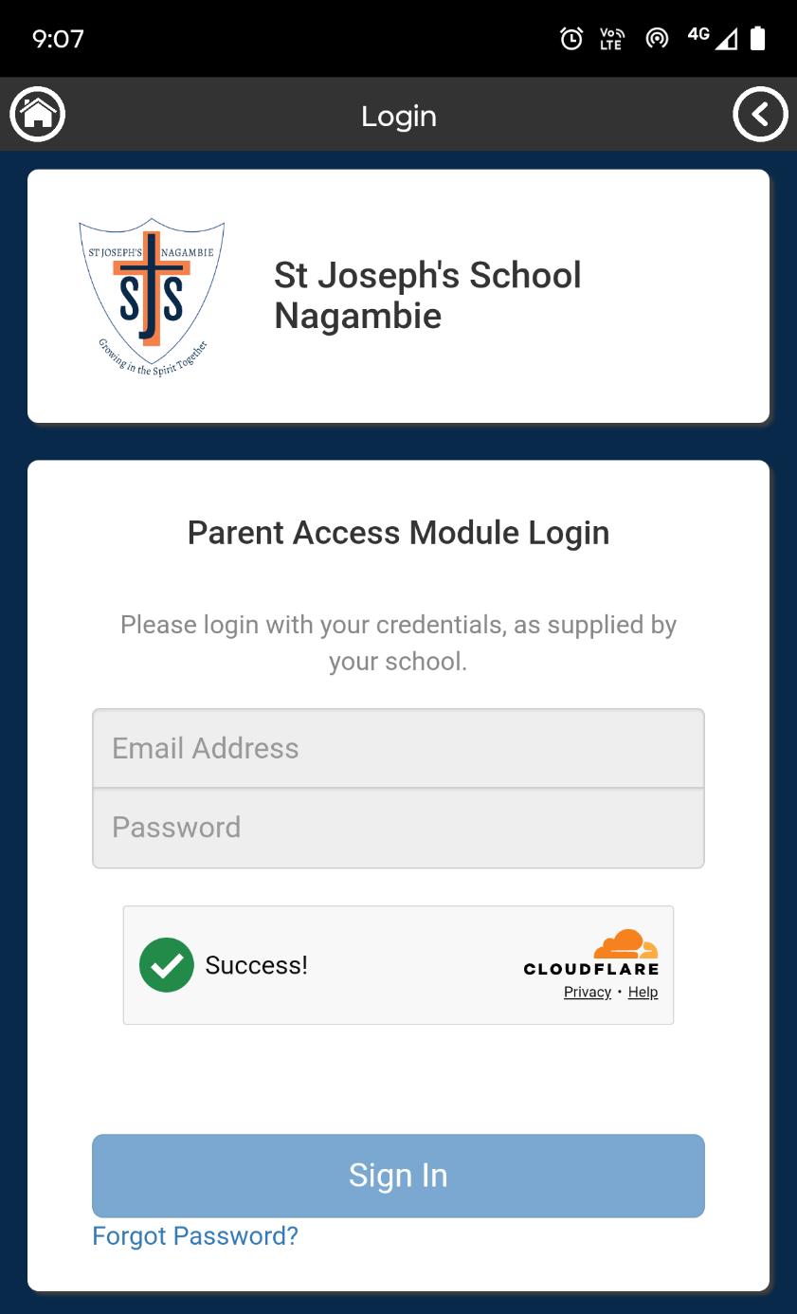
Add the MFA code to the Authentication screen | 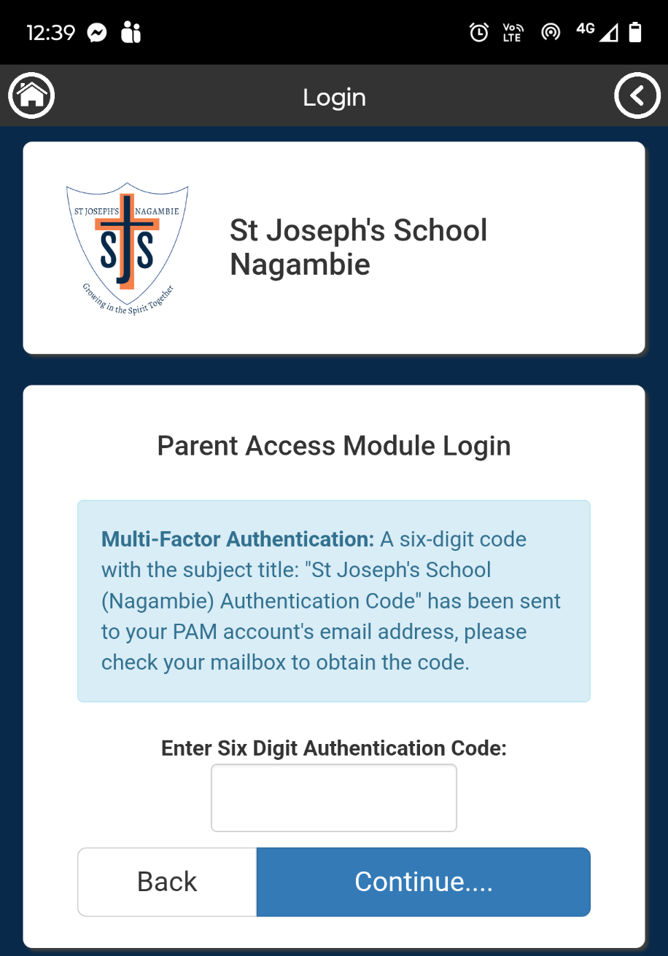
Now you can access PAM to send absences, see reports, the calendar and receive notifications from the school. | 