
Tzatziki Dip

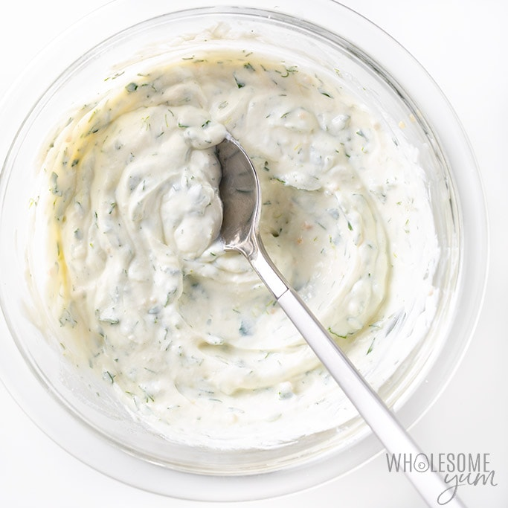

Source: www.thewholesomedish.com

Season: Summer

Type: Dip

Difficulty: Moderate

Serves: Serves 24 to taste

Fresh from the garden: cucumber, mint, garlic

Equipment:  - Chopping board  - 2 Large bowls  - Measuring cups and spoons  - Grater  - Garlic crusher  - Knife  - Serving bowls | Ingredients:  - 1/2 a large cucumber, unpeeled  - 1 1/2 cups plain full-fat Greek yogurt  - 2 large garlic cloves, finely minced  - 2 tablespoons extra virgin olive oil  - 1 tablespoon white vinegar  - 1/2 teaspoon salt  - 1 tablespoon minced fresh mint

What to do:

- Grate the cucumber and drain through a fine mesh sieve (it’s best left overnight in the fridge).
- Combine the yogurt, garlic, oil, vinegar, and salt in a large bowl. Cover and refrigerate overnight (if you’ve got time).
- Transfer the grated cucumber and fresh mint to the yogurt mixture and stir to combine. Serve chilled with baked pita bread and vegetable sticks for dipping.

