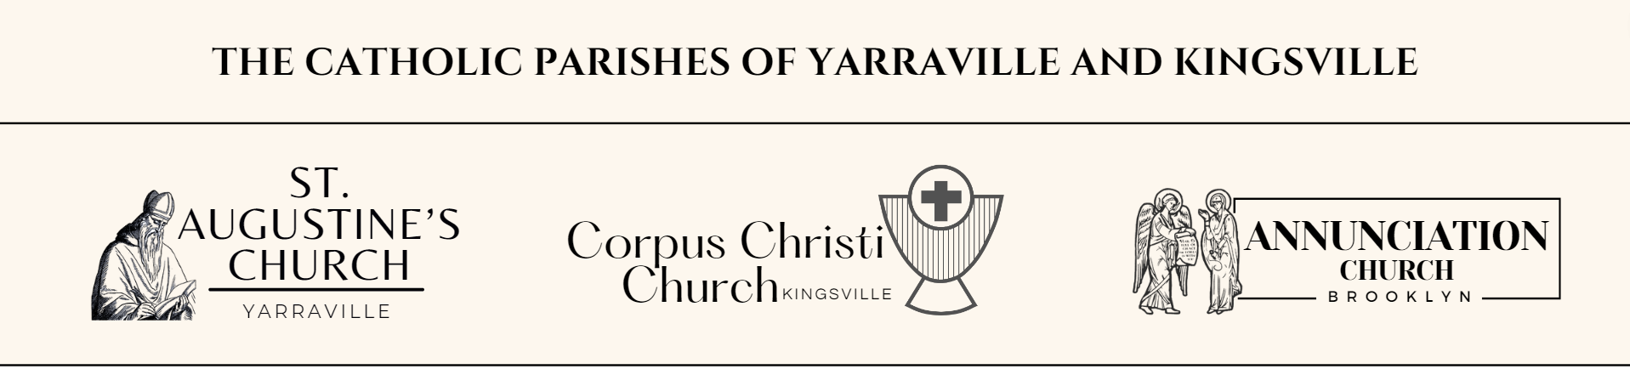

**Advent Timetable**

**Wednesday 11th December 10.30am**

End of school Year Mass at Annunciation Church Brooklyn.

**Thursday 12th December 7.00pm**

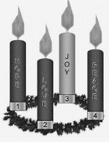

Advent Group Reflection evening at St. Augustine’s.

**Friday 13th December 9.15am**

End of school Year Mass at Corpus Christi Kingsville

**Monday 16th December 7.00pm**

Sacrament of Reconciliation at St. Augustine’s Yarraville

**Tuesday 17th December 9.15am**

End of school Year Mass at St Augustine’s Yarraville

**Thursday 19th December 7.00pm**

Advent Group Reflection evening at St. Augustine’s.

**Saturday 21st December 6.30pm**

Christmas Carols at St. Augustine’s Yarraville

**Christmas Masses**

**Tuesday 24th December**

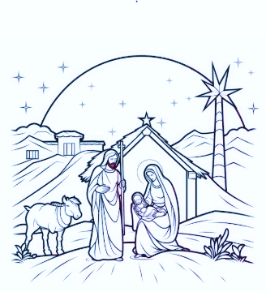

**CHRISTMAS EVE:**

**5pm** St. Augustine’s, Yarraville

**8pm** Corpus Christi, Kingsville

**10pm** **(Polish)**  St. Augustine’s, Yarraville

**Midnight** St. Augustine’s, Yarraville

**Wednesday 25th December**

**CHRISTMAS DAY:**

**8am** Annunciation, Brooklyn

**9.30am** St. Augustine’s, Yarraville

**11am** Corpus Christi, Kingsville

**11.30am** **(Polish)** St. Augustine’s, Yarraville