**CAREER NEWS** **Friday 21 February**

 **Dates to Diarise in Term 1**

* **Victorian Careers and Employment Expo** – 20 to 22 March 2025

**Medical Work Experience Overseas for High School Students**  
*Projects Abroad has spent over 30 years helping our participants fulfill their potential and make the world a better place.*

Projects Abroad offers a range of [Medical Work Experience](https://www.projects-abroad.com.au/projects/?is-filtered=true&type_of_work%5B%5D=5bf816b1a5305d067c065f0f&projects%5B%5D=5bf816b1a5305d067c065f1d&projects%5B%5D=5bf816b1a5305d067c065f11&projects%5B%5D=5bf816b1a5305d067c065f17&projects%5B%5D=5bf816b1a5305d067c065f1f&projects%5B%5D=5bf816b1a5305d067c065f15&projects%5B%5D=5bf816b1a5305d067c065f19&projects%5B%5D=5bf816b1a5305d067c065f23&projects%5B%5D=5bf816b1a5305d067c065f21&projects%5B%5D=5bf816b1a5305d067c065f25&projects%5B%5D=5bf816b1a5305d067c065f1b) programs for high school students, and a number of the destinations are overseas.  These overseas medical programs might be of interest to students keen to pursue studies and careers in medicine and healthcare.

These programs are designed for students in Years 10, 11, and 12 and run in the mid-year break and over the summer holiday.  They are ideal for individuals or groups of friends.

Projects Abroad has been running these programs for over 15 years. They are very popular with students from across Australia, New Zealand, Europe, and North America.

Projects Abroad will be running a *free* webinar for those students interested in the ***Overseas Medical Experience for High School Students***

**Date:**               Tuesday 4 March 2025  
**Time:**               6.30pm (AEST)  
  
**Register at** [**Projects Abroad Medical Work Experience Webinar**](https://www.projects-abroad.com.au/about-us/information-events/webinar-register/?eventid=9221829866332041050)**.**

 **Discover Monash Events**Monash University will be hosting several [Discover Monash](https://www.monash.edu/discover/events) events or activities over the coming weeks. Unless specified online**\*\***, these will be face-to-face events.

Participating in one or more of these events will assist students in making informed choices about their study options after Year 12.

The following events will take place from March until May and students are encouraged to register early. **For a complete list, and to register, visit** [**Events Calendar - Discover Monash**](https://www.monash.edu/discover/events/events-calendar)**.**

|  |  |
| --- | --- |
| **Information Evening – Caulfield Campus** | Tuesday 4 March, 6.30pm - 8.00pm |
| **Discover Medicine \*\*** | Tuesday 18 March, 5.30pm – 6.30pm |
| **Information Evening – Peninsula Campus** | Monday 25 March, 6.30pm – 8.00pm |
| **Discover Pharmacy and Pharmaceutical Sciences \*\*** | Thursday 27 March, 6.00pm – 7.00pm |
| **Clayton Campus Tour** | Thursday 10 April, 10.00am – 11.30am |
| **Peninsula Campus Tour** | Thursday 10 April, 2.00pm – 3.15pm |
| **Caulfield Campus Tour** | Friday 11 April, 10.00am – 11.15am |
| **Discover Business** | Friday 11 April, 11.15am – 12.15pm |
| **Clayton Campus Tour** | Friday 11 April, 2.00pm – 3.30pm |
| **Discover Nursing & Midwifery \*\*** | Tuesday 6 May, 5.30pm – 6.45pm |
| **Discover Fine Art, Curating, Design and Architecture \*\*** | Tuesday 6 May, 6.30pm – 7.00pm |
| **Discover Arts** | Thursday 8 May, 6.15pm – 7.45pm |
| **Discover Science: The Monash Science Experience** | Thursday 8 May, 6.00pm – 8.00pm |
| **Discover Biomedical Science and Nutrition Science \*\*** | Tuesday 13 May, 5.30pm – 6.45pm |
| **Discover the Bachelor of Media Communication** | Tuesday 13 May, 6.30pm – 8.00pm |
| **Discover Engineering** | Monday 19 May, 6.15pm – 7.15pm |
| **Discover Occupational Therapy, Physiotherapy, Paramedicine \*\*** | Tuesday 20 May, 5.30pm – 6.45pm |
| **Discover Radiation Sciences, and Medical Imaging and Radiography \*\*** | Wednesday 21 May, 5.30pm – 6.30pm |
| **Discover Teaching and Learning Design - Peninsula** | Thursday 22 May, 6.30pm – 7.30pm |
| **Discover Degrees in Global Relations, Politics, and Economics** | Thursday 22 May, 6.15pm – 7.45pm |
| **Discover Health Sciences, Public Health, and Psychology \*\*** | Tuesday 27 May, 5.30pm – 6.30pm |
| **Discover Teaching and Learning Design - Clayton** | Tuesday 27 May, 6.30pm – 7.30pm |
| **Discover Fine Art, Curating, Design and Architecture** | Wednesday 28 May, 6.00pm – 7.30pm |
| **Discover the Bachelor of Learning Design and Technology \*\*** | Thursday 29 May, 6.30pm – 7.30pm |

** Future Forum - Melbourne**

***Future Forum*** is open to ambitious Year 11 and 12 students keen on connecting with like-minded students, educators, and mentors who share the same drive for excellence. Attendees will leave feeling better informed, more confident in their choices, and empowered to take their next steps toward a bright future.  
  
The event is a unique, innovative and memorable dining experience in an exciting venue, pairing each course with the guest speaker and designed to spark interesting conversation.   
  
Students will hear from esteemed Bond alumni, each a leader in their field with a global reputation for visionary thinking and a unique capacity for turning dreams into realities. At the same time, students will be encouraged to share their own ideas and passions for the future by engaging in thought-provoking discussions and networking opportunities with these experts, academics and like-minded students.

The Melbourne forum will take place on **Sunday 30 March 2025**. This is a *free* event, starting at 5.00pm. The complimentary event includes dinner and refreshments and places are limited, so students should register their interest as soon as possible at [**Future Forum - Bond University**](https://bond.edu.au/bond-future-forum)**.**

**Cetacean Sisters - Inspiring Future Female Scientists through Cetacean Science***We would like to share with you a unique science workshop series designed especially for female secondary school students to further their understanding of science and knowledge of cetaceans (whales and dolphins).*

Workshop Series Details:

This series comprises five, [two-hour workshops](https://www.cetaceanscience.com.au/girls_in_science/) held either in the picturesque Cowes on Phillip Island or in scenic Mount Martha on the Mornington Peninsula. These sessions provide an opportunity for girls interested in science and marine biology to connect with like-minded peers in a positive and collaborative setting.

What to Expect:

Limited to only 20 students, each workshop offers interactive and practical experiences that will deepen students’ understanding of the cetaceans found in our local waters. Led by Dr. Sue Mason, a passionate local cetacean scientist and experienced educator, these sessions provide valuable insights into marine science careers, shedding light on the opportunities and realities of working with marine wildlife.  
  
The next series of workshops are scheduled for March and April. Details, including specific dates and the cost, as well as bookings can be made **online via the**[**Cetacean Sisters page**](https://events.humanitix.com/host/cetacean-sisters)**.**

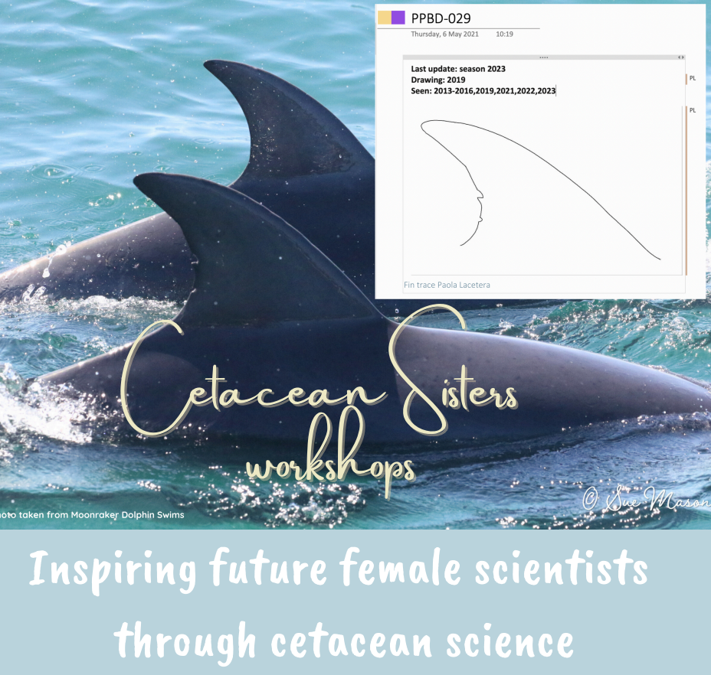

**Ac****counting & Actuarial Science Degrees in Victoria in 2025**

Accounting is offered at many universities in Victoria. It is often offered as a major or minor in a business or commerce degree, but many universities also offer dedicated accounting degrees. Below is a list of many **specific accounting-focused** degrees and an **actuarial science** degree offered at Victorian universities. **Note:** The University of Melbourne offers [actuarial studies](https://study.unimelb.edu.au/find/courses/major/actuarial-studies/) as a major in the Commerce degree. **Visit** [**VTAC**](http://www.vtac.edu.au/) **for more comprehensive information on these and other courses – including double-degrees – that offer accounting.**

|  |  |  |  |
| --- | --- | --- | --- |
| **INSTITUTION** | **COURSE** | **MAJOR STUDIES IN 2025** | **VCE PREREQUISITES** |
| **ACU** | **Accounting and Finance** | Accounting Theory, Auditing, Company Law, Corporate Accounting, Economics, Financial Accounting, Financial Risk Management, Principles of Finance, Taxation Law | Units 3 and 4: a study score of at least 30 in English (EAL) or at least 25 in English other than EAL. **ATAR 2025: 63.30 (Melbourne)** |
| **CHARLES STURT** | **Accounting** | Accounting, auditing, business (law), business (management), business (taxation), finance, financial accounting, management accounting | Successful completion of Year 12 and ATAR used for selection.  **ATAR 2025: L/N (Albury-Wodonga)** |
| **CQU Melbourne** (direct application) | **Accounting** | Financial planning, property, management, entrepreneurship and accounting, marketing, or professional project. | Successful completion of Year 12 and English Language Proficiency requirements. The ATAR is used for selection. **ATAR 2025: 60.00 (Melbourne)** |
| **LA TROBE UNIVERSITY** | **Accounting** | Agribusiness, Business analytics, Digital business, Economics, Enterprise, Event management, Finance, Human resource management, International business, Management, Marketing, Tourism and hospitality. | Units 3 and 4: a study score of at least 25 in English (EAL) or at least 20 in English other than EAL.  **ATAR 2025: 65.65 (Bendigo)  56.40 (Melbourne)** |
| **MONASH UNIVERSITY** | **Accounting** | Accounting, Business management. | Units 3 and 4: a study score of at least 27 in English (EAL) or at least 25 in English other than EAL; Units 3 and 4: a study score of at least 22 in one of Maths: Mathematical Methods or Maths: Specialist Mathematics or at least 25 in Maths: General Mathematics. **ATAR 2025: 76.75 (Caulfield)** |
| **Actuarial Science**  **Note:** *Also on offer -* [Bachelor of Actuarial Science/Master of Actuarial Studies](https://www.monash.edu/study/courses/find-a-course/actuarial-science-and-actuarial-studies-b6060) **\*** | Actuarial analytics, Actuarial Science, Actuarial studies, Statistics | Units 3 and 4: a study score of at least 27 in English as an Additional Language (EAL) or at least 25 in English other than EAL. Units 3 and 4: a study score of at least 25 in one of Maths: Mathematical Methods or Maths: Specialist Mathematics.  **ATAR 2025: 92.20 (Clayton) ATAR 2025: 93.60 (Clayton) \*** |
| **RMIT UNIVERSITY** | **Accounting** | Accounting. | Units 3 and 4: a study score of at least 30 in English (EAL) or at least 25 in English other than EAL.  **ATAR 2025: 67.20 (City)** |
| **SWINBURNE UNIVERSITY** | **Accounting** | Accounting theory, Auditing, Company accounting, Financial information systems, Financial management, Financial statistics, Management accounting for planning and control, Taxation | Units 3 and 4: a study score of at least 30 in English (EAL) or at least 25 in English other than EAL. **ATAR 2025: 61.45 (Hawthorn)** |
| **Accounting and Business Information Technology (Professional)** | Accounting theory, Auditing, Business digitalisation, Business intelligence and data visualisation, Business process analysis, Cloud approaches for enterprise systems, Company accounting, Contemporary management principles, Cyber security for business, Data management and analytics, Digital business analysis and design, Economics for business decision making, Enterprise systems, Financial information for decision making, Financial information systems, Financial management, Financial statistics, Forensic accounting, Governing digital technologies, IT program and project management, Law of commerce, Management accounting for planning and control, Programming concepts, Taxation | Units 3 and 4: a study score of at least 30 in English (EAL) or at least 25 in English other than EAL. **ATAR 2025: 76.65 (Hawthorn)** |
| **VICTORIA UNIVERSITY** | **Accounting** | Accounting, Business Analytics, Data and Information Systems Management, Finance, Risk Management | Units 3 and 4: a study score of at least 25 in English (EAL) or at least 20 in English other than EAL.  **ATAR 2025: N/P (City)** |

** Snapshot of Bond University in 2025**

* **A High Rating University**

*In the 2025* [*Good Universities Guide*](https://www.gooduniversitiesguide.com.au/university-ratings-rankings/latest/undergraduate/overall-experience)*, Bond University was awarded more 5-star ratings in the Educational Experience category with 5 stars being the maximum rating awarded.   
The QS star rankings were similar.*

Description: Five Stars  Student Support Description: Five Stars Teaching Quality

Description: Five Stars Overall Experience Description: Five Stars Learner Engagement

Description: Five Stars Learning Resources Description: Five Stars Skills Development

Description: Five Stars Student Teacher Ratio

**Bond also ranked #23 in world's best small universities** **according to the 2024 Times Higher Education (THE) Best Small Universities rankings, which ranks universities with fewer than 5,000 students.** [**Our rankings | Bond University**](https://bond.edu.au/study/why-study-at-bond/our-rankings)

* [**Accelerated degrees**](https://bond.edu.au/study/why-study-at-bond/accelerated-degrees)

Graduate up to 12 months ahead of the rest by studying three semesters per year and earn an income up to a year ahead of graduates from other universities. Students learn from world-renowned, highly qualified academics and high-level corporate and government consultants who take a hands-on role in guiding students’ career paths.

* [**Core Curriculum**](https://bond.edu.au/current-students/study-information/enrolment/program-structure-and-sequence/core-curriculum)

**The** Core Curriculum, embedded in each undergraduate program, establishes and begins the development of essential graduate attributes, supports students’ capacity to acquire the knowledge and skills taught in their discipline-specific coursework, and prepares graduates to translate these capabilities into successful professional and personal lives.

* [**Leadership Development**](https://bond.edu.au/BondExperience/LeadershipDevelopment)

Part of Bond University’s unique approach is to help students develop a strong foundation of key leadership attributes that will prepare them for career success, regardless of which field of study they choose.

* [**Study facilities**](https://bond.edu.au/life-at-bond/life-on-campus/study-facilities)

Bond not only has state-of-the-art facilities, but it also offers unprecedented access to them. This means students can apply their profession as they learn it, in an environment far more akin to the real thing.

* [**Industry Experience Program**](https://bond.edu.au/industry-experience-program)

Bond is committed to producing graduates who are “ready to hit the ground running”. The Industry Experience Program (IEP) provides a vital link between employers and students that can result in a mutually beneficial partnership. 

* [**Beyond Bond**](https://bond.edu.au/current-students/opportunities/beyond-bond)

A practical, activity-based program that extends across the duration of all undergraduate degrees, as a mandatory degree requirement, ensuring all Bond students engage in various extra-curricular activities that complement their academic studies.

* [**Clubs and societies**](https://bond.edu.au/current-students/campus-life/busa/clubs-and-societies)

Students have access to many sporting and social clubs, fitness centres, cafes, restaurants, and support services on offer, all available on campus.

* [**Bond alumni**](https://bond.edu.au/alumni/about-bond-alumni)

Bond has a global network of 33,000 alumni, which is active in over 120 countries around the world, so students can be connected practically anywhere their ambition may take them.