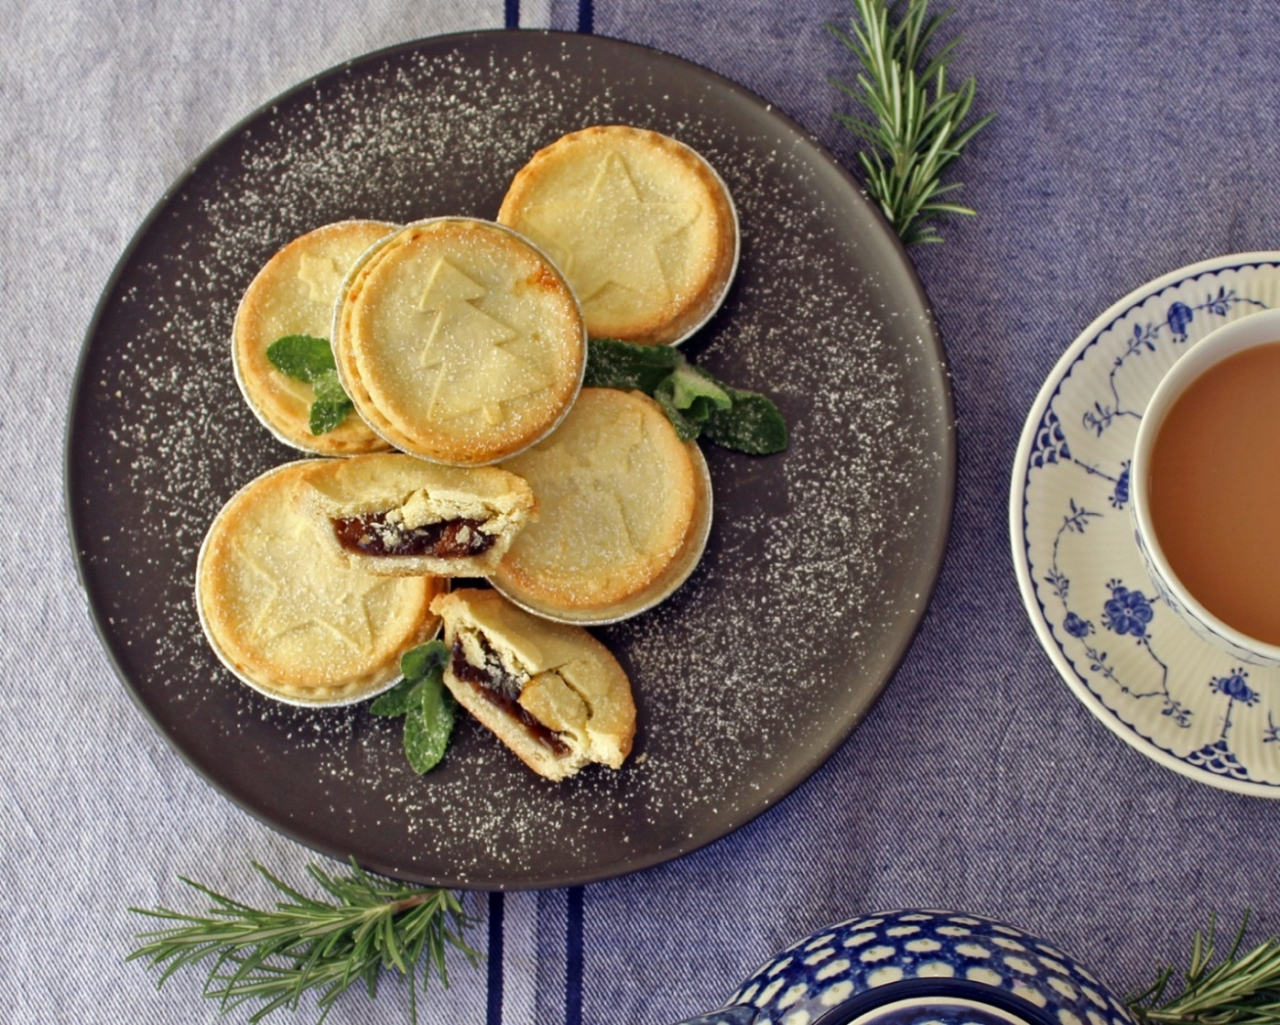

Christmas Mince Pies Orders

Name ______________________________________________
Delivery Address ______________________________________________
Contact Name: ___________________Tel No: _________________

Name | No of Packs  (6 pies in a pack) | Price  $12 per pack
Total | Packs | $
>> $1.50 per pack will support “End Polio Now” campaign<<

The support of Bread Street Bakery, Hamilton Street, Mont Albert
is greatly appreciated

One payment for the Total Order would be appreciated

Payment made by Direct Deposit into MASH account – see details below
Account Name: Rotary Club of MASH BSB: 633 000, A/c No 123530552
Email orders by 30 November to: david_winter1954@hotmail.com

Thank you for your support!

