Macintosh HD:Users:08289542:Desktop:Teesdale Primary School Logo.pdf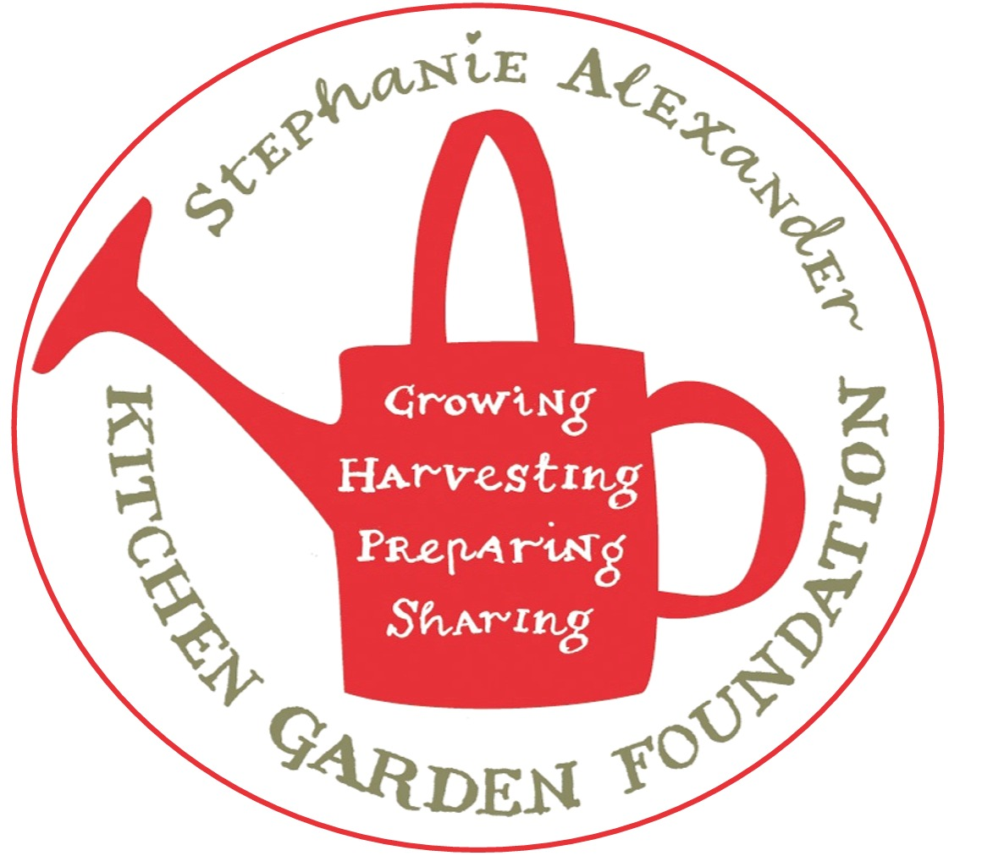

Dear Parents,

During term 3 children from grades Prep/1 Lindsay and Prep Fletcher will commence cooking and gardening classes as part of The Stephanie Alexander Kitchen Garden Program.

The program introduces children to the concept of “fork to plate’ which consists of the children learning the process of raising seedlings, planting and harvesting a variety of herbs, fruits and vegetables.

The children will begin with basic introduction to our school garden and kitchen.

In the garden they will learn about the variety of produce we grow, different ways we harvest, how to use tools and equipment and how maintain our kitchen garden.

In the kitchen we will start with learning about table settings and table manners before moving on to some basic recipes. The children will then get to eat their cooking for morning tea the following morning as part of their snack.

Classes are held on Wednesday afternoons from 2:15p.m.–3:00 p.m. Classes will run in 4 week blocks in the kitchen and 4 weeks in the garden.

We are asking for parents/carer support in the role of volunteering in the kitchen and garden to assist the children in learning new skills and how to safely work in a kitchen/ garden environment. You do not need to be a whiz in the kitchen or a master gardener to assist. If you are able to offer your support as a volunteer, please return your availability to your child’s classroom teacher ASAP. I do not create a roster as such but welcome you to attend any sessions you can.

We look forward to having you share this experience with your child/ren.

Kind regards

Suzanne O’Mealley

Kitchen Specialist

✁ Cut here -------------------------------------------------------------------------------

**Students Name­­­­­­­­­­_________________________________________________________________________**

|  |  |  |  |  |
| --- | --- | --- | --- | --- |
|  | **Kitchen** | Family Name | **Garden** | Family Name |
| **24th July** | Prep/1 Lindsay |  | Prep Fletcher |  |
| **31st July** | Prep/1 Lindsay |  | Prep Fletcher |  |
| **7th August** | Prep/1 Lindsay |  | Prep Fletcher |  |
| **14th August** | Prep/1 Lindsay |  | Prep Fletcher |  |
| **21st August** | Prep Fletcher |  | Prep/1 Lindsay |  |
| **28th August** | Prep Fletcher |  | Prep/1 Lindsay |  |
| **4th September** | Prep Fletcher |  | Prep/1 Lindsay |  |
| **11th September** | Prep Fletcher |  | Prep/1 Lindsay |  |