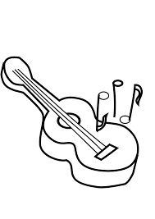
KEYBOARD/PIANO Lessons

Expression of Interest

Dear Parent/Guardian,
New enrolments for Term 1, 2025 and beyond are now being accepted for instrumental lessons at Pascoe Vale North Primary. Please take a copy of this form and fill out your details to express interest in your child enrolling in music tuition. For prompt commencement of lessons please contact Matt on 0401 324 334 or email:
matthew.ericksongtr@gmail.com

Details
Time: Thursdays (limited spaces available)
Cost: $20 per 30min session (group sessions)
$40 per 30min/$27 per 20min session (individual lesson)

All lessons are held at school. Lessons run weekly and are charged on a per term basis.
Regards,
Matthew Erickson (BMus,Dip.Ed)

Child’s name: Grade/Year Level:

Parent/Guardian’s name:
Teachers name: _______________________________________

Email: Phone:

