

**O9/03/2024**

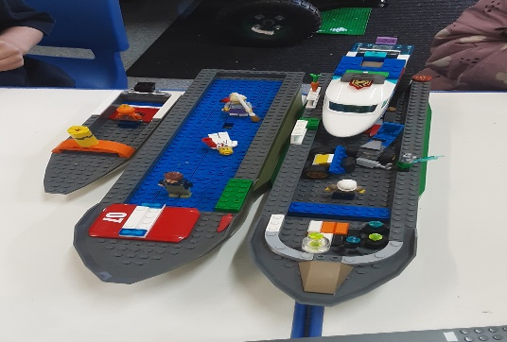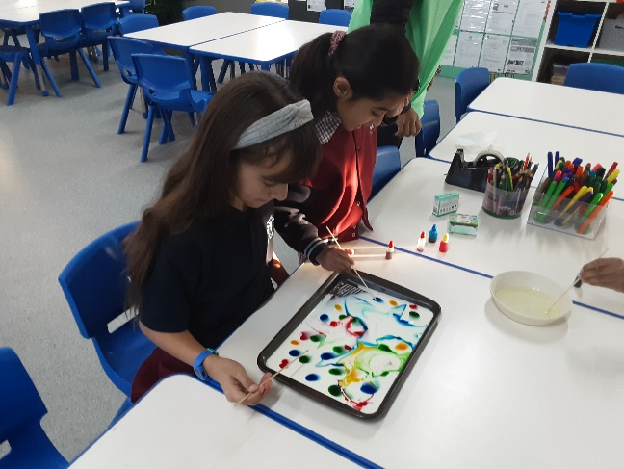[](https://pp.campaustralia.com.au/)

**A message from your Coordinator**

Rocketeers starts after Easter Break, with an awesome trip to Melbourne Zoo to learn and explore the life of animals in our wild and undersea adventure. Visit the butterflies in the Avery, and understand how gentle we can be handling them . We are also going to the Melbourne Soccer Ground to visit and meet the players and bring home many memories and skill learnt from the Coaches and the skill share with us on the day.

* Ice Cream Making
* Country Flags
* Foam Block Construction

**Activities coming up**

Figure

Figure

Join in the fun of Outside School Hours Care activities and experiences with Your OSHC and Rocketeers.

**Make a booking**

Book now

**Oatlands Primary School OSHC**