Working as a General Assistant handbook
Table of Contents
1 What’s in your handbook? 4
1.1 Purpose 4
1.2 Finding what you need 4
1.3 Links and web address information 4
2 Joining your team 5
2.1 About school and school staff 5
2.2 Role description for a General Assistant 5
2.3 Code of Conduct 7
2.4 Statement of ethics 7
2.5 Mandatory training 9
2.5.1 Mandatory training for schools 9
2.6 Induction 9
2.7 Questions for a General Assistant to ask on entry of duty [new and relieving] 10
2.8 Employee Self Service in SAP (accessing payslips, leave, payment summaries) 12
2.9 Performance Development Plans (PDPs) 13
2.10 MyPL and accessing professional Learning 17
3 Information to do your job 18
3.1 Working within the school team 18
3.2 Working in the presence of students 18
3.3 Work Practices 19
3.4 Record keeping 21
3.5 Managing resources 21
3.6 Asset management plan 22
3.7 Orders 22
3.8 Receiving and distributing stores 22
3.9 Stocktaking 23
3.10 The write-off and disposal of assets and equipment 23
3.11 Servicing plant, machinery and equipment 24
3.12 School Infrastructure NSW (formerly Asset Management Directorate) 24
3.13 Maintenance of school grounds and landscapes 26
3.14 Maintaining crops and grassed areas 27
3.15 Agricultural chemicals 29
3.16 Companion planting 31
3.17 Integrated weed management 32
4 Additional information 37
4.1 Site visitor log book 37
4.2 Compliance contracts 37
5 Keeping you and others safe 39
5.1 Health and safety 39
5.2 Risk management 41
5.3 Safety alerts 42
5.4 Safe working procedures for General Assistants 44
5.5 What is STRETCH? 46
5.6 Vehicles on school grounds 46
5.7 Working at heights 47
5.8 Personal protective equipment 47
5.9 Manual handling 48
5.10 Chemical safety 49
5.11 Sun safety 49
5.12 Working alone 50
5.13 Emergency management 51
5.14 Incident and injury management 51
5.15 Staff wellbeing 52
5.16 Cruelty to animals 52
5.17 Electrical hazard 54
5.18 Bushfire planning and response 56
5.19 Control and management of asbestos in the workplace 56
5.20 Professional Learning Non-Teaching Staff (PLNTS) course catalogue 57

- What’s in your handbook?
- Purpose
This resource is intended for the use by General Assistants (GA) working in government schools. It provides useful reference material for both newly appointed GAs and experienced GAs. It is also intended as a guide for other staff in the school regarding the roles and responsibilities of the GA.
- Finding what you need
- Browsing – You can browse the table of contents to see what topics are covered
- Searching – Use Ctrl + F on your PC keyboard (Command + F on a Mac) to open the Find window and type in keywords.
- Links and web address information
- Hyperlinks
This document contains many hyperlinks (a word or phrase in blue text and underlined) that you can click on to jump to a web page or another section in this document.
Back to top of the document

- Joining your team
- About school and school staff
In New South Wales (NSW) around two-thirds of all school students attend government schools. Pre-schools, primary schools, central schools, high schools, colleges and specialist schools provide a range of learning environments to cater for individual student needs.
Schools employ both teaching and non-teaching staff. To support the enhancement of teaching and learning, schools utilise a vast range of resources that align to the curriculum and the whole-school plan. Assets such as buildings, classrooms, halls, playgrounds, fields, gymnasiums, sporting equipment, furniture, machinery and equipment all contribute to improving student learning outcomes.
GAs are employed in all government schools in NSW. They undertake a vital role in supporting the principal and staff in the functioning of school activities and in monitoring and maintaining a range of school resources.
- Role description for a General Assistant
The role description for a General Assistant can be found at in the School-based role description library, in the Human Resources website.
Here are the key sections for your convenience.
- Primary purpose of the role
Performs a range of tasks relating to the routine maintenance and upkeep of a Departmental school/grounds. The role may assist with the set-up and removal of furniture and equipment for school activities. The range of duties performed at the school will be dependent upon the time allocation of a General Assistant to the school.
- Key accountabilities
A General Assistant may be required, subject to Workplace Health and Safety obligations, to perform duties from the range listed
- Organising rooms, furniture, audio visual aids, public address systems, lockers and other items/equipment for school activities as required; dismantle and store items when not in use (with assistance where required). (NB. the role is not responsible for operating audio-visual equipment or public address systems)
- Identify and report maintenance / safety issues to the role supervisor; undertake minor maintenance of buildings and equipment not covered by contracts or requiring a qualified tradesperson
- Maintaining and caring for school grounds, including: mowing school lawns and playing fields; marking of school playing fields; preparation of ground for planting trees and shrubs and planting and watering of same; pruning shrubs, trimming hedges, light lopping and trimming of trees. Safely and proficiently operate mowers, tools and equipment; store and maintain mowers, tools and equipment in accordance with WHYS standards.
- Unpack, store and/or distribute supplies in accordance with school procedures and safe work standards (e.g. chemical storage and handling); assist with school stocktakes as required
- Monitoring school security systems and reporting faults to the Principal or School Teaching Executive
- Other related duties of the role, within the capabilities of the General Assistant, as directed by the Principal or School Teaching Executive.
- Key challenges
Working cooperatively with the role supervisor to prioritise upcoming tasks • Responding flexibly to competing / emerging minor maintenance priorities • Maintaining cooperative relationships with teaching and non-teaching staff.
Any questions you have about your role should be raised and clarified with your principal or supervisor.
Specific enquiries about conditions of employment can be directed to EDConnect on telephone 1300 32 32 32.
Crown Employees (General Assistants in School – Department of Education) Award and Crown Employees (Public Service Conditions of Employment) Reviewed Award
- Essential requirement
Valid Working with Children Check clearance
- Code of Conduct
The Code of Conduct clarifies the standards of behaviour that are expected of NSW Department of Education (DoE) staff in the performance of their duties and provides guidance in areas where staff need to make personal and ethical decisions. This Code of Conduct applies to all employees of the DoE, whether employed on a permanent, temporary or casual basis.
It is important for you to read the Code of Conduct (PDF, 932 KB) during your induction period. The document is located in the Code of Conduct Policy web page in the Policy library.
- Statement of ethics
The DoE is committed to improving the social and economic wellbeing of the people of NSW through the provision of high-quality services to the community. As employees of the DoE, we have significant influence in developing an informed, dynamic and democratic society by providing experiences that inspire and facilitate personal development.
We can do this by creating inclusive and welcoming communities and workplaces and by promoting an organisational culture of innovative thinking and continuous self-development. The values that underpin our work include fairness, respect, integrity and responsibility.
We demonstrate these values in our daily work by:
- providing quality services whether in the community or the classroom
- being consistently honest, trustworthy and accountable
- being courteous and responsive in dealing with others
- being committed to social justice by opposing prejudice, injustice and dishonesty
- making decisions that are procedurally fair to people and which avoid discrimination, for example, on grounds such as gender, race, religion and culture
- promoting dignity and respect by avoiding behaviour which is, or might reasonably be perceived as, harassing, bullying or intimidating
- maintaining professional relationships with:
  - clients, customers and members of the public
  - students and young people
  - parents and carers
  - colleagues
  - business partners
- working collaboratively with colleagues to reach our common goals
- maintaining and developing our professional and work practices
- acknowledging our stakeholders as partners in our work, and
- behaving in ways that advance vibrant, sustainable, inclusive and responsible communities across NSW.

- Mandatory training
- Mandatory training for schools
All staff must complete a range of mandatory training to comply with departmental and legislative requirements. Mandatory training is required when staff enter the department as part of the induction process and on an ongoing basis throughout employment. This applies to all permanent, temporary and casual staff, both school-based and non-school-based.
The Mandatory training for schools web page contains up-to-date information about what mandatory training.is required, how it can be accessed, when it is required to be completed and its timing.
For additional information you can also refer to the School Staff Training Guide Jan 2020, available on the MyPL home page.
- Induction
Induction is a process in which a new employee is introduced to their school or work environment within the department. This includes the provision of essential information for them to be successful in their new role.
The online NSW Department of Education induction program includes information on department’s strategic plan, mandatory training and a welcome and orientation module. The program is for new teaching and school based staff.
- School based non-teaching staff induction learning plan – all classifications
In addition to the department’s induction program, the PLNTS team has developed a school based non-teaching staff Induction Learning Plan for each classification. The learning plan includes live and anywhere/anytime (recorded) professional learning.
Professional Learning Non-teaching Staff (PLNTS) induction web page.
- Questions for a General Assistant to ask on entry of duty [new and relieving]
Questions Relevant to the School | Answer
Who is my supervisor?
How do I get access to the staff portal?
Who do I contact if I need to reset my password or have technical issues?
How many staff work in the school? What are their roles?
Who and how do I contact if I am sick?
Where are the teaching timetables so I can manage my duties around it?
Can I have a list of staff and their responsibilities?
What are the procedures for staff leaving the school before school starts or arriving late or leaving during the school day?
Who are the executive staff and what are their roles?
How do I access buildings and technology? What codes do I need?
What keys will I be allocated and who else has a copy?
What are the procedures for before and after-hours access?
Is there a staff uniform or identification badge?
Where can I locate the school’s procedures for an emergency – evacuation, bomb threat, fire, lockdown, suspect package? Who is my first point of contact?
Which school policies do I need to read first? E.g. Code of Conduct
How do I get access to the mandatory training for Departmental employees? When will I complete this?
How is the school day organised? What are the school hours? Opening, closing, morning tea, lunch?
How does the school communicate “bell times”? Bell, buzzer, music, loud speaker?
Is there a staff daily bulletin? How do I access it?
Is there a map of the school I can access?
Do I have a designated car park?
Is there a staff lunch room I can access?
Who do I speak with about training/professional development opportunities?
These questions may assist you to settle into your new role quickly and smoothly. You may wish to include additional questions. As you respond, tick the appropriate box.
You may wish to discuss questions with your principal (or delegate), head teacher Technology and Applied Sciences (TAS), agricultural teacher or school administrative manager (SAM).
Questions Relevant to the Role | Answer
How do I access my personal protection equipment that I require for the position?
Where is the chemical register and other safety registers and processes kept?
What are the procedures for purchasing or ordering supplies and consumables, for example petrol, tools, etc.
What major plant equipment does the school own? For example, tractor, ride-on mower
Where are the GA tools stored?
Do we have preferred local suppliers for equipment maintenance?
Is there a set/agreed time that I meet with the principal or supervisor regarding weekly duties and to discuss issues as they arise?
Is there a preferred internal communication method for outstanding maintenance jobs to be completed?
What is the process if I am injured at work or there is an incident or near miss in the workplace?
Who do I report to when my supervisor is away?

Oher Questions | Answer
- Employee Self Service in SAP (accessing payslips, leave, payment summaries)
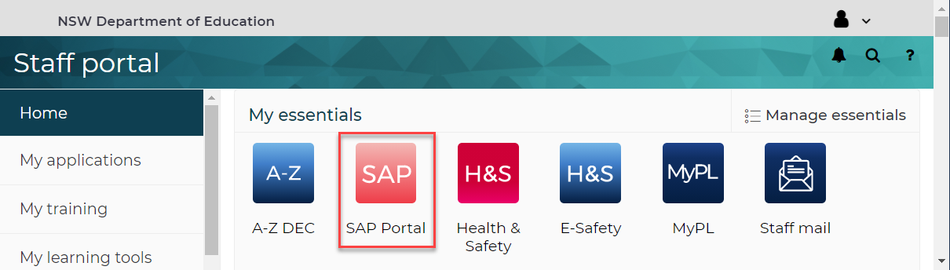
Employee Self Service is available to all DoE employees. This includes school and corporate employees that are casual, temporary and permanent.
Employee Self Service can be accessed via the SAP Portal (New) icon on the staff portal page.
It enables an employee to view and action leave related information including:
- create and submit leave requests for approval
- check leave request status
- change dates of a leave request
- cancel leave requests
- display leave history
- check and forecast leave balances.
- view unauthorised non- attendance (absences) which are pending a leave request to be submitted.
- employees are also able to access and print pay slips and payment summaries at their own convenience.
By selecting the Personal Information link, employees can update personal details including:
- email,
- home and mail address,
- emergency contacts and main bank account.
- update Working With Children Check information
- Casuals Short-term temporary GAs
Short term temporary GAs are employed for a period of one school term or less. Employee are paid fortnightly, based on an approved timesheet entered into the SAP system. A short-term temporary GA has one timesheet even if the work in more than one school. Each school has their own process for managing casual timesheets.
Contact your supervisor or the School Administrative Manager (SAM) to ensure you are clear on the process.
- Performance Development Plans (PDPs)
The Human resources website contains valuable information about PDPs.
The performance and development process for non teaching staff in schools supports our commitment of developing a skilled, engaged and professional workforce to ensure better outcomes for our students.
Non-teaching staff in schools are valued members of the school and this process will enable them to have meaningful conversations about their performance and development.
The performance and development process ensure that we:
- have clear work goals and understand what is expected of us
- have the opportunity to identify and work towards career goals
- engage in meaningful conversations about our work and development to support staff to be the best they can be
- receive fair and regular feedback about how we are performing
- are recognised for our contribution to the school
- build a strong focus and commitment to our student and school outcomes, with work goals aligned to the school plan and priorities.
There are three phases in the performance and development process:
- Plan (PDF 116.3KB) for the year ahead - setting and clarifying expectations, identifying work and career goals, and preparing the PDP
- Implement (PDF 100.59KB) the actions and development to achieve goals identified in the PDP
- Review (PDF 108.22KB) work performance and development against the goals identified in the PDP
The Human Resources, Performance - Non teaching staff in schools e-Learning page contain e-learning modules that will support you in exploring the performance and development process.
They are available for all non-teaching staff to gain a better understanding of the process and benefits of Performance Development Plans (PDPs). This takes approximately 60 minutes.

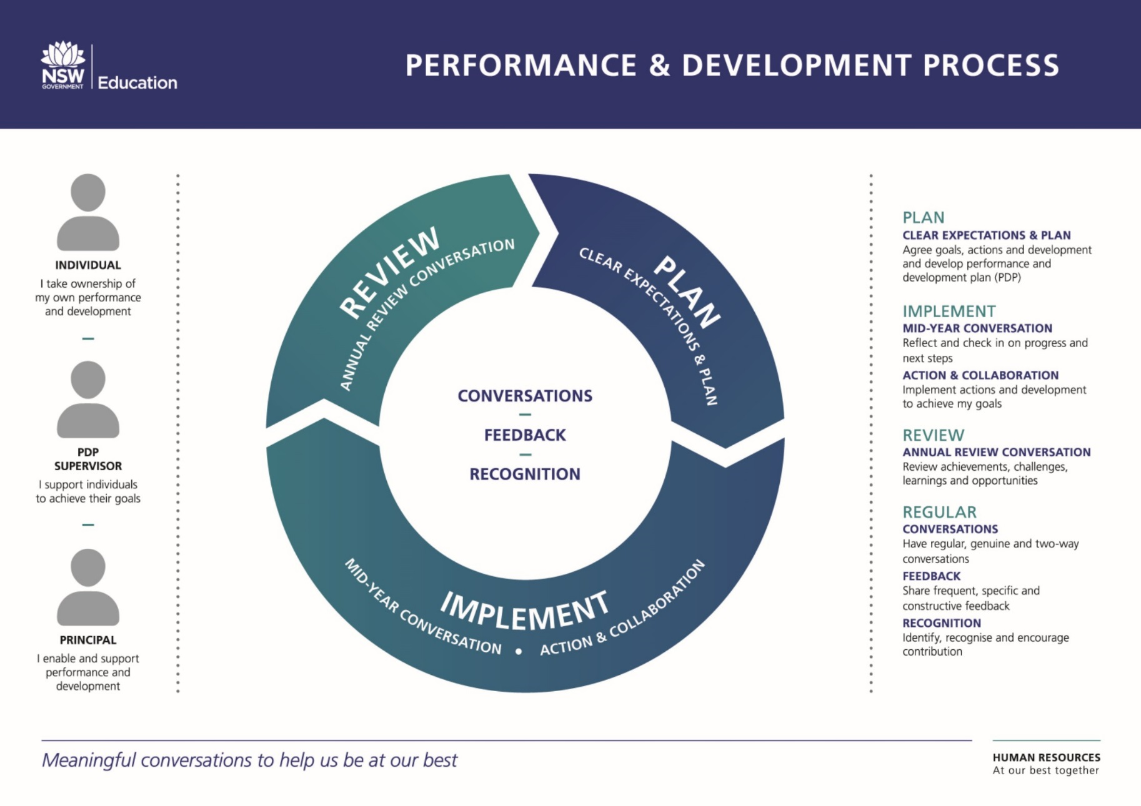
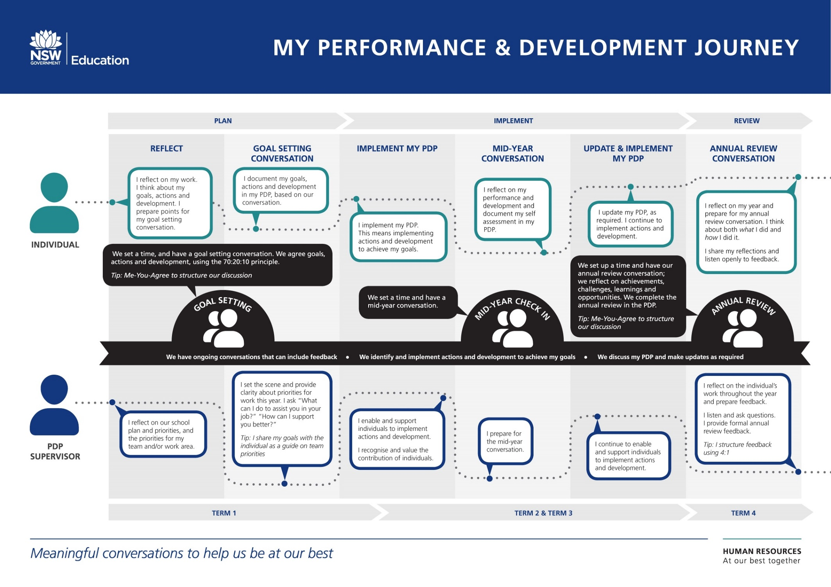
- MyPL and accessing professional Learning
The MyPL website contains information about the MyPL system access, support and the types of courses available..
The MyPL system allows all staff within the Department of Education to manage their professional learning. It is available in the DoE staff portal.
Staff can browse Professional Learning courses being offered, register for courses and keep a record of their professional and mandatory learning.
Back top of the document

- Information to do your job
- Working within the school team
While you are likely to work independently in much of your day to day work, you remain an integral team member within the school environment. Other members within your team will include your supervisor, the principal and school executive, teachers, school administrative and support staff and other non-teaching staff in schools.
In teams that work well together, members communicate effectively and interact cooperatively. Wherever possible, take the opportunity to participate in team meetings and to meet with your other team members.
Your principal has a responsibility to ensure you receive training in the safe use of machinery and equipment. In return, you have a responsibility and a ‘duty of care’ to safely operate such equipment in accordance with the supplier’s instruction manual.
As a staff member, you must also be familiar with general school organisation and routines. These include bell times, procedures for signing on and off, arrangements for emergency evacuations, the layout of the school, and the location of other staff impacting on your work.
- Working in the presence of students
Many of the tasks undertaken by a GA are indirectly related to supporting and enhancing the students’ learning environment.
It is important to remember that GAs do not teach students, nor should they be left responsible for the control or discipline of students. This is the role of a teacher.
However, you must support other staff in ensuring that students are not placing themselves in potentially dangerous situations where injury may occur. This is a part of your ‘duty of care’. Similarly, you must assist where possible, within the bounds of your duties, to ensure that the security of the school’s grounds, buildings and physical resources are not breached.
If you have any questions about working in the presence of children be sure to raise these with the principal or your supervisor.

- Work Practices
The work undertaken by a GA is integral to the efficient and effective functioning of the school. By effectively managing routines, GAs work in close consultation with their supervisor.
Once you become familiar with how your school operates, you will be better able to predict the flow of regular tasks and to establish your own personal work schedule. Remember that work practices and routine tasks may vary from school to school.
It’s important to ensure that your workspaces, such as your room, shed and storage areas are secured to prevent access to tools and hazardous substances, by students and the public.
- Planning and work flow
Planning gives you more control over how you utilise your time in the workplace. One effective strategy is to identify the tasks to be completed along with their associated timeframes. Then prioritise these into your work routine.
Remember that while unforeseen circumstances will often occur, careful planning will help to minimise their impact.
You may also wish to consider the use of a diary. As a work flow tool, a diary can assist you in managing your day to day work and monitoring your progress on larger jobs. Regular tasks tend to be done on a daily, weekly, term or annual basis.
Some examples may include:
Daily Check security systems
Unpack and distribute stores
Set up and put away PA system
Weekly Watering trees and shrubs
Mowing lawns and playing fields
Term Marking playing fields
Set up furniture for examinations
Annual Allocation of student lockers
- Allocation of tasks
Schools differ in the methods used to communicate tasks required. In some schools the GAs are notified of tasks electronically, for example, email or third-party software, whilst other schools use a centrally located ‘task diary or notebook’.
Whichever method is used, you should regularly check so that important tasks do not escape notice.
Some tasks will be communicated orally but will still need to be recorded using the school’s procedures.
- Identifying specific tasks
Your supervisor may consider developing an annual planner, or timetable that lists in specific time order the known tasks that will need to be performed during the year. Examples of tasks for the planner could include scheduled maintenance and also regular jobs, such as lawn mowing.
Remember that a plan should be reviewed at regular intervals and updated accordingly. Regular team meetings will provide an opportunity for such reviews to take place and for decisions to be taken in relation to the work that needs to be performed.
If you are new to your role, take time to familiarise yourself with your annual plan. This helps ensure that you understand the scope and timing of each of the scheduled tasks.
- Putting tasks into priority order
Priorities are determined by considering the deadlines for scheduled tasks against any unanticipated requests or tasks that may have arisen.
You may find it useful to have informal briefings with your supervisor to discuss your current work priorities and the nature of any unanticipated requests.
- Allocating time for task completion
Ensure that you allow sufficient time to finish your work within the scheduled timeframe, being mindful of any preparation time required to complete specific tasks.
It is good work practice to keep your supervisor informed of your progress. Remember to advise your supervisor as soon as practicable if you believe that there are issues that may affect your ability to meet your scheduled work commitments.
It is also good practice to tell the requesting staff member when the task is scheduled (if it is a future task), and when it is completed.
- Record keeping
Schools are accountable for maintaining financial and other types of records. These are regularly examined by the auditors. It is vital that any record keeping related to the work of a GA is accurate, up to date and readily accessible in preparation for audit.
A GA may be required to provide assistance in maintaining relevant records including:
- assets register: records all assets issued within the school and their location
- Services Maintenance and Repairs Register: records details related to contractor site visits and other maintenance undertaken within the school
- Chemical Register: records potentially hazardous substances and dangerous goods, including relevant Material Safety Data Sheets
- Record of Condemnings: lists all accountable items that have been condemned as unserviceable, considered surplus, sold or otherwise disposed of.
Located in the Schools finance website, the Finance in Schools Handbook (FISH) - Section 9 Asset and Equipment Management has further information about record keeping.
- Managing resources
As part of the school planning process, the principal is responsible for allocating budgets to recurrent and consumable items such as fuel, as well as designating a budget for one-off purchases of capital items such as ride-on mowers.
Assets, described as capital items, include the school’s buildings, machinery, equipment, tools, vehicles, scientific apparatus, furniture and floor coverings, to name a few.
If you are unsure as to your responsibility in supporting the management of the school’s assets, stock and supplies be sure to discuss this with your supervisor.

- Asset management plan
The principal is responsible for developing the school’s Asset Management Plan. This plan is prepared utilising information available on the computerised asset management system (AMS).
Access to the AMS on the Web application is provided via the Staff Portal under the My Applications tab.
The AMS on the Web application makes property related details on schools and TAFE colleges available to all DET and TAFE Staff.
The AMS describes the layout and room use for all school buildings and facilities. When referring to a building, or a room, use the numbering as indicated on the school’s AMS plan.
Only approved modifications to buildings and changes to building or room usage may be registered on the AMS by the Asset Management Directorate. If you are viewing the AMS and discover a discrepancy or omission, report this immediately to your principal or supervisor who can inform the regional Asset Management Unit.
The list of contacts for state office and regional Asset Management Units are available by clicking the Contact Us tab.
You may also visit the School Infrastructure NSW website for additional information
- Orders
Procedures for ordering equipment and supplies for maintenance purposes varies from school to school. You should confirm your school’s ordering procedures with your principal or supervisor.
- Receiving and distributing stores
Unpacking, storing and distributing stores delivered to the school are duties often performed by GAs.
As per the GA Role description, duties include:
Unpack, store and/or distribute supplies in accordance with school procedures and safe work standards (e.g. chemical storage and handling); assist with school stocktakes as required
The valuable and often perishable or fragile nature of stores necessitates procedures that ensure safe and secure storage of the items and ease of access by authorised school staff.
It is important to note that any assets received must be appropriately marked as being school property. They must be sighted during the stocktake, and disposed of as required in line with departmental policy.
Note: all school staff must undergo training before handling, storing and/or disposing of hazardous substances.
For information about this training refer to the section Chemical Safety in this document.
Visit the EPA website for further useful information about dangerous goods.
- Stocktaking
As noted in the GA role description, the GA may be required to assist with a school stocktake.
A stocktake of all accountable items of assets and equipment must be performed annually. A stocktake involves the physical sighting of accountable items of assets and equipment and records the results. Typical tasks could include:
- sighting and initialling on the stocktake spreadsheet when an item of accountable equipment has been sighted and is deemed serviceable
- investigating the whereabouts of missing assets
- detailing unlisted items
- updating asset and equipment register spreadsheets as required.
If you are unsure as to your responsibility in the stocktake process be sure to discuss this with your supervisor.
For more information, refer to Section 9 - Asset and equipment management in the Finance in Schools Handbook (FISH) which is located in the Schools finance website.
- The write-off and disposal of assets and equipment
GAs may be required to assist in the disposal of items after a stocktake or as requested by their supervisor.
For more information on disposing of asses and selecting the most apporpriate method of disposal, refer to the Disposal of goods Policy and related links, located in the Procurement website.
- Servicing plant, machinery and equipment
Schools may have service contracts in place for their plant, machinery and equipment. Prior to considering options for repairs to any asset speak with your principal or supervisor, to ascertain whether there is a contract or service agreement in place.
Where servicing and/or repairs are necessary, the asset must be sent to the authorised repairer. Do not attempt to undertake your own repairs as you may invalidate the existing contract or warranty.
The warranty details the context in which an item can be used and defines what is classified as misuse. Be aware that a warranty can be voided if any item is used in a way that is not intended for.
- School Infrastructure NSW (formerly Asset Management Directorate)
All NSW government school facilities cleaning and most areas of maintenance are carried out through a NSW ‘Whole of Government’ contract.
The contract area boundaries are defined by the Asset Management Unit (AMU) areas. Your local AMU can be contacted via 132 779 for any issues relating to maintenance of school facilities.
The maintenance contract includes planned maintenance work, emergency repairs, miscellaneous work and demountable work. The contract provides 24-hour, seven-day-a-week maintenance support. Speak with your principal or supervisor for further information.
Prior to considering options for repairs to any asset speak with your principal or supervisor to ascertain whether it is covered by the contract or there is a service agreement in place.
If you have any questions about the items included in, or excluded from the contract, discuss these with your principal. He or she can seek clarification from the regional Asset Management Unit with respect to any buildings or facilities within the school currently excluded from the contract and, as necessary, discuss with your alternative maintenance arrangements.
Where servicing and/or repairs to an asset are necessary, the authorised repairer must be engaged to complete the work. Do not attempt to undertake major repairs as you may invalidate the contract or an existing warranty.
Note: That your Principal or their delegate using the FM Web system will log any urgent, essential repairs or maintenance to building or building services. The Principal may delegate this function to you as GA.
For more information about maintenance and service contracts, refer to the School infrastructure NSW, Procurement and contracts intranet site.
- ChemWatch contract
For information about the ChemWatch Contract refer to the School infrastructure NSW, website:
- School Infrastructure NSW
- Procurement and contracts
- Compliance contracts
- ChemWatch.

- Maintenance of school grounds and landscapes
The management of the local environment and school grounds is an important aspect of Department policy. Well-designed and maintained school landscapes play a role in providing a positive environment for students, staff and the community.
In this regard, the GA may be responsible to the principal for:
- preparation of ground for the planting of trees and shrubs and planting and watering of same
- pruning shrubs, trimming hedges, light lopping and trimming of trees
- mowing school lawns and playing fields
- general ground and garden maintenance.
For information about Landscaping for thermal management refer to the webpage:
- School Infrastructure NSW
- School design, environment sustainability and property services
- Environmental sustainability
- Thermal management.

- Maintaining crops and grassed areas
- Watering
Across NSW, there are a large number of Local Water Utilities and two metropolitan water utilities: Sydney Water and Hunter Water.
These utilities are responsible for providing water supply to communities and for setting and monitoring any restrictions on water usage.
The NSW Department of Planning, Industry and Environment’s water information page includes up to date information about water restrictions and the conservation of water.
Your school may be issued a water exemption certificate from the local water utility. Any questions you have about water restrictions, as they apply to your school, should be raised and clarified with your principal or supervisor.
Keeping lawn plots green requires a large amount of water. Many lawns however only require a regular deep water during their growing season. One deep soaking per week allows the soil to dry out enough to reduce the risk of fungal infection, encourages the growth of a deeper root system and improves drought tolerance.
In some climatic areas, grasses naturally lay dormant in winter. In other areas they may lay dormant in summer and brown-off. Not wasting water to maintain an out-of-season green lawn is just one water wise practice you can adopt.
Other ‘water wise’ tips include:

- turning off taps tightly and fixing dripping taps
- water in the cool of the day
- using hose sprays with a trigger control
- installing automated tap timers or systems – one forgotten sprinkler can waste 1000 liters of water an hour.
Sprinklers vary in design and use. Set sprinklers are deployed below ground and pop up under pressure. They are connected to special irrigation hose or piping. Moveable sprinklers are placed manually and are often connected to a garden hose. A rose shower is fitted to a hand-held hose and is suitable for hand-watering purposes.
Water management information can also be located at:
- School Infrastructure NSW
- School design, environment sustainability and property services
- Environmental sustainability
- Water management
- The benefits of mulching
Mulching helps to insulate the soil, reduce evaporation and conserve soil moisture. This reduces the need for watering and provides a cooler root system for plants. Additionally, mulching suppresses weed growth and weed-seed germination.
The mulch you choose will depend on the availability and cost of suitable material, the type of plantings being mulched, aesthetics, and local climatic conditions. For example, while water-absorbing mulches such as paper, straw or un-composted lawn clippings are relatively inexpensive and readily available, they can cause problems in a hot dry climate.
Organic-based mulches break down and add goodness to the soil. Consider chipping and recycling pruned vegetation for use as mulch. Materials such as wood and palm frond chippings, tea-trees, and sugar cane can all be suitable. However, do not use any weed species for mulch as this may result in further weed infestation.
Mulch material that has not been composted can cause short-term nitrogen loss from the soil beneath. As bacterial microbes use available nitrogen to aid in decomposition of the mulch above, nitrogen in the soil is depleted.
Composted pine bark mulch does not have this problem. Any yellowing of a plant’s leaves that is caused by nitrogen or a nitrogen deficiency can be relieved by the use of liquid fertiliser containing nitrogen.
Organic mulches have the added benefit of adding life to the soil but can generate humidity. Australian plants, especially ‘dryland’ species, benefit from a reduction in the humidity generated by organic mulches.
Contrasting colours of mulch can look effective, such as composted wood-fibre spread around plants beside a path of red gum chips, although over time the mulch colour will fade.
- Mowing grassed areas
As a guide, lawns should be cut to a height of 4–6 cm every week during the growing season. Alternatively, mow lawns as necessary but to a recommended height where no more than one third of the grass is removed. This practice, coupled with regular deep watering, encourages the grass to develop a deeper, more extensive root system thereby improving drought tolerance.
Mower blades should be checked prior to mowing to ensure they are safe and sharp. Dull blades tear the grass rather than cutting it clean. This damage can lead to excessive water loss and the risk of disease.
Line trimmers, may be powered by petrol or electricity. In both types the cutting line is the part that needs to be replaced most regularly.
Read and familiarise yourself with equipment operating manuals prior to use and advise your supervisor if repairs or servicing are necessary. Do not attempt to undertake your own repairs as you may invalidate an existing warranty or contract.
- Agricultural chemicals
Agricultural chemicals are toxic substances, the four most common types being:
- fertilisers
- herbicides
- insecticides
- fungicides
Remember that all school staff must undergo training before handling, storing and/or disposing of hazardous substances.
Specific information on the use of agricultural chemicals in schools in contained in:
- Chemical safety in schools Section 3: Curriculum support document
  - 3.3: Technology and applied studies (TAS)
  - 3.3.4: Information about common dangerous or hazardous activities
  - 3.3.4.3 Agricultural chemicals.
The Chemical safety in schools (CSIS) webpage contains detailed information all chemicals and is located at:.
- School Infrastructure NSW
- Compliance and safety
- Chemical safety in schools
General information on working safely with hazardous substances and the use of personal protective equipment is summarised in the Health and Safety section of this document.
- Fertilisers
Understanding the use of fertilisers is essential for soil improvement. A complete fertiliser will contain the following elements:
N = Nitrogen: develops foliage
P = Phosphorous: encourages root development and food storage
K = Potassium: encourages flower and fruit production.
Fertilisers may be classified as either organic or chemical.
Organic fertilisers are natural products. They improve impoverished soil by adding organic matter and nutrients to the soil, with some also assisting in the retention of soil-moisture. Examples include composts, blood and bone, manures and fish emulsions. It is important to note that if used individually they tend not to provide the full range of elements, however complete organic fertilisers are commercially available.
Complete chemical fertilisers on the other hand release elements at pre-determined temperature and moisture levels and offer predictable results. However, they do not improve the structure or moisture retaining qualities of soil and can sometimes affect its pH level.
Thrive® is an example of a commercially available water-soluble fertiliser. An advantage of using this type of fertiliser is that it can be applied directly to the plants in the soil. This gives an instant effect and it is possible to see quick results.
An example of a dry, slow-release fertiliser is Osmocote®. When adding any dry fertiliser to soil firstly rake away the mulch then rake the fertiliser into the soil prior to repositioning the mulch.
Whatever type of fertiliser is used, be aware that it will accelerate the breakdown of the soil’s organic matter. Soil without organic matter becomes lifeless. Adding compost, seaweed or any organic material that rots is one way of counteracting this effect.
In warm climates, compost is usually ready to be used after approximately two months, while in cooler climates composting may take four to five months. When maintaining a compost heap, or a compost bin, it is important to:
- locate the compost heap, or compost bin, away from students’ playing areas
- turn the contents over at least once a week to encourage the process of decomposition
- test the compost with a soil kit to determine pH level.
- Pesticides
The term pesticide is generic and includes herbicides, insecticides and fungicides. In NSW, the Pesticides Act 1999 (amended 13 May 2015) requires the users of registered pesticides to strictly follow the approved label or permit directions.
The EPA regulates the safe and correct use of pesticides in NSW, from the point of sale, under the Pesticides Act 1999 and the Pesticides Regulation 2017 to protect the environment and community.
Product packaging labels provide details of the pesticide’s active ingredients and other chemical constituents. Other labelling information includes application rates, relevant withholding periods, and waiting time between each application.
Pesticide companies can supply information regarding the correct application of products and most major companies have websites with labels, safety data sheets and technical information about their products.
Herbicides can be an important tool for managing weeds. Many modern herbicides are highly selective, effectively controlling only specific weeds, leaving other plants unharmed.
Insecticides and fungicides fall into two main categories:
- Contact poisons work by directly hitting the pests or disease.
- Systemic poisons work their way through the entire plant so it becomes toxic to the pest or disease.
Insecticides can also control insects such as caterpillars or slugs that feed on plants, via stomach poisoning.
All pesticides (and veterinary medicines) must be registered with the Australian Pesticide and Veterinary Medicines Authority. This website lists all registered agricultural and veterinary chemicals (and also those removed from registration) with their conditions of use.
- Companion planting
It is also possible to use plants to help manage pests. Often referred to as companion planting, this process maintains garden health and encourages biodiversity.
Some pest controlling plants repel or confuse insects owing to their strong scent. Examples include sage, thyme, oregano, lavender, basil and scented geranium.
Other plants such as elder, dill and fennel have flowers or foliage that attracts beneficial insects that prey on damaging insect pests.
For further information about companion planting visit the Sustainable Gardening Australia website.
- Integrated weed management
Integrated Weed Management combines the use of biological controls, cultural practices, and mechanical and chemical controls to manage weeds in such a way that health and environment risks are minimised.
For further information about weed management visit the following websites
Environmental Protection Authority - Pesticides – NSW overview
Weeds in Australia (Australian Government, Department of Water, Agriculture and the Environment).
Back to top of the document

- Preparation for planting
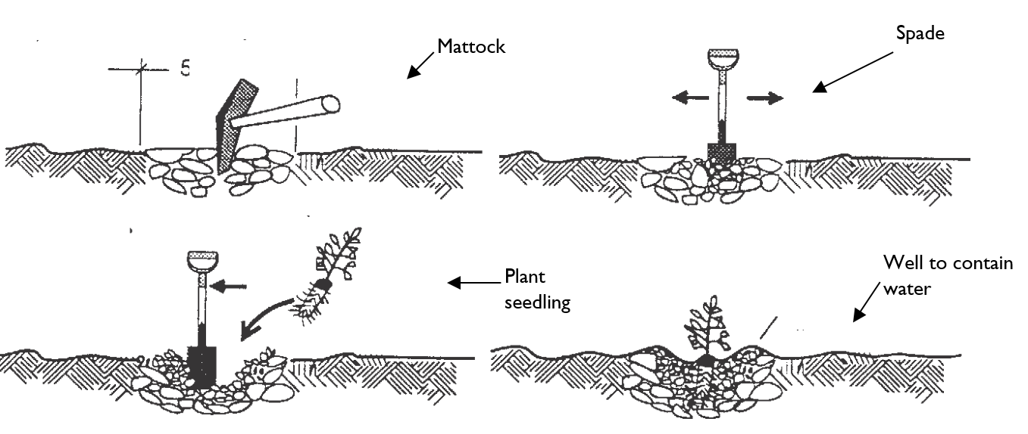
- Using a mattock or spade, turn the soil over as much as possible, breaking down any large clods. Heavy clay soils can be improved with the addition of gypsum, or in the case of acidic soils, dolomite. These products help break up the soil making it more friable. Sandy soils on the other hand are improved with the addition of rotting organic matter such as compost, and Bentonite clay to help retain nutrients.
- The planting area should be wider and slightly deeper than the depth of the plant container. For seedlings, it is not essential to dig a hole, rather dig over and loosen the soil, then plant by parting the soil.
- If the soil is very dry, water may be added to the planting area prior to planting. Once planted give each plant a final watering.
- As a general rule you may fertilise immediately using slow release or water-soluble fertilisers. Follow the product directions and apply at the suggested rate and times. Be aware that manures and other strong-smelling fertilisers may attract unwanted animals or insects into school grounds or may cause an adverse reaction in some people.
- Mulch each plant to a depth of between 50 to 75mm. Keep mulch away from contact with the tree stem or rot may occur.
- Control weeds by hand at least during the first year. In the second year, if hand weeding is not possible consider the information in the Integrated Weed Management section of this document.
- Replace any failed, stunted or damaged plants.
For further information about soil preparation and general plant care visit the ABC Gardening Australia website.
- Pruning and lopping
Every tree has its own individual shape. Heavy pruning or lopping often destroys the shape of the tree and may be totally unnecessary. However, it is important to prune out dead and diseased branches.
Discuss with your principal or supervisor the need to conduct lopping or pruning of trees and shrubs. Such discussions should occur prior to any lopping taking place as it may be necessary in certain instances to engage a contractor for this purpose.
Some shrubs, hedges and small trees, in particular fruit trees, do need to be pruned regularly. It is a simple and effective method of keeping plants healthy and productive. The reasons for pruning may include to:
- encourage flowers and improve fruit bearing
- remove diseased or weak wood
- direct and control the vigour of plants.
There is a wide variety of tools varying in size and function available for pruning purposes. Secateurs are small, easy to use and have a safety catch for when not in use. Long handled secateurs give a more powerful cut as a result of their greater leverage and can be used to cut relatively thick branches. However, as the branches get thicker a pruning saw may be required.
Whatever pruning tools you use, ensure that they are cleaned and lubricated both before and after use. This will help minimise the spread of fungal and other diseases from plant to plant.
Pruning techniques will be dependent upon the plant type that is being pruned. Take the case of Australian natives. In the wild the native plant is reduced by fire, animals, poor soil and drought. In the garden, it is pruned for shape and to get a better flower. In general, pruning is done when the plant has finished flowering and is ready to shoot out lateral growth.
Bush roses, hydrangeas, hibiscus and camellias are among the exotic plants that respond well to pruning. Pruning exotics to a simple structure, and in the appropriate season, liberates the plant allowing it to shoot freely and flower prolifically into the next season.
Winter is the best time to prune deciduous fruit trees such as apples, pears and stone fruits. These trees will fruit well whether or not they are pruned, but if the trees grow too tall the fruit is high and hard to reach. When there are unproductive wood fruit trees don't tend to crop reliably.
Chainsaws should never be used without formal instruction/training.
Refer to the Chainsaw (Electric) safe operating procedure (PDF 102.9 KB).
- Environmentally friendly controls
Inorganic chemicals can often cause unintended problems in gardens. They can affect beneficial micro-organisms in the soil and can kill pollinators such as bees.
Over the past twenty years there has been a cultural shift away from using toxic agricultural chemicals. A good example is snail baits. In the past, snail pesticides contained metaldehyde, a stomach poison, but nowadays you can obtain an organic form containing an Iron EDTA complex which interferes with the calcium metabolism in the gut of slugs and snails, causing them to stop eating.
Horticultural oils are one of the most effective controls for a broad range of sap-sucking pests. They are organic and effective to use. These oils work by blocking the breathing pores of insects. They are effective for controlling a range of pests, including aphids, scale, mealy bug, caterpillars, young grasshoppers, mites and their eggs.
What makes these oils so effective is that they suffocate the insects rather than poison them. Naturally, no insect will ever develop resistance to horticultural oils because they all need to breathe. However, it is important to note that the pest must be completely covered with the oil, and that timing of application must coincide with activity of the pest.
Most pests have natural enemies known as biological control agents. Encouraging beneficial insects requires identifying the insect pest and matching it with its control agent. The control agents have evolved over time to seek out a host and feed on it, thus controlling the population. There are two types of biological control agents: predators and parasites.
Predators include ladybirds, lacewings and praying mantis. They feed on their host to complete their development. Parasites include tiny wasps and some flies. They are powerful biological control agents because they lay eggs onto or into specific pests, and when the larvae emerge they eat their host and use it to continue their development.
For further information about pests and biological controls visit the following websites:
CSIRO – About Insects
Biological Services
Green Harvest- Organic Pest Control
Green Harvest Organic Pest Control / Fungal Disease Organic Control Information
- Playground equipment
The Department is committed to the health and wellbeing of students. It is essential that the school playground is an area where children can play in safety.
As a GA you may be directed by your Principal nominee or representative to perform minor maintenance on playground equipment.
School playground equipment and impact-absorbing material must be regularly inspected and maintained in a safe condition. Preferably inspections should be made daily before students use the equipment.
Equipment can have been designed, fabricated and installed perfectly but not maintained correctly and may eventually not comply. It is the school’s responsibility to ensure that equipment is maintained in accordance with the manufacturer’s instructions. Injury due to lack of maintenance is possible and must be avoided by ensuring that correct and on-going maintenance occurs.
Manufacturers must supply a maintenance schedule, and advice should be sought from the supplier about the equipment’s maintenance schedule. The schedule should be adopted and a log kept. The school should organise regular inspections to ensure that all fittings remain tight. Written records of inspection should be kept.
Only genuine parts from the manufacturer should be used to replace worn parts on equipment. This is particularly so during the warranty period otherwise the equipment warranty will be voided. Loose impact-absorbing material should be monitored daily for even spread and depth and foreign matter. It should be maintained regularly, e.g. by raking and topping up to maintain a depth of 300mm. loose materials should be regularly checked for hazards.
Any questions you may have about this task should be raised and clarified with your principal or supervisor.
For information about keeping school playgrounds safe refer to the School Infrastructure NSW webpage:
- School Infrastructure NSW
- Compliance and safety
- Fixed playground equipment in schools.
Also refer to the guidelines for the installation and maintenance of playground equipment in NSW (PDF 2320 KB) within the above section of the webpage.
Back top of the document
- Additional information
- Site visitor log book
This register records details related to contractor site visits and other maintenance undertaken within the school. All contractors must sign in and out.
- Compliance contracts
The School infrastructure NSW, Procurement and contracts intranet site contains the list of compliance contracts.
- Industrial arts and VET machine tools supply contract
Schools wishing to purchase and install any new equipment are advised that purchase and machine placement approval must be obtained from the School Infrastructure directorate prior to placing a purchase order.
For information about Equipment safety in schools refer to the School infrastructure NSW, Procurement and contracts intranet site.
- Fire extinguisher contract
For information about the Fire extinguisher contract refer to the School infrastructure NSW, Procurement and contracts intranet site.
- Low level glazing contract
This contract has been established for a period of up to six years to survey schools for non-compliant glazing and undertake the necessary rectification works. This contract upgrades glazing in schools to comply with Australian Standard 1288, mostly by the application of safety film to non-compliant glazing in doors and side panels, and windows below 1000mm. For information about the Low level glazing contract refer to the School infrastructure NSW, Procurement and contracts intranet site.
- Hygienist panel contract (asbestos)
The Hygienist panel contract (PDF 207.4 KB) have been established to ensure fully compliant reporting is achieved for asbestos related issues. A new panel contract has been established and put in place during 2016 for another 3+1+1 years before the existing contract lapses.
- Electrical testing contract
A new contract for the testing of portable electrical appliances (2017-2021) has been established by Property NSW for a period of three (3), with two (2) one (1) year extensions. While the contracts were signed in November 2017. Due to late commencement of contract, contractors began to contact schools in last term of 2017, for testing activities. Schools are requested to provide every support, including access by contractors, to undertake the testing and tagging at your school. For information about the Electrical testing contact refer to the School infrastructure NSW, Procurement and contracts intranet site.
- Residual current devices contract
For information about the Residual current devices contract refer to the School infrastructure NSW, Procurement and contracts intranet site.
- Tree management panel contract
For information about the: Tree management panel contact refer to the School infrastructure NSW, Procurement and contracts intranet site.
- Equipment Safety In Schools (ESIS) Website
The ESIS website is maintained by the DoE and lists plant and machinery used within schools. The website contains guidance notes and usage controls for plant, machinery and equipment. It is essential that before equipment is purchased or used schools must consult this website to ensure its usage is approved and if so what control guidelines are stipulated.
For information on ESIS refer to the Equipment safety in schools website. Can also be accessed via your DoE portal.
Back to top of the document
- Keeping you and others safe
- Health and safety
The Department is committed to providing a safe working and learning environment for all staff, students, visitors and others, with an emphasis on preventing incidents, illness and injury. The Department’s commitments to health and safety and the responsibilities of all staff in relation to health and safety are detailed in the Work Health and Safety (WHS) Policy.
All employees are encouraged to become familiar with its Health and Safety website which is easily assessable via your portal
Any concerns you have about health and safety at your workplace should be raised with the school’s principal, your supervisor, health and safety representative (if applicable) or health and safety consultation committee (if applicable).
Similarly, approach them when you need further information about safe work practices in your school to prevent harm to yourself and others. Any hazards you observe should be immediately reported.
- Health and safety consultation
Effective consultation ensures that health and safety management is of the highest standard.
Under the health and safety legislation, consultation is a legal requirement and an essential part of managing health and safety risks and maintaining a safe working environment. A safe workplace is more easily achieved when people at the workplace communicate with each other about potential health and safety problems and work together to find solutions.
Meaningful and effective consultation means drawing upon knowledge, experience and ideas of employees and others undertaking work and encouraging their participation and input into the improvement of systems for managing health and safety. This enables more informed decisions to be made about how the work is to be carried out safely.
Effective consultation in the workplace empowers employees to resolve many health and safety matters at the local level and they have a greater awareness of health and safety and risk management.
Consultation involves:
- sharing relevant information about health and safety matters with employees and others undertaking work
- providing employees and others undertaking work with a reasonable opportunity to express their views, raise health and safety matters and contribute to the decision making process relating to the risk or hazard
- taking the views of employees and others undertaking work into account
- advising employees and others undertaking work of the outcome of any consultation in a timely manner
- resolving issues in a timely manner
Become familiar with the consultation procedures in your workplace by contacting your principal, supervisor or health and safety representative.
For information on Health and Safety Consultation refer to the Health and Safety website.
- Risk management
Risk management is a four-step process for controlling exposure to health and safety risks associated with hazards in the workplace. The four-step risk management process is depicted in the diagram below, followed by a description of each step.
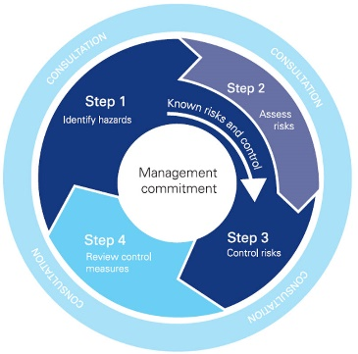
- Step 1: Identify the hazards
The first step in the risk management process is to identify workplace hazards. This means looking for those things in the workplace that have the potential to cause harm
- Step 2: Assess and prioritise the risk
This step involves assessing the likelihood and consequences of injury or illness that may result from exposure to work-related hazards.
- Step 3: Control risks
After assessing the risk and determining which factor(s) have the greatest contribution to that risk, the most appropriate control measure(s) that are reasonably practicable in the circumstances need to be selected and implemented. When selecting a particular control, it is important to be able to justify why it was chosen over a different measure.
- Step 4: Review control measures
The last step of the risk management process is to review the effectiveness of the control measures that have been implemented to ensure they are working as planned. When reviewing the effectiveness of control measures, it is important to weigh up whether the chosen controls are effective or whether they need some modification.
For information on risk management refer the Health and Safety website.
- Safety alerts
Safety alerts contain urgent safety information which needs to be considered in the workplace. Staff are responsible for checking the website to ensure that they have identified and read all safety alerts.
For information on safety alerts refer to the Health and Safety website
- Plant, machinery and equipment safety
Equipment related accidents can contribute to substantial injuries in the work place. Do not operate plant, machinery or equipment without fully understanding and adhering to its Safe Operating Procedures (SOP) and undergoing all necessary training essential for its safe use.
SOP contain the following information:
- personal protective equipment (PPE) that must be worn when operating plant and machinery
- safety hazards and risks identified
- procedures to eliminate or reduce the hazards and risks identified
- any particular additional warning relevant to the particular piece of plant or machinery
- any notes, in particular, if you are to refer to the manufacturers safe work procedures (SWP) for more details
For information on Safe Operating Procedures refer to the Health and Safety website.

- Equipment maintenance
Work health and safety legislation requires employers to ensure that equipment used in the workplace is safe and without risk when properly used.
The establishment of regular inspection and maintenance of equipment assists to reduce the possibility of workplace injury caused by faulty or damaged equipment.
Establish a schedule for regular inspection and maintenance (if required) of fittings and equipment:
- rectify maintenance issues resulting from a health and safety risk as a matter of priority
- checks to ensure that all safety guards are attached and in good order. Check that PPE is in good order and in sufficient quantities for all people participating in an activity
- document all maintenance and repairs on the plant, machinery and equipment inspection log
- establish a mechanism for reporting faulty or damaged items
- remove faulty equipment and tag ‘out of service - do not operate’
- only use licensed persons for repair of electrical equipment
- dispose of, replace or repair faulty and damaged items. Avoid accumulating them as they may create a hazard
- when disposing of faulty portable electrical equipment cut off the power cord before scrapping the item
- include all electrical equipment in the annual ‘test n tag’ process conducted by the DoE
For information on Plant and equipment refer to the Health and Safety website.

- Safe working procedures for General Assistants
The safe working procedures available below have been tailored to a school environment, in particular GAs and farm assistants to provide additional support to the wellbeing of staff in these settings. These resources are available in both a flyer and poster form which can be displayed around your school. Support resources are available from the Health and Safety, STRETCH Manual Handling Program website including
Building maintenance:
- moving furniture and equipment
- setting up furniture
- storage and transfer of goods
- safe carrying and use of step ladders
Grounds maintenance:
- garden equipment
- gardens and plants
Risk management tools:
- sample risk management plan – manual handling
- guidance in completing the risk management plan proforma – manual handling
- checklist for risk assessment – manual handling

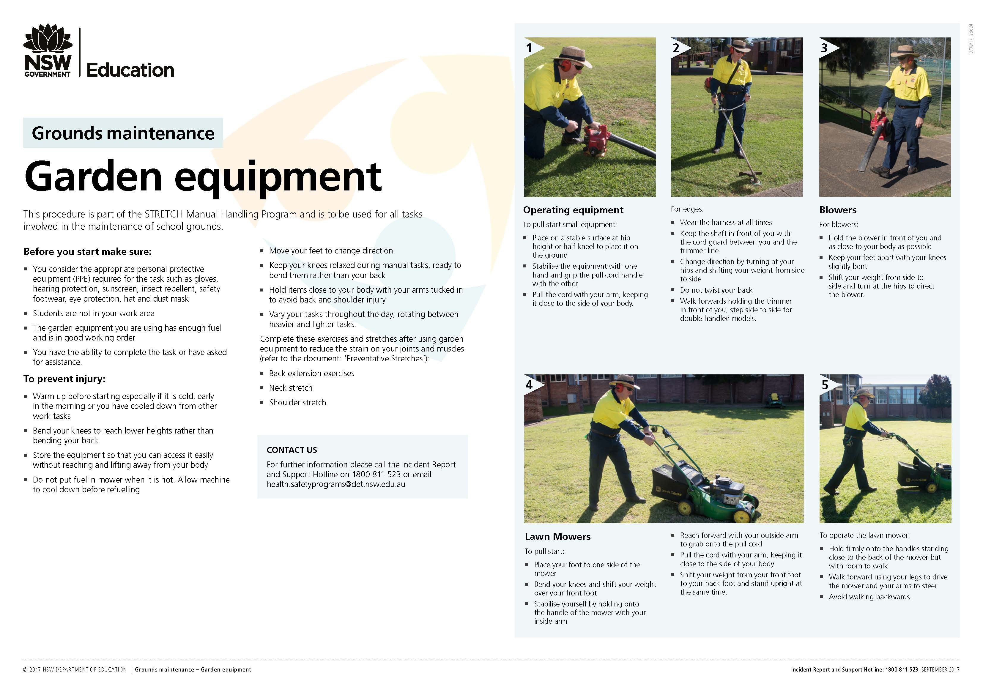
- What is STRETCH?
STRETCH is an easy acronym that has been developed to help you remember the key principles of safe manual handling and to keep you and your colleagues safe in the workplace.
Safe moves for everyone – remember the principles of safe manual handling
Think about the task – plan the task and think about your posture
Retrain your mind – think about your own wellbeing and the things that are important to you like family and being there for your students
Examine your environment and use equipment where appropriate – select the right equipment and make sure you know how to operate it
Talk to your colleagues – ask for assistance if needed and look out for each other
Care about yourself – rotate tasks and carry out stretches throughout the day
Healthier workplace for everyone – our end goal is a happy, healthy and safe workplace
For information on the DoE STRETCH program refer to DoE Health and Safety website.
- Vehicles on school grounds
Employees should take particular care when driving or operating equipment around children. Children are more susceptible to vehicle related accidents because:
- they can be impulsive and have little sense of danger
- their thinking and sensing skills may not be fully developed
- they do not always behave in a consistent or predictable manner
- they may be small and not visible by the machine operator or over a parked vehicle.
For further information on vehicles on school grounds including fact sheets, overview and risk management plans refer to the Health and Safety website.
- Working at heights
The DoE advises that no staff member, student or visitor in a NSW government school is to undertake any activity where they are positioned with their feet at heights above two metres such as working from a ladder, tall scope, temporary scaffold or suspended platform to undertake work or activity (safety alert 19).
For information on Working at heights refer to the DoE Health and safety website.
Work activities that require working above two metres are to be undertaken by the Department’s Asset Maintenance Contractors or other suitably trained and competent contractors. For information, concerning services provided under the Asset Maintenance Contracts, please contact the local School Infrastructure NSW Unit Project Officer.
- Personal protective equipment
Personal protective equipment (PPE), is any clothing or equipment that you use for protection including:
- goggles
- ear plugs
- respirators
- safety harnesses
- safety shoes
- hard hats
- sunscreen and the like
Appropriate PPE must be worn when undertaking each task. All PPE is to be maintained in good order and in sufficient quantities to cover all people participating in the activity where it is recommended/required.
For information on Personal protective equipment (PPE) refer to the Safe Work NSW website and the General Assistants –Protective Clothing and Equipment information page.
- Manual handling
A manual task involves using your body to lift, lower, push, pull, carry or otherwise move, hold or restrain any person, animal or thing. Most jobs involve carrying out some type of manual tasks, but not all of them are hazardous.
There is no longer a prescribed weight limit for loads to be lifted by men or women. This is because the weight of a load to be moved is only one of the factors that may contribute to injury.
Other factors that increase the risk of strains, sprains or other musculoskeletal disorders are:
- the number of times the load is lifted or moved
- the person's posture when lifting
- the distance the load is to be moved
- the design of the work area and
- layout of the workplace
For Example:
- whether the load is to be moved in a restricted space or on an uneven surface
- movements
- forces and vibration relating to the task
- the duration of the task
- the systems of work used and
- the features of the load e.g. whether it is compact or bulky, and the ease of getting a grip on it.
Work health and safety legislation provides that hazardous manual tasks have to be identified, and the risks of lifting or moving the load must be managed. That is, the risks of strains, sprains or other injuries must be eliminated, or if that is not reasonably practicable, the risks must be minimised. In order to do this, the person conducting the lifting or undertaking must have regard to the weight of the load as well as all the other relevant factors that may contribute to an injury.
GAs are to undertake the DoE STRETCH manual handling program.
- Chemical safety
Activities involving chemicals pose a high risk as they can cause harm simply by making contact with or entering the body. Chemicals can be inhaled into the lungs, absorbed through the skin, eaten or drunk, splashed into the eyes or injected.
All work places, including schools, have legislative obligations to use and handle chemicals safely. Chemicals are used in schools for both administrative and educational purposes. School make use of a wide range of chemicals. There are two groups of chemicals defined by legislation that schools need to recognise. These are dangerous goods and hazardous substances.
The Chemical Safety in Schools (CSIS) package assists schools to use and store chemicals in a safe manner, control the risk from chemicals, meet legislative requirements and identify best practice in the use of chemicals within the school. All staff, prior to handling chemicals, are to undertake the CSIS training module prior to handling chemicals.
ChemWatch provides support to the DoE CSIS Program. It provides:
- access to current safety data sheets
- chemical labels specific to DoE needs
- information to assist with the safe management of chemicals and other hazardous substances
- chemical manifest facilities that satisfies the needs of a chemical register
Staff are to undertake the ChemWatch online training.
For information on chemical safety refer to the DoE Health and Safety website.
For information on the CSIS program refer to the DoE Health and Safety website.
- Sun safety
Australia has the highest incidence of skin cancer in the world, with one in two Australians developing some form of skin cancer during their lifetime. Over exposure to the sun during childhood and adolescence is known to be a major cause of skin cancer. Employees, others undertaking work and students are at risk from sun exposure unless these risks are properly managed.
Everyone has a responsibility and a role to play in protecting themselves and each other from the dangers of exposure to ultraviolet (UV) radiation. Too much UV radiation from the sun can cause sunburn skin damage, eye damage and skin cancer.
GAs must wear appropriate PPE when undertaking regular outdoor activities. Consult the workplace manager about providing PPE to ensure protection from the sun when outdoors.
Types of personal protection:
- hats that protect the face, neck and ears and any exposed skin on the head
- clothing such as long pants, shorts and shirts with sleeves and a high neck or collar
- SPF 30+ broad spectrum, water resistant sunscreen
- UV protective sunglasses
For information on sun safety refer to the DoE Health and Safety website.
- Working alone
Work health and safety is an important consideration for anyone working alone or in isolation. For example, a GA working during the school vacation period. Risk management practices and communication arrangements between the GA and their principal or delegate is imperative in addressing any health and safety risks associated with working alone.
The Department’s risk management resources set out the process for managing risks associated with working alone or in isolation. GA’s who will be working alone and their workplace manager should meet to discuss the work that is to be undertaken when working alone or in isolation, consider what measures are appropriate to eliminate or minimise any risk and to document this in a risk management plan. The risk management plan needs to be reviewed and updated prior to any period of working alone.
For information on working alone refer to the DoE Health and Safety website.

- Emergency management
Each workplace has an emergency management plan that sets out how the school or workplace will respond in the event of an emergency event or incident. The plan will identify the nature and range of emergencies to which students and staff may be exposed, including preventative strategies, and outline response and recovery actions in the event of an emergency.
All staff should obtain a copy and become familiar with their workplace Emergency Management Plan.
- Incident and injury management
When an incident occurs, all employee’s must actively respond. Each school has a local system based on the department’s incident notification and response procedures to respond to incidents and all staff must follow these procedures. Employees need to notify both their principal or relevant manager and the department’s Incident Report and Support Hotline on 1800 811 523 where an incident or injury has occurred. More information is available in the Incident Notification and Response Procedures (PDF 215KB).
Assistance and support is provided to all staff with an injury, illness or health conditions to enable them to recover at work safely.
The Departments Recovery at Work program, located on the Health and Safety intranet page, outlines the supports available to all staff for the management of workplace injuries as well as personal health conditions to ensure all employees with an illness, injury or health condition are supported in the work place by:
- Ensuring the injured or ill employee is provided with information, advice and support early in the process.
- Helping the employee understand the recovery at work process
- Promoting an early, safe and durable recovery at work through the development and implementation of individual recovery at work plans
- Ensuring that all employees understand and meet their obligations in the recovery at work process.
- Provides information and assistance when determining reasonable adjustments that me be required when employees require a change to their substantive role.
- Staff wellbeing
The Department has a range of programs and supports aimed to provide staff with access to information, resources and tools to improve their overall wellbeing, The Being Well website brings together all of these resources together into one location. Key programs include
- Respectful Workplaces
- Living Well
- Fitness Passport Program
- Employee Assistance Program (EAP) Supporting you
A free confidential lifestyle check through NSW Health is also available to staff.
Further details and how to access the programs and initiatives are located on the Health and Safety intranet page.
- Cruelty to animals
Cruelty to animals may occur due to behavioural issues with particular students or staff, or due to negligence or ignorance of the needs of animals
- Animal cruelty may occur:
- on the school premises
- during excursions
- during school activities e.g., sports carnivals
- while students are travelling to and from school
- to school animals while on agistment or housed elsewhere
Negligence in the care of school animals may result from:
- inadequate provision of food and water
- inadequate protection from extremes of weather or attack by humans, dogs and foxes
- inadequate monitoring of animals especially during holidays and weekends
- failure to carry out routine husbandry operations
- failure to seek veterinary assistance for sick or injured animals
For information on Cruelty to Animals (PDF) refer to the Health and Safety page and the Animal Welfare Policy – Schools

- Electrical hazard
Electricity is potentially dangerous if care is not taken. In addition to posing a direct risk of fatality or serious injury, an electrical fault can trigger a chain reaction (e.g. fire).
- Risk factors
- electrocution from faulty electrical wiring or equipment, frayed chords, bad connections, overload of power boards or another electrical fault
- fire arising from faulty electrical equipment
- use of high-risk electrical equipment such as handheld equipment (e.g. power tools, hair dryers, commercial kitchen appliances)
- portable equipment (equipment that due to its size or mass can be easily moved from place to place e.g. fans, heaters.
- Prevention strategies
- ensure regular testing of electrical equipment
- encourage reporting of all electrical faults
- all electrical repairs are to be carried out by a licensed electrician
- consider electrical safety as part of WHS risk assessment and risk management programs
- electrical equipment is maintained in a safe condition
- unused electrical equipment is stored safely
- power cords and switches have no obvious signs of wear
- defective and/or obsolete equipment is safely disposed
- leads and cables are not a trip hazard
- circuits are not overloaded.
- Encourage general safety precautions:
- use correct appliance for the specified task
- ensure that appliances are dry and clean
- do not use a general purpose electrical appliance when it is wet or you are in wet areas
- do not withdraw a plug from a socket by pulling the cable
For information on Electrical Hazard (PDF) refer to the DoE Health and Safety website.

- Bushfire planning and response
Each year during the warmer months, NSW is subject to risk of bush fire across large parts of the state. Bush fires have the potential to cause loss of life and have severe impacts on communities. Effective emergency planning is important to assist schools and workplaces prepare and respond in the event of a bush fire situation.
For information on bushfire planning and response refer to the Health and Safety website.
The Bushfire e-learning module provides employees with an overview of the Bush Fire Program. It includes information for schools on the three categories of bush fire risk:
- workplaces that have been identified as being in a bushfire prone area by the NSW Rural Fire Service
- workplaces that are located in a bush fire prone area assessed at increased risk and place on the department’s Bush Fire Register, and
- workplaces that are not identified as being in a bush fire prone area.
- Control and management of asbestos in the workplace
The e-learning module control and management of asbestos in the workplace has been developed to enable employees to further develop their knowledge and understanding of the Department's Asbestos Management Plan and the processes in place for controlling and managing asbestos in the workplace.
It is suggested that the GA is provided with a copy of the Asbestos register so that they can keep it the shed for quick referral when required.
Back top of the document
- Professional Learning Non-Teaching Staff (PLNTS) course catalogue
The Professional Learning Non-Teaching Staff (PLNTS) team design, develop and deliver professional learning for schools to create a future of excellence in service, high functioning teams, and best practice that supports students, schools, principals, parents/caregivers and the community.
Please refer to the Course Catalogue for Non-Teaching Staff for courses that will enhance your skills. The catalogue includes live and recorded sessions as well as links to other relevant online learning resources.
Back to top of the document

Content in this Handbook referencing School Infrastructure NSW (SINSW) and related procedures is currently under review: May 2021.
Content in this Handbook referencing School Infrastructure NSW (SINSW) and related procedures is currently under review: May 2021.

