School Council Elections 2022

Dear Parents/Carers, Students and Staff of MGSC
I am calling for nominations for the Parent, Student and Employee Category of School Council. The number of positions are outlined below. Each parent of each child or children at the school, each student and each staff member is eligible to nominate, and to vote if the election goes to a ballot. Nomination forms are available for each category from the General Office.

FORM 1: NOTICE OF FIRST SCHOOL COUNCIL ELECTION AND CALL FOR NOMINATIONS
(Formerly Schedule 3: New Schools – Notice of Election and call for nominations – first school council election)

An election is to be conducted for members of the school council of

MENTONE GIRLS’ SECONDARY COLLEGE
Nomination forms may be obtained from the school and must be lodged by 4.00 pm on 16th February 2022

The ballot will close at 4.00 pm on 2nd March 2022

Following the closing of nominations, a list of the nominations received will be posted at the school.
The terms of office, membership categories and number of positions in each membership category open for election are as follows:
MEMBERSHIP CATEGORY | TERM OF OFFICE | NUMBER OF POSITIONS
Parent member -  two-year term of office | From the day after the date of the declaration of the poll in 2022  to and inclusive of the date of the declaration of pool in 2024 | 4
School employee member –  two-year term of office | From the day after the date of the declaration of the poll in 2022  to and inclusive of the date of the declaration of pool in 2024 | 1
Student member –  two-year term of office | From the day after the date of the declaration of the poll in 2022  to and inclusive of the date of the declaration of pool in 2024 | 1

If the number of nominations is less than the number of vacancies, a notice to that effect and calling for further nominations will be posted in a prominent position at the school.

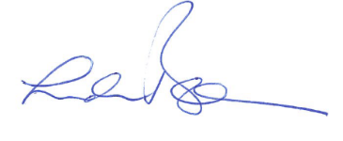
Principal signature

