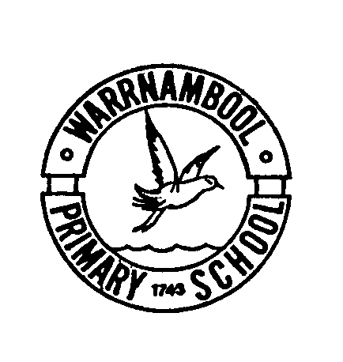
Warrnambool Primary School
** UNIFORM ORDERS WILL BE FILLED ON TUESDAYS & THURSDAYS **

Uniform Order Form
Uniform shop hours
Tuesday – 8.30am – 9.30am
Thursday - 3pm – 4pm
Please note: Uniform sales are no longer available through the office and are only available during the above times or by completing this form.

Date: ___ / ___ / ___

Name: ______________________________________ Grade: _______________

Items | Sizes Available | Unit Price |  | Qty | Size | Price |  | Total
Polo Top (short sleeve) Gold with Logo | 4 – 16 & S, M, L, XL | $20.00
Polo Top (long sleeve) Gold with Logo | 4 - 16 | $25.00
Trackpants Brown - Unisex | 4 - 20 | $25.00
Shorts Brown - Unisex | 4 – 16 & S, M, L, XL | $20.00
Check Cullottes | 4 – 22 | $42.00
Dress | 4 - 14 | $55.00
Jacket Waterproof | 4 – 16 & S, M, L | $67.00
Jumper Polar Fleece | 6 - 14 | $45.00
Rugby Tops (Years 5/6 only) | 8, 10, 12 | $82.00
Rugby Tops (Years 5/6 only) | 14, 16, 18, 20 | $90.00
School Hat - Brown wide brim with Logo | S, S-M, M-L | $16.00
School Bag - Warrnambool Primary School | One size | $45.00
Chair Bag | One size | $10.00
Jamo Socks | 2-7 | $5.00
Brown Tights (2pack) | 3-5, 6-9, 10-12, Mids, Talls | $20.00
Moki Headphones | One size | $15.00
 |  |  |  |  |  | TOTAL |  | $

Payment enclosed : CASH CHEQUE

CREDIT CARD Card Number: __ __ __ __ __ __ __ __ __ __ __ __ __ __ __ __ exp : ___/ ___ Signature : ____________________________

NAME ON CARD : ______________________________________________________

