STUDENTS ACCESS TO AUDIO AND EBOOKS FICTION BOOKS
Wheelers ePlatform gives your library access to a huge range of eBooks through an easy-to-use, customisable, and secure lending system.
- Your can browse, borrow, and read eBooks or listen to audio books from anywhere at home or on the go.
- Tailored specifically for Australia and New Zealand with access to a wide range of local and international content.
- Titles are available on almost all reading devices.
- There are 100’s of titles available through the Wheelers website with new publishers being signed up every week.
- Students that are struggling readers or have Dyslexia are able to change the format, (colour, font & size) to enable reading more accessible.
- 14 day loan, books automatically return themselves, reservations options, plus so much more

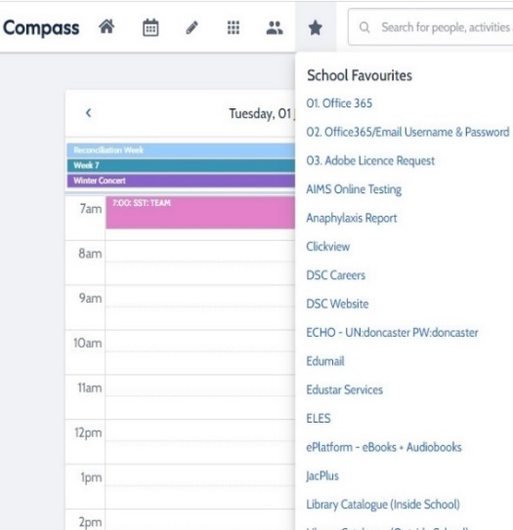
HOW TO ACCESS THE E BOOKS
- log on to compass
- Go to favourites
- Click on the eplatform-e books-audiobooks

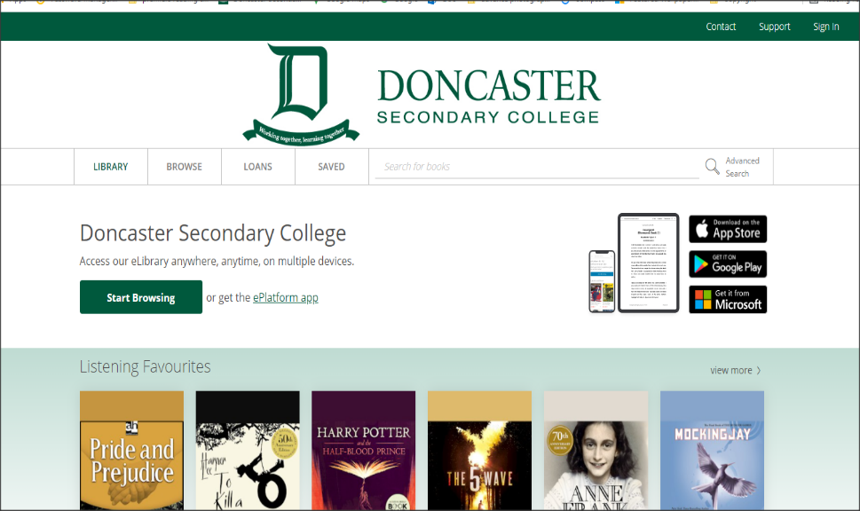
HOW TO SIGN IN – TOP RIGHT HAND CORNER
Using your Compass/Student Barcode eg Walker – WAL0001
Password is LIBRARY – ALL UPPERCASE

Once you are signed in you can browse, sample chapters, listen to audio chapter samples till you decide on what to borrow or reserve

YOU CAN ALSO USE OTHER DEVICES TO ACCESS THE EPLATFORM.

