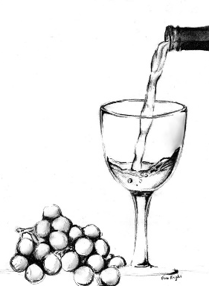
Warrandyte Primary School Fundraiser
celebrating the local community
Warrandyte Primary School is partnering again with local business The Hops & Vine to raise funds for our school. All you need to do is buy some wine!
The Hops & Vine will provide our school a $1000 donation for every 24 cases (12 bottles in each case) that are sold. In 2020, we were pleased to raise $2000 for the school.
The wine dozens cost $240 each but retail at $350+. Each box contains a stunning collection of your favourite wines – reds, whites, or a combination of both. You will need to note your preference regarding the type of wine - reds, whites, or combination in the section below. If purchasing multiple cases, note the number next to the type of wine.
To thank one lucky buyer, included in one of the 24 cases will be an iconic red valued at $250+.
Please place your order by 4:00pm on Monday 22nd November. Wine cases will be available for collection from the school from approximately the 10th of December.
Please note terms: payment is required in advance via credit card. Families can select to purchase and share a case with another family but only one form should be completed for the full dozen. You are welcome to order as many cases as you like – a great Christmas present for loved ones. All cases will be inspected by the school prior to collection to ensure items aren’t damaged.

Full Name: ________________________________________________________________________
Contact Number: ___________________________________________________________________
Email address: _____________________________________________________________________
Number of cases ($240 each, circle relevant number): 1 2 3 Other: __________
Wine type (circle relevant selection or note number of if more than one):
Red White Combination of red & white
Total cost: ________________________________________________________________________
Card Number: _ _ _ _ _ _ _ _ _ _ _ _ _ _ _ _
Expiry Date: _ _ / _ _
CCV: _ _ _
Signature: _________________________________________________________________________

