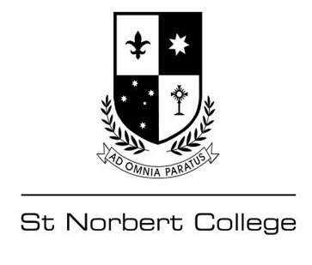

OLNA Schedule 2023 – Round 2

The OLNA schedule for Term Two will be for year 10 students only, and they are required to attend Homeroom to be marked as ‘present’ and then proceed to the Business Centre.

Please ensure that you bring your laptop (fully charged) and headphones and that you have shut down all other applications prior to logging in – the College will provide the Student Login details and any other required materials.

The ICT Staff will be in attendance to assist with any technical issues and when you have completed the OLNA, you must click ‘Submit’ and receive confirmation that the test has been completed – You may then return to your scheduled lesson on the timetable.

Schedule
OLNA – Writing: Monday 1 May; 9:00am – 10:00am (60 minutes)
Year 10 students only
Venue: Business Centre

OLNA – Reading: Tuesday 2 May; 9:00am – 10:00am (60 minutes)
Year 10 students only
Venue: Business Centre

OLNA – Numeracy: Monday 8 May; 9:00am – 10:00am (60 minutes)
Year 10 students only
Venue: Business Centre

OLNA – Catch Up:
Writing only: Tuesday 2 May
Reading: Wednesday May 3 to Friday 12 May
Numeracy: Monday 8 May to Friday 12 May

