# Spinach and ricotta rolls

* 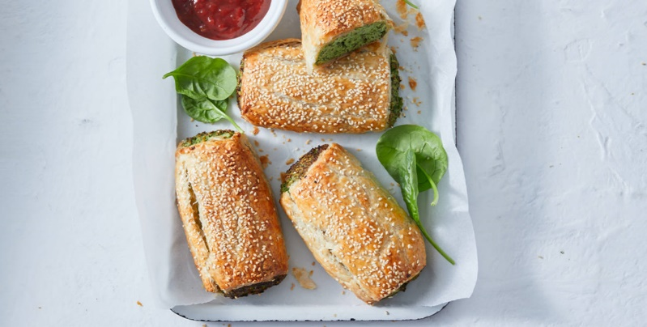
* **Ingredients**
* 3 silverbeet stalks, leaves and stems roughly chopped
* ¼ cup parsley roughly chopped
* 200g fresh ricotta
* 30g parmesan, finely grated
* spring onion, thinly sliced
* 1/2 cup panko breadcrumbs
* 2 sheet  puff pastry, partially thawed
* 1 free range egg, lightly beaten
* 120g baby spinach leaves

## **Equipment Needed**

* Baking tray
* Baking paper
* Knife and chopping board
* Food processor
* Pastry brush
* Fine grater
* Measuring cups
* Small bowl and beater
* Scales

## **Method**

* Preheat oven to 220°C/200°C fan-forced. Line a baking tray with baking paper.
* Place silverbeet, parsley, ricotta, parmesan, onion and breadcrumbs in a food processor. Process until chopped and combined (do not overprocess).
* Lay pastry sheets on a clean work surface. Place silverbeet mixture along 1 edge of both pastry sheets. Brush opposite ends with a little egg. Starting at end with mixture, roll to enclose filling. Cut each roll in half crossways to make 4 smaller rolls.
* Transfer rolls to tray. Brush with a little egg.
* Bake 25 mins until golden and heated through..

Don’t forget to clean up! ☺