

**06/05/2024**

**Dundas Public School**

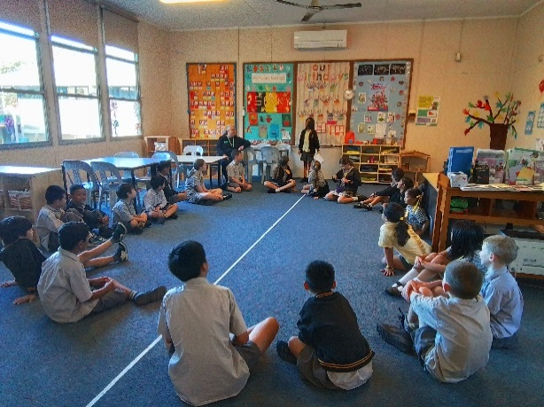[](https://apps.apple.com/app/apple-store/id1529575453?pt=120333103&ct=edmbookings&mt=8)[](https://play.google.com/store/apps/details?id=au.com.campaustralia.parent)[Graphical user interface, text, application
](https://pp.campaustralia.com.au/)

* Paint Drag and Pen
* Painted Gift Bags
* Soccer Match
* Creating animals with Hama Beads
* Garden Group

AND MUCH MORE!!

**Activities coming up**

Welcome back to school our Out of School Hours (OOSH) program after what we hope was a restful and enjoyable holiday break. It was truly heartwarming to reconnect with all of you after the two-week break. We are delighted to announce that our recent Rocketeers event was a success, and we are now fully geared up for Term 2, ready to provide exceptional before and after school care services. With Dundas Public School, we are committed to offering outstanding services aimed at extending child development and ensuring every child's experience with us is filled with joy and learning.

During the first week of Term 2, we dedicated our time to rekindling connections, sharing stories, and engaging in fun-filled activities. We believe in creating an environment where children not only learn but also thrive and create lasting memories.

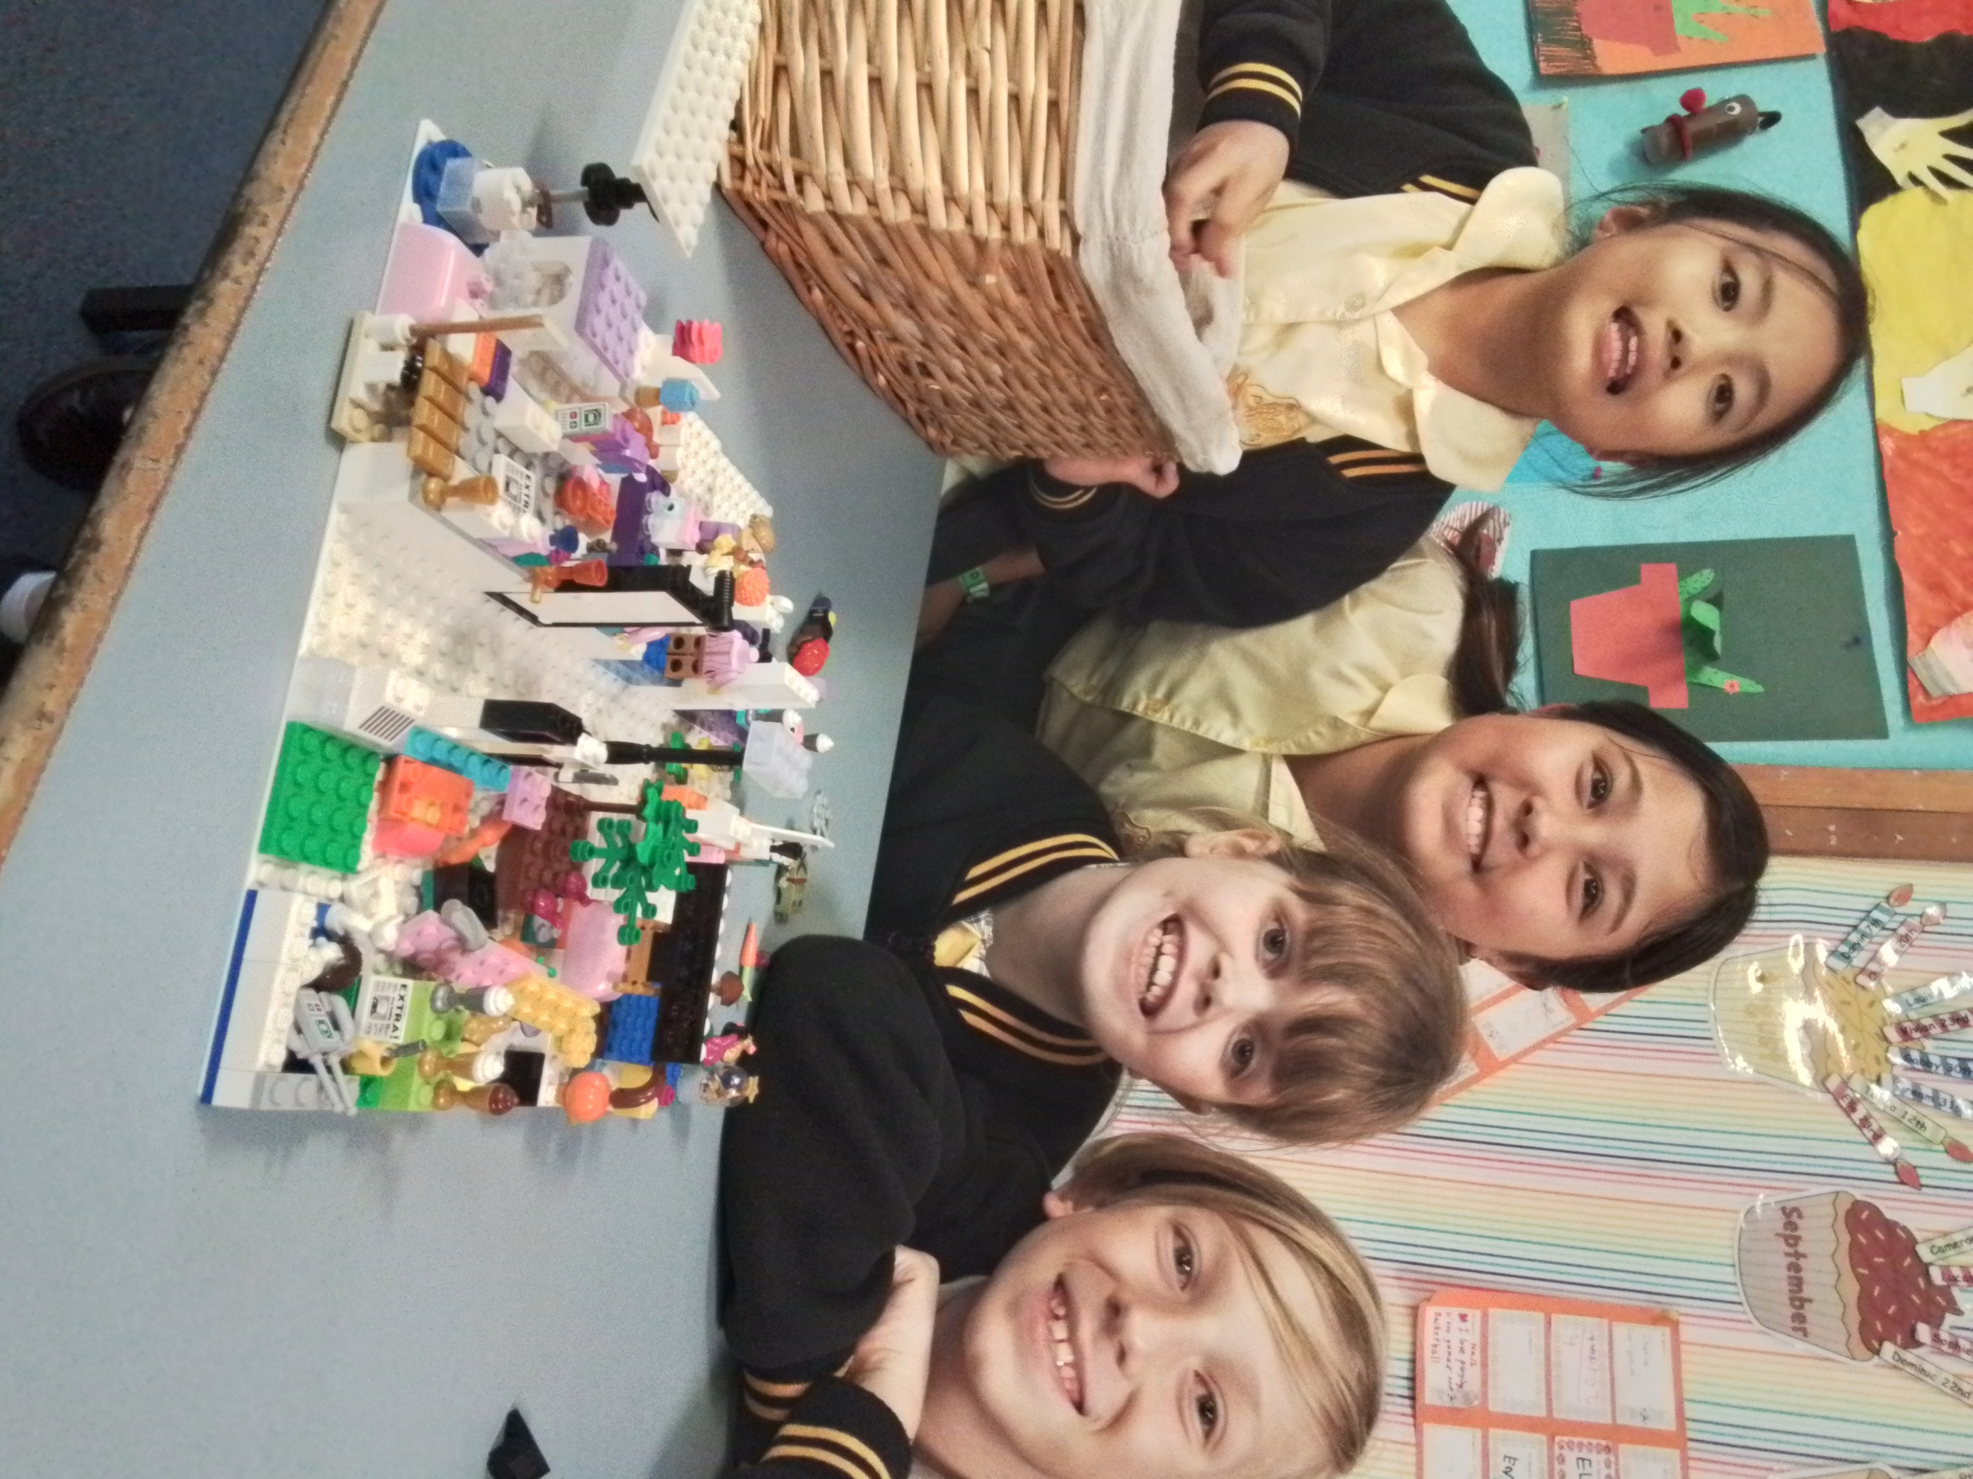 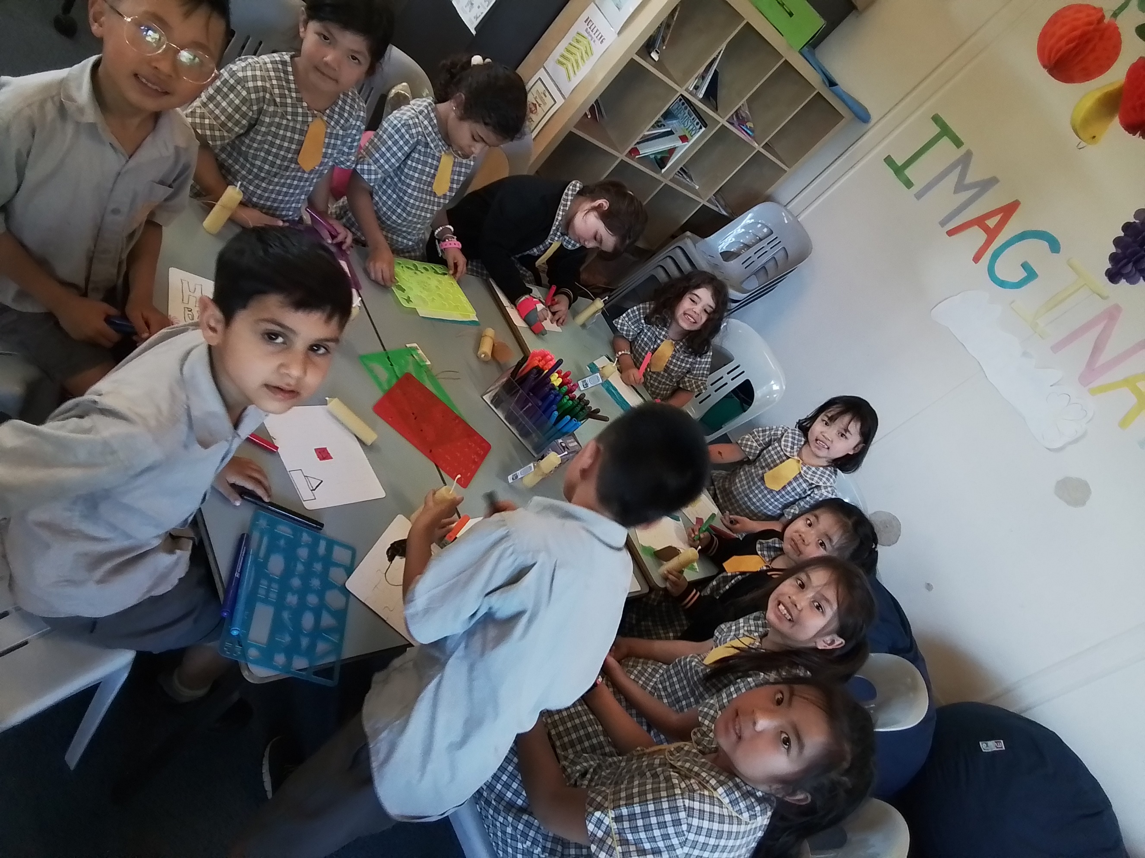

We warmly invite you and your children to join us for what promises to be a wonderful time and enriching experience at OOSH. Together, let's make this term memorable and full of exciting opportunities for growth and exploration.

Join in the fun of Outside School Hours Care activities and experiences with Your OSHC and Rocketeers.

**Make a booking**

Book now