Uralla Central School Principal: Brad Hunt
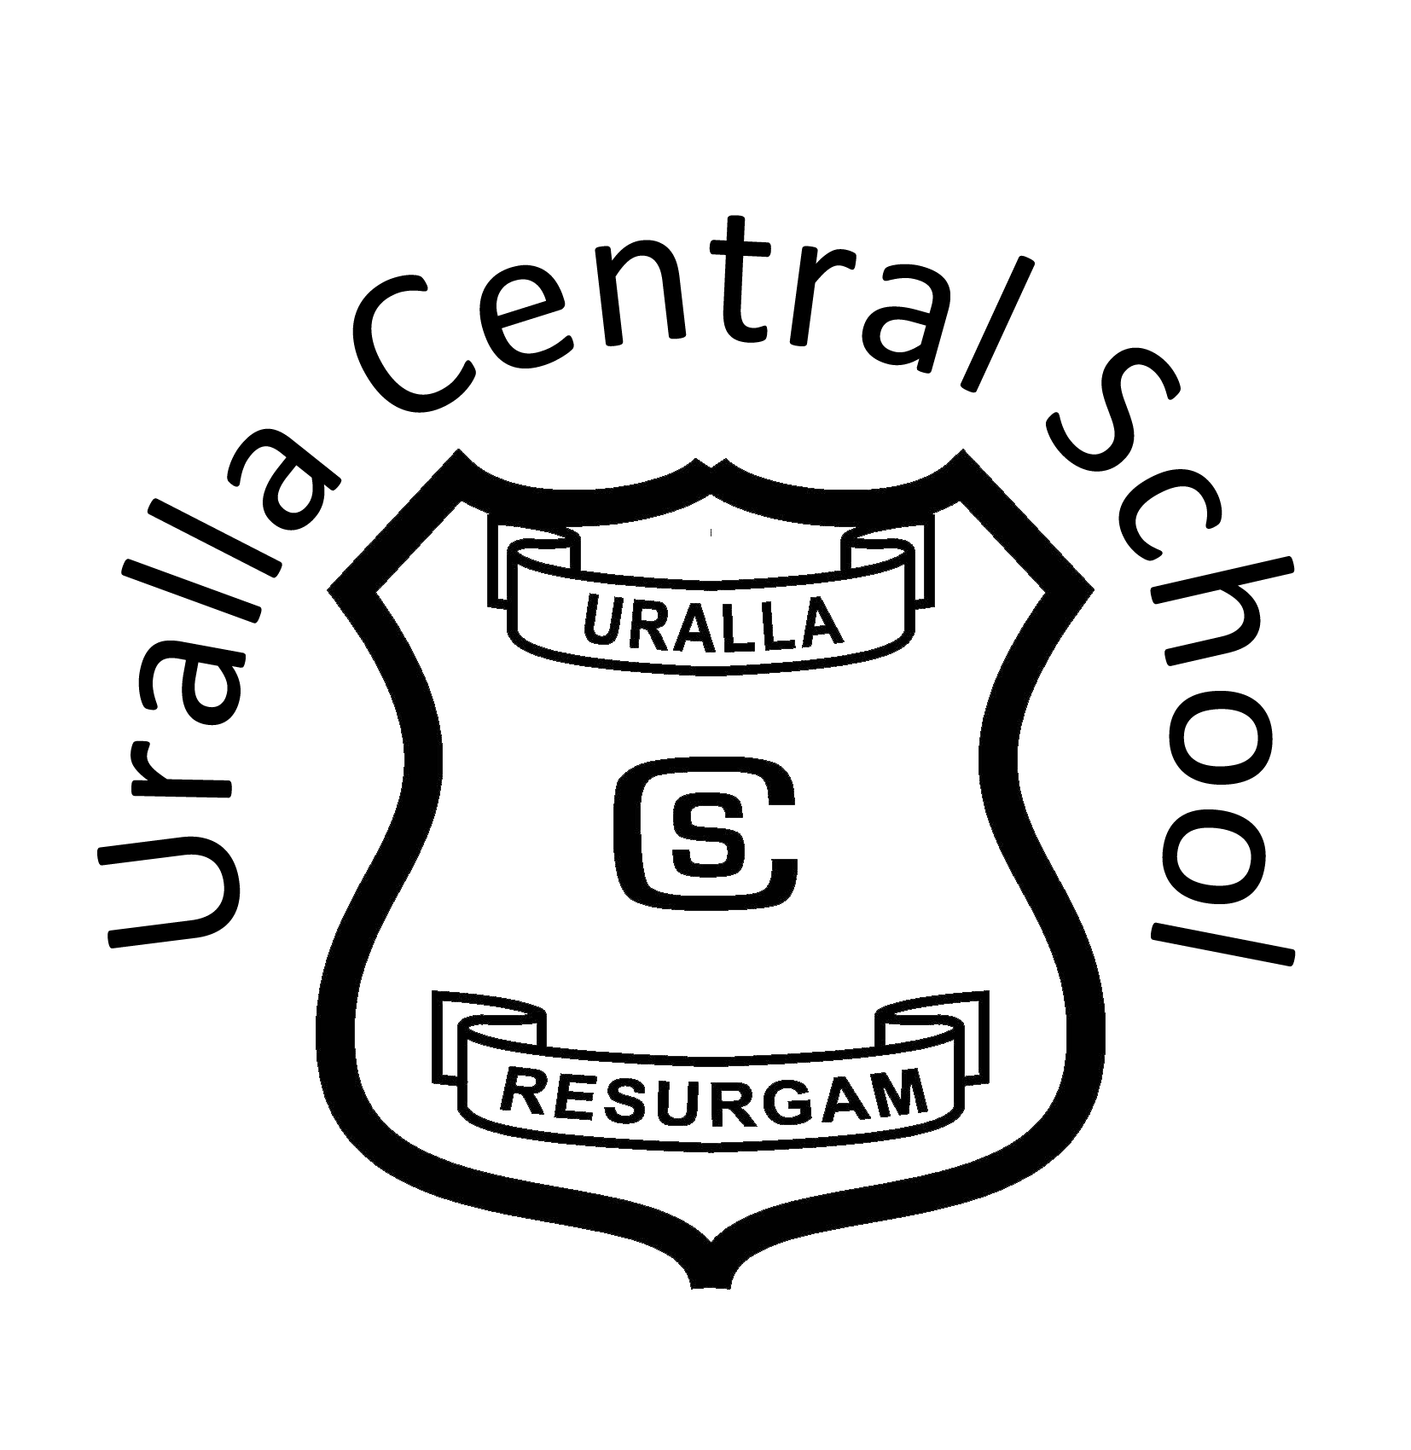
Telephone: (02) 6778 4204
P.O. Box 45 Fax: (02) 6778 5090
Park Street E-Mail: uralla-c.school@det.nsw.edu.au
URALLA NSW 2358 Web: www.uralla-c.schools.nsw.gov.au

Providing Enrichment, Innovation, Opportunity and Success since 1862

Activity Consent

14 October 2025

Dear Parent/Carer,

I hereby consent to the participation of my child in the following school activity:

Activity: Halloween Teddy Bears Picnic/Grandparents Day - Kindergarten - Year 8 Students

Venue: Uralla Central School

Date of Activity Friday 31 October 2025

Time of Activity: 10.30am to 1.25pm (Years 7-8)
11.25am to 1.25pm (Kindergarten to Year 6)

Method of Travel: N/A

Cost: N/A

Staff Attending: Mrs Jodie Taylor, Mrs Lousie Upjohn and all Primary School staff

School Uniform Required: Halloween dress up (Kindergarten to Year 6)
Full school uniform (Years 7-8)

Extra Information: Prizes given for teddy bears dressed up with a Halloween theme. **Please complete the slip below to indicate numbers of grandparents/family members attending**

Brad Hunt
Principal

Please complete the section below and return by: Wednesday 22 October 2025
_ _ _ _ _ _ _ _ _ _ _ _ _ _ _ _ _ _ _ _ _ _ _ _ _ _ _ _ _ _ _ _ _ _ _ _ _ _ _ _ _ _ _ _ _ _ _ _ _ _ _ _ _ _ _ _ _ _ _ _ _ _

I hereby consent to my child ________________________________________ Year_______________________

Participating in the following activity: Halloween Teddy Bears Picnic/Grandparents Day on Friday 31 October 2025 at Uralla Central School at no cost to the students.

Signature of Parent/Carer: ___________________________________________ Date: _____________________

Number of Grandparents/Family members attending: _____________

