
CAREER NEWSLETTER
NEWS, RESOURCES, EVENTS


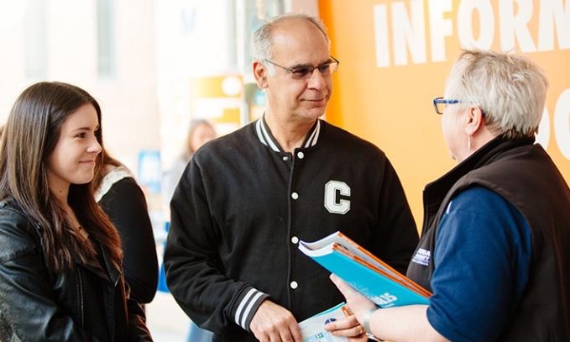


OPEN DAYS ARE HERE!

This information is for all students.

Selected open days running soon:

SATURDAY 19 AUGUST

JMC Academy | Melbourne

SUNDAY 20 AUGUST

Deakin University | Geelong
Monash University | Parkville
The Uni. of Melbourne | Parkville
RMIT University | Point Cook
Victoria University | Footscray

SATURDAY 26 AUGUST

Collarts | Melbourne
La Trobe University | Shepparton

SUNDAY 27 AUGUST

Victoria University | Footscray
Deakin University | Burwood
RMIT University | Bendigo
La Trobe University | Bendigo
Australian Catholic University | Ballarat

Open Day dates

For a list of open day dates for Victoria, NSW, and Canberra, visit https://slmcareerresources.edublogs.org/

UNIVERSITY APPLICATIONS - RESOURCES

Get help with the VTAC application process (Victorian courses)

The Victorian Tertiary Admissions Centre (VTAC) process course applications on behalf of most tertiary institutes in Victoria. VTAC staff are running the following live webinars to assist students and families with applications:

August
23 | Refugee and asylum seeker information session.
30 | Nursing and midwifery applicants.

September
5 | Pathways.
12 | VTAC application process.

To register for an upcoming session, visit https://www.vtac.edu.au/events

Watch information videos via www.youtube.com/@vtacmedia6131

Get help with the UAC application process (NSW and Canberra courses)

The Universities Admissions Centre (UAC) process course applications on behalf of most tertiary institutes in NSW and Canberra. UAC staff are running a series of live webinars to assist students and families with applications. Register for an upcoming session,
www.uac.edu.au/schools/uac-digital

Other states

Students can access information about course applications via:

SA & NT | www.satac.edu.au
Queensland | www.qtac.edu.au
Western Australia | www.tisc.edu.au
Tasmania | www.utas.edu.au

Thursday 17 August 2023

YEAR 12 STUDENTS

TERTIARY APPLICATIONS

University applications via most state-based Tertiary Admission Centres are now open!

Year 12 students can download the
following resources from https://slmcareerresources.edublogs.org/

Early entry programs – Victoria,
NSW and Canberra. Note – all early entry programs are now open.

How to apply for courses via Tertiary Admissions Centres for Victoria, NSW and Canberra.

Scholarships guide.

Accommodation guide.

Open day calendar – Victoria,
NSW and Canberra.












YEAR 12 TERTIARY DATES: VICTORIA

August
 | University applications – VTAC (now open)  Victorian Tertiary Admission Centre (VTAC) applications open for undergraduate courses, scholarships, Special Entry Access Scheme (SEAS) etc. | www.vtac.edu.au
 | Early entry applications close for
31 | Charles Sturt University – Charles Sturt Advantage | www.csu.edu.au

September
 | Early entry applications close for
1 | La Trobe University Aspire – Community Contribution | www.latrobe.edu.au
17 | RMIT – Early Entry | www.rmit.edu.au
18 | Australian Catholic University – ACU Guarantee | www.acu.edu.au
 | University applications – VTAC
15 | Last date that VTAC guarantees they can contact applicants about incorrect or missing evidence/ documents for SEAS. Applicants are encouraged to submit evidence before this date. | www.vtac.edu.au
28 | Timely applications close for undergraduate courses.  Applications close for courses that have early closing dates.

October
6 | University applications – VTAC  Applications close for Special Entry Access Scheme (SEAS) and Scholarships. | www.vtac.edu.au
 | Early/guaranteed entry applications close for
6 | University of Melbourne – Access Melbourne | www.unimelb.edu.au
6 | Monash University – Monash Guarantee | www.monash.edu
6 | RMIT University – SNAP | www.rmit.edu.au
9 | Swinburne University – Early Entry | www.swinburne.edu.au
TBC | Victoria University – VU Guaranteed | www.vu.edu.au

December
 | Early entry applications close for
1 | CQUniversity – Principal’s Recommendation Scheme | www.cqu.edu.au
1 | Federation University – Early Entry | www.federation.edu.au
TBC | Deakin University – Regional Access Scheme | www.deakin.edu.au
 | VTAC Applications
1 | Personal Statement applications close | www.vtac.edu.au
11 | VCE results and ATAR released
13 | Last day to finalise course preferences (Vic students)
14 | Last day to finalise course preferences (NSW students)
13 | December round offers released
 | January offer round 1 released on 12 January 2024.

REMINDERS - VICTORIAN UNI APPLICATIONS

Applying for nursing or midwifery?

Once you have applied for a nursing or midwifery course via VTAC, you will be required to complete the ‘Nursing and Midwifery Declaration Form’. This is located in your VTAC account under ‘Making an Application’.

Initial teacher education - Victoria

Students planning to apply for initial teacher education courses in Victoria for the 2024 intake are required to sit the Casper test: CSP 10409 – Australian Undergraduate Teacher Education. Register for the test via https://acuityinsights.app/casper/

REMINDERS - NSW/ACT UNI APPLICATIONS

Applying for nursing or midwifery?

Once you have applied for a nursing or midwifery course via UAC, you will be required to submit an ‘English proficiency declaration’. The declaration will appear once you review your course preferences.

Applying for a teaching degree?

You may need to complete the Teaching Questionnaire in your UAC account. You may also need to complete a ‘motivation to teach’ statement direct to the university.

REMINDER – ALL STATES

Applying for a course that requires a folio, interview, design task or audition?

Once you add the course/s to your Tertiary Admission Centre preference list and submit your application, you will be emailed information about the additional selection criteria you need to complete.




YEAR 12 TERTIARY DATES – NSW & ACT

August
 | University applications – UAC (now open)  Universities Admissions Centre (UAC) applications are open for undergraduate courses, Equity Scholarships, Education Access Schemes (EAS). Schools Recommendation Schemes etc. | www.uac.edu.au
 | Early entry applications close for
31 | Charles Sturt University – Charles Sturt Advantage | www.csu.edu.au

September
 | Early entry applications close for
4 | University of Technology Sydney - Early Entry | www.uts.edu.au
15 | University of New England – Early Entry | www.une.edu.au
18 | UAC - Schools Recommendation Scheme | www.uac.edu.au
18 | Australian Catholic University – ACU Guarantee | www.acu.edu.au
30 | Southern Cross University – Early Offer | www.scu.edu.au
 | University applications – UAC
29 | Timely applications close for undergraduate courses. Applications close for some courses with early closing dates such as medicine. | www.uac.edu.au

November
 | University applications – UAC | www.uac.edu.au
3 | Preferences close for Schools Recommendation Scheme
10 | Offers released for Schools Recommendation Scheme
22 | Educational Access Scheme - applications close for December Round 2 offers.

December
 | Early Entry applications close for:
1 | CQUniversity – Principal’s Recommendation Scheme | www.cqu.edu.au
 | University applications – UAC | www.uac.edu.au
8 | Equity Scholarships – applications close for December 2 Round of offers
14 | HSC results released
21 | December Round 2 offers released.

CAREER AND COURSE EXPLORATION RESOURCES

Good Universities Guide

Students can search over 400 different occupations narrowed down by the field or type of work they would like to do in the future, explore university courses and compare ratings for undergraduate degrees, www.gooduniversitiesguide.com.au

Course Seeker

Students can explore university courses for each state in the one website and can research courses, prerequisites, selection criteria and ATAR profiles for the 2024 intake, www.courseseeker.edu.au/

ACCOMMODATION

If you have to move away to study, you will need to consider accommodation options. If you would like to live on-campus, you will need to start considering your options now as some universities are ‘first in, first served’.

Steps to apply for on-campus accommodation

- Make an Excel sheet or table in Word.
- List the universities you are applying to.
- Google the university and the term ‘accommodation’
- In your table, list the types of accommodation available (e.g., studio, shared apartment, catered, non-catered)
- Then list the weekly or yearly price for each option and the contract period.
- List the application method, the closing date, cost to apply and if a deposit is required.
- Speak to your family about budget considerations.
- Then tick off the accommodation you have applied for once this is completed.

Download a Victorian accommodation guide https://slmcareerresources.edublogs.org/





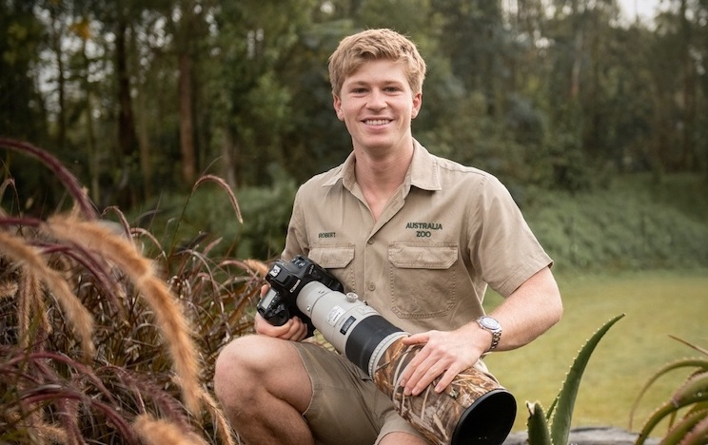

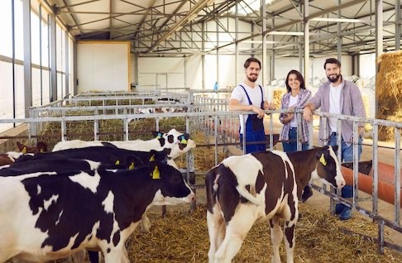

COMPETITIONS

Pursue your passion and add to your resume with these amazing competitions.

Wildlife photography

2023 Crikey! Magazine Photography Competition. This is a partnership between Crikey! Magazine and the Australia Zoo. Applications close 31 August, www.australiazoo.com.au

Science Writing

The UNSW Bragg Student Prize is a science writing competition for students in Years 7 – 10 designed to complement and enrich your science and English study. All you need to do is write a short essay on ‘AI in STEM’, and you could win a fantastic set of prizes, including publication in Australia’s top science websites. Entries close on 25 August 2023, https://bit.ly/47y8ipI

Creative Arts

Bright Awards – run by Billy Blue College of Design at Torrens University. Entries are open for students in years 10-12 and their school to win monetary prizes to help kick start creative dreams. Applications close 3 September, www.torrens.edu.au//bright-awards

Money

Tax, Super + You: this exciting competition is for students in Years 7 – 12. To enter, you will make a creative project that highlights a set topic. Applications close 25 August.
For information on the amazing prizes and how to enter, visit https://taxsuperandyou.gov.au/competition

ALL STUDENTS

APPRENTICESHIP AND TRAINEESHIP RESOURCES

Australian Apprenticeship Pathways

You will be able to undertake apprenticeship aptitude tests, find local apprenticeship and group training centres, and learn about different trade occupations, www.aapathways.com.au/

4 steps to finding an apprenticeship or traineeship

Australian Apprenticeships Pathways has developed a fantastic 4-step process for students to follow when seeking an apprenticeship or traineeship, www.aapathways.com.au/

My Skills

You can search for and explore vocational courses across Australia, learn about in demand jobs and watch videos of young people who have completed vocational training, www.myskills.gov.au

EMPLOYMENT RESOURCES

Do you need a Tax File Number (TFN)?

If you are planning to get a job or if you would like to study at university or TAFE next year, you will need a TFN. To start the application process, go to www.ato.gov.au

Find out about your rights at work

Learn about your rights, responsibilities, how to resolve issues in the workplace and rules about unpaid work, www.fairwork.gov.au

Learn about safety in the workplace

Your rights and responsibilities,
www.safe-t1.net.au

How to stay safe - www.worksafe.vic.gov.au/young-workers

YEAR 10 & 11 STUDENTS

DEFYING THE DRIFT PROGRAM

This is an amazing two stage program for young people keen to learn about careers in agriculture. You will participate in a 3-day residential program at Longerenong College in September and then present to a Rotary Club about your experience in the program. A fee of $350 per participant is payable. Sponsor Rotary Clubs assist by contributing part or all of the fee. For information and to apply, visit
www.defyingthedrift.org

YEAR 9 & 10 STUDENTS

THE SANTOS SCIENCE EXPERIENCE - AGRICULTURE

The University of Melbourne is running an exciting 3-day program at the Dookie campus between 29 November – 1 December 2023. Dookie campus is a working farm - a centre of agricultural research and teaching. You will join scientists and agricultural student mentors in hands on activities in the laboratory and paddock investigating real world issues. Activities include biodiversity, sheep science, plant science, protein content of milk,
cheese making and robotic dairy. There are 35 places left and accommodation is available at an additional cost. Book your place via www.scienceexperience.com.au

ALL STUDENTS

THE NEW-PRINT OF CONSTRUCTION

Construction is big business in Australia, but many people don’t really know what it’s like to work in the industry. Year13 has teamed up with Construction Skills Queensland to show you what’s available in the industry, what it takes to make a career of it, and what the future could hold for you. You can complete 5 modules that will prepare you for the industry:

- Skills of the industry
- Working in construction
- Making it happen
- Gearing up for the job
- Breaking new ground.

Complete the modules via https://year13.com.au/academy











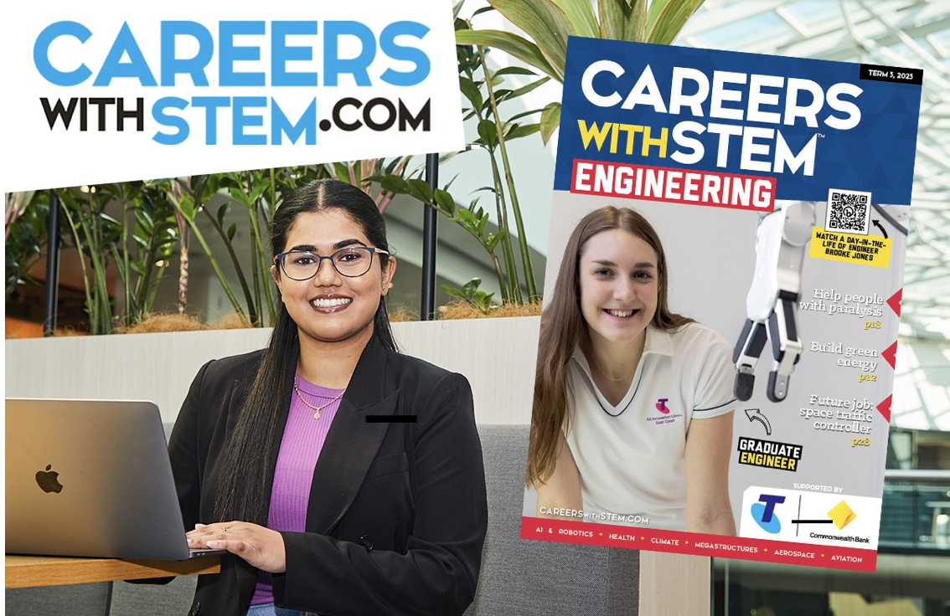

UNIVERSITY OF NEW SOUTH WALES (UNSW)

Join the mission for earth habitation

‘The world is changing, and you can make a real impact. Make a difference in the issues you care most about. Right here, right now. Whether you want to tackle climate change, evolve mental health policies, or improve lives with the latest tech, you could make Earth a better place to live. Want inspiration for where your studies could take you? Let’s look at where our leading researchers are making an impact’,
www.unsw.edu.au/study/earth-habitation

ENGINEERING AT MONASH UNIVERSITY

If you’re keen to study engineering at Monash University but concerned you may not achieve the ATAR, there is a new pathway into graduate entry engineering via the Bachelor of Science. Students can complete the Bachelor of Science and progress into the Master of Professional Engineering providing they complete the required undergraduate subjects in the science degree and achieve the academic requirements for the Master program, https://bit.ly/3YKF0QP

UPCOMING CAREER EVENTS

RMIT UNIVERSITY - FLIGHT TRAINING & AVIATION OPEN DAYS

Learn about aviation courses at the following campuses:

Point Cook, Sunday 20 August
Bendigo, Sunday 27 August

For information and to register your place, visit www.rmit.edu.au/openday

Indigenous Australian Engineering School (IAES) 2024

The IAES will be held at Sydney between 14 – 20 January 2023. Year 10 – 12 participants will experience:

- a fully sponsored week-long program
- exploration of various engineering fields
- site visits, cultural activities, and more
- networking with industry professionals
- recreational fun on Sydney Harbour.

For information and to express an interest in the program, visit https://bit.ly/3QZtLSX

DIGITAL TECHNOLOGIES

Grok Academy – free courses!

Interested in coding or quantum computing? How about cyber security or data analytics? Passionate about all things IT? Grok Academy offers free courses and competitions for students. You can choose between beginners to advanced level short courses and work at your own pace from the comfort of home. Add the courses to your resume and start your preparation for post school courses at TAFE and university, https://groklearning.com/

Uber Global Hackathon

Get a small team together and register for the Uber Global Hackathon. This is an amazing competition with incredible prizes! This is the world’s first ever global and virtual hackathon for high school students. You can choose from 3 different categories and win cash and the opportunity to undertake work experience at a top tech company. Register by 31 August, www.uberglobalhackathon.org

PODCASTS

Arrive and Thrive

Tyson Day and Daniel Lunardi have created a podcast for students and educators. They interview interesting people in the world of careers. Tune in via https://bit.ly/47CPaXC

That Careers Show

This podcast will feature interviews with inspiring people in different careers. Tune in via https://bit.ly/3YFIMuA

CAREERS IN ENGINEERING

Careers with STEM

Careers with STEM have the following engineering career resources on their website:

Engineering articles
Free downloadable e-magazines
Job Kits exploring engineering specialisations (featuring a new kit on ‘Metaverse Engineering’)
Profiles on inspiring engineers
STEM + X (combining science with another passion such as sport or health)
Quizzes
Webinars
Studying vocational and higher education engineering courses.

Access these amazing free resources via https://careerswithstem.com.au/

My Career Match

My Career Match is a company that provides a commercial service for personality and career testing. They have just released one of 16 fantastic guides on engineering careers. Download the engineering careers guide for ‘Analyser’ personality types via https://bit.ly/47zS3bO

According to the company:

‘Analysers are thinkers, great with facts and numbers. They are well-organised, strive for accuracy and like to pay attention to details.’

Regarding engineering, they write:

‘Australia faces an engineer shortage due to a combination of factors. Rapid technological advancement and infrastructure growth create high demand for specialised skills.

The domestic education system produces fewer engineering graduates than required. Retirements in the aging engineering workforce further deplete numbers.

As industries like mining, renewables, and IT expand, the gap between demand and supply of skilled engineers continues to widen. Addressing this imbalance is crucial for Australia's future development and competitiveness.’

https://mycareermatch.com.au/







MONASH UNIVERSITY CONT…

Information evening (online)

The University is running an online information session for prospective students and families on Thursday 24 August, starting at 6.30pm.

Campus tours

Monash is running campus tours for prospective students and families during August and September.

Discover Monash

Monash is running the following exciting course information sessions in September:

5 | Discover Engineering
7 | Discover Music
14 | Discover Politics, Philosophy, Economics and Global Studies
27 | Discover IT

Register your place for the above events via www.monash.edu/discover

Access Monash

Monash will be running an online exam preparation and techniques seminar for prospective students and their families on 12 September. Register via https://bit.ly/3kVijtH

VCE revision lectures

Monash is running VCE revision lectures in the following subjects: Biology, Physics, Chemistry, and Mathematical Methods during the September holidays. Book your place via https://bit.ly/3K0xds0

Business Explorer Program

This is a free program for students who are keen to explore course and career options in business. The next event will run on 27 September at the Clayton campus. www.monash.edu/business/business-explorer

Spring into Monash: Indigenous Camp

This camp will provide Aboriginal and/or Torres Strait Islander students from Yrs 10 to 12 with an insight into university life and an opportunity to connect with youth from across the country. The camp will run between 24 – 27 September 2023, https://bit.ly/44QnNaF

UPCOMING CAREER EVENTS

ENDEAVOUR COLLEGE OF NATURAL HEALTH – FUTURE OF WELLNESS

Endeavour College offers courses in the following study areas: Naturopathy, Nutritional and Dietetic Medicine, Acupuncture Therapies, Chinese Medicine, and Complimentary Medicine

The College is running virtual information sessions between 1 – 30 September for prospective students who are interested in natural health careers. Information and registration, www.endeavour.edu.au/events/

WHITEHOUSE INSTITUTE OF DESIGN

Illustration & Portfolio Workshop

Whitehouse is running the following workshops in September at the Melbourne campus:

18 | Illustration & Portfolio Workshop
19 | Adobe Portfolio Workshop
20 | Foundation Sewing Workshop (3-day program)

The workshops are for aspiring designers and recommended as a starting point for those wishing to develop their illustration skills and create a portfolio for application to the Bachelor of Design program. For information on costs and to register your place, visit https://whitehouse-design.edu.au/workshops

AUSTRALIAN CATHOLIC UNIVERSITY

ACU is running the following online ‘Talk with Industry’ seminars in in September. Hear from professionals working in the following careers and learn about courses at ACU.

12 | Occupational Therapists, Speech Pathologists and Physiotherapists
20 | Exercise Science & High-Performance Sport
26 | Psychologists, Youth Workers, and Social Workers
27 | Nutritionists and Dietitians

Register your place for the events above via www.acu.edu.au/about-acu/events

GIRLS PROGRAMMING NETWORK

The University of Melbourne is running a free workshop for girls who are interested in programming. No experience in coding is needed. The event will be held at the Parkville campus on Saturday 2 September between 9.30am – 4pm. The event will fill quickly, so register soon, https://bit.ly/45aaiCD

CAMP SEEK

Camp Seek is a 4-day STEM focussed learning and immersion program for girls and non-binary young people aged 14 – 16. The camp is taking place during the September school holidays. Information - www.seek.com.au/camp-seek/

AUSTRALIAN DEFENCE FORCE

You can find out about careers in the Australian Defence Force through participating in free information sessions. There are sessions running at various locations across Victoria and NSW and online sessions, www.defencejobs.gov.au/events

DRAMA & THEATRE ARTS INFORMATION SESSION

Melbourne Polytechnic offer exciting vocational courses in:

Costume design
Live production
Specialist make-up services
Theatre arts

The Institute is running an online information session for prospective students and families on Tuesday 29 August starting at 4.30pm. Register via https://bit.ly/45u6RqP

MONASH UNIVERSITY

Fine Art, Design & Architecture Experience Day

This on-campus event is for students interested in studying Fine Art, Design or Architecture. Students will participate in hands-on workshops and learn about Monash courses. The program will run on 26 & 27 September at the Caulfield campus. Spaces will fill quickly. Register your place via https://bit.ly/3YDbNHu

.

