Gallipoli by Justin Coates
Who was at Gallipoli? Troops from New Zealand, alongside those from Australia, Great Britain and Ireland, France, India, and Newfoundland
What was the battle about? The Allies wanted to take the beach so they would have control of the surrounding area.
When was Gallipoli? The battle started on the February 17th, 1915 and ended on January 9th, 1916.
Where was the battle of Gallipoli? The battle of Gallipoli was in Turkey ANZAC Cove.
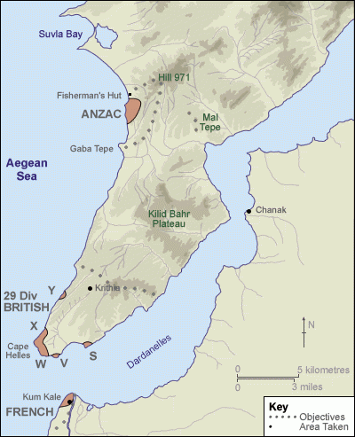
Why were they at Gallipoli? The Allies wanted to take control of a river Called the Dardanelles so they could get ship to attack Constantinople.

BY Justin

